Revision History

|  |  |  |
| --- | --- | --- |
| **Revision** | **Description of Change** | **Revision date** |
| 1.0 | Test report phase 1 | 2019-06-28 |
| 2.0 | Test report phase 2 | 2019-07-01 |
|  |  |  |
|  |  |  |
|  |  |  |
|  |  |  |
|  |  |  |
|  |  |  |
|  |  |  |
|  |  |  |
|  |  |  |

**TABLE OF CONTENTS**

[Introduction 3](#_Toc12884135)

[1 Test Object 4](#_Toc12884136)

[2 Test Environment 5](#_Toc12884137)

[3 Testing work （Phase 1） 6](#_Toc12884138)

[3.1 Test Environment 6](#_Toc12884139)

[3.2 Test scenario and strategy 7](#_Toc12884140)

[3.3 Test Tool 7](#_Toc12884141)

[3.4 Database setting 7](#_Toc12884142)

[3.5 IIS setting 8](#_Toc12884143)

[3.6 Test Object version 8](#_Toc12884144)

[3.7 Background data 8](#_Toc12884145)

[3.8 Test Error 9](#_Toc12884146)

[3.9 Test result of PS server 9](#_Toc12884147)

[Test result of PS transactions 9](#_Toc12884148)

[Transaction summary result of PS 10](#_Toc12884149)

[Transaction response time result of PS 11](#_Toc12884150)

[3.10 Test result of Web service 12](#_Toc12884151)

[Test Statistic Report of Web 12](#_Toc12884152)

[Transaction summary result of Web 14](#_Toc12884153)

[Transaction response time result of Web 14](#_Toc12884154)

[3.11 Performance bottleneck analysis 15](#_Toc12884155)

[Hardware usage analysis- Main Server 16](#_Toc12884156)

[Hardware usage analysis- PS Server 18](#_Toc12884157)

[SQL Server resource usage analysis 23](#_Toc12884158)

[MS IIS resource usage analysis 25](#_Toc12884159)

[3.12 Test Conclusion 27](#_Toc12884160)

[3.13 Tune suggestion: 28](#_Toc12884161)

[System related: 28](#_Toc12884162)

[Database related: 28](#_Toc12884163)

[4 Testing work （Phase 1） 30](#_Toc12884164)

[4.1 Test Environment 30](#_Toc12884165)

[4.2 Test scenario and strategy 30](#_Toc12884166)

[4.3 Test Tool 31](#_Toc12884167)

[4.4 Database setting 31](#_Toc12884168)

[4.5 IIS setting 31](#_Toc12884169)

[4.6 Test Object version 31](#_Toc12884170)

[4.7 Background data 31](#_Toc12884171)

[4.8 Test Error 32](#_Toc12884172)

[4.9 Test result of PS server 33](#_Toc12884173)

[Test result of PS transactions 33](#_Toc12884174)

[Transaction summary result of PS 34](#_Toc12884175)

[Transaction response time result of PS 35](#_Toc12884176)

[4.10 Test result of Web service 36](#_Toc12884177)

[Test Statistic Report of Web 36](#_Toc12884178)

[Transaction summary result of Web 38](#_Toc12884179)

[Transaction response time result of Web 38](#_Toc12884180)

[4.11 Performance bottleneck analysis 40](#_Toc12884181)

[Hardware usage analysis- Main Server 40](#_Toc12884182)

[Hardware usage analysis- PS Server 41](#_Toc12884183)

[SQL Server resource usage analysis 47](#_Toc12884184)

[MS IIS resource usage analysis 50](#_Toc12884185)

[4.12 Test Conclusion 52](#_Toc12884186)

# Introduction

The PUMA MR2 performance testing works will focus on main work flow of the Print Server of Kiosk (PS).

The PUMA PS system will integrated with other 3rd systems like HIS, RIS, LIS etc. System will synchronize 3rd party data and provide the film include gray and color type and report printing services. The PUMA system will integrate with PS and get the patient information and images data from PS system.

We should confirm the performance of PS system will meet the requirements on real work environments. Ensure the new added features will not affect main workflow of PS system.

# Test Object

The PUMA system will support film and report printing and notice push service for different departments of entire hospital.

We will integrate the 3rd party system and patients can print their films and reports in ONE terminal. The patient can print their color films to paper or films. Patients can query different information, and get report status notice service from the product.

PUMA MR1 system will provide the patient images data upload service for Cloud Film system. System will provide the patient can print their color films to film or paper media. The patient can view the image files including picture and DICOM type from WeChat platform or by scanning from 2D image code.

Notice: We will not test the images upload feature in performance testing.

The architecture as follow:

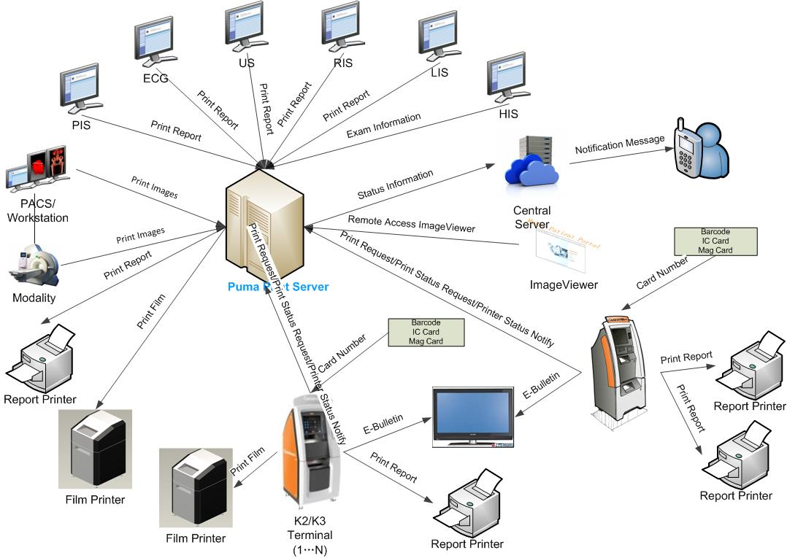Figure 3.1.2

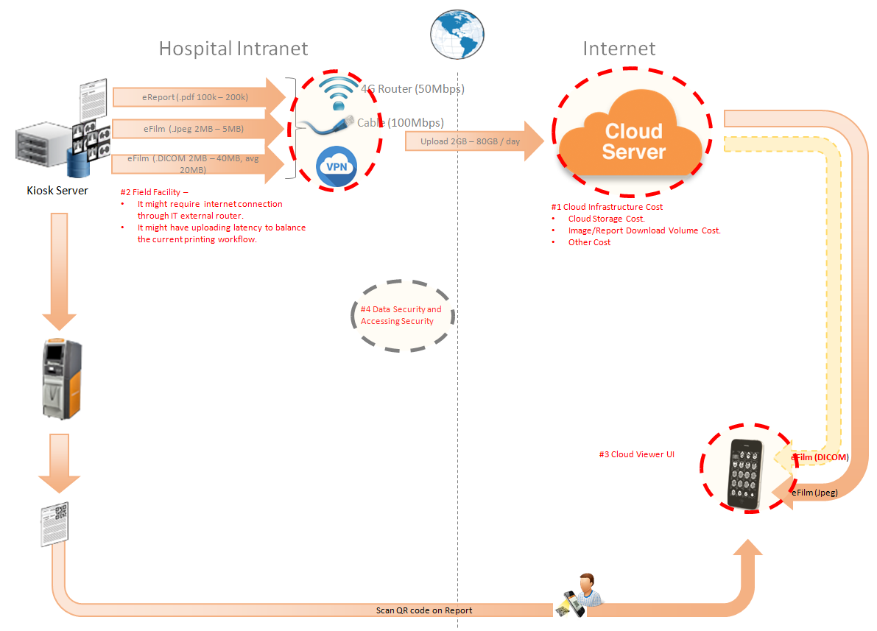Figure 3.1.2

The performance testing work will focus on the PS system. We will simulate the web service call and send them to PS server, and monitor the transactions response time, service performance and hardware resource usage. This scenario will include the 3rd request, report archived, gray and color film and report print, web query and update status operations etc.

# Test Environment

The detailed hardware configurations of all servers are described as follow:

|  |  |  |  |  |  |  |
| --- | --- | --- | --- | --- | --- | --- |
| **Computer name** | **CPU** | **Memory** | **HD** | **OS** | **Other** | **Comments** |
| PUMA Main Server | Intel(R) Xeon® Bronze CPU 3140 @ 1.70 \* 6 | 16GB | 300GB | Windows 2012 R2 64bit |  |  |
| PUMA Store Server | Intel(R) Xeon® Bronze CPU 3140 @ 1.70 \* 6 | 16GB | 8T | Windows 2012 R2 64bit |  |  |
| PUMA virtual server | Intel(R) Xeon® Bronze CPU 3140 @ 1.70 \* 6 | 12GB | 7T | Windows 2012 R2 64bit | SQL server 2008 Sp3 | PS 3.0.4.0.0031 |
| Terminal | Intel(R) Celeron CPU J1900 2.0GHz | 4GB | 450GB | Windows 10 Enterprise 2016 | AUTOIT 3.0 |  |

Table 1 Hardware Configuration

# Testing work （Phase 1）

## Test Environment

The detailed hardware configurations of all servers are described as follow:

|  |  |  |  |  |  |  |
| --- | --- | --- | --- | --- | --- | --- |
| **Computer name** | **CPU** | **Memory** | **HD** | **OS** | **Other** | **Comments** |
| PUMA Main Server | Intel(R) Xeon® Bronze CPU 3140 @ 1.70 \* 6 | 16GB | 300GB | Windows 2012 R2 64bit |  |  |
| PUMA Store Server | Intel(R) Xeon® Bronze CPU 3140 @ 1.70 \* 6 | 16GB | 8T | Windows 2012 R2 64bit |  |  |
| PUMA virtual server | Intel(R) Xeon® Bronze CPU 3140 @ 1.70 \* 6 | 12GB | 7T | Windows 2012 R2 64bit | SQL server 2008 Sp3 | PS 3.0.4.0.0031 |
| Terminal | Intel(R) Celeron CPU J1900 2.0GHz | 4GB | 450GB | Windows 10 Enterprise 2016 | AUTOIT 3.0 |  |

Table 1 Hardware Configuration

## Test scenario and strategy

Virtual User: 59 Users

Duration: 8 hour

Description: Use the test tool simulates the patient operations. Monitor the server software and hardware resource usage. The detail information as follow:

1. Use automation tool simulate the doctor print film work. Simulate 20 workstations print films to PS server every 90 seconds in 8 hours.
2. Use LR tool simulate 8 K2/K3 terminals to print gray films. Each client prints one film which size is 10MB random 5 to 30 seconds.
3. Use AUTO tool simulate 1 K2/K3 terminals to print color films. Each client prints one film which size is 83MB in real terminal. The color films will print to PDF file with PDF created software instead of the real paper printer.
4. Use LR tool simulate 21 users to do paper report archive and print operations. Each client archive report in random 5 to 30 seconds and size is random with 100kb and 4Mb.
5. The OCR setting will has rule configuration from test tool in step1 and thread setting is set as 10. The OCR rule will has ROI setting of patient id and accession number in OCR.
6. Simulate 10 users to do the query information, view monitor page, query reconciliation films and report, expand the record, change the status, set holding time and other operations in work list. The users will execute the operations random 60 to 120 seconds.
7. Monitor the transaction response time.
8. Monitor the hardware resource usage on PS.
9. Monitor the resource usage for database on PS.
10. Start/Stop 2 virtual users every 10 seconds and run the scenario for 8 hours.

Note:

We will do the performance testing work under stress for system. If system can work well under current stress and the transaction process ability meets the requirement, we will give the conclusion the system performance is pass.

## Test Tool

Load Runner 12.

## Database setting

Memory: Set the min and max memory size to 6GB.

Index fill factor: 80.

File: Increase the data and log files size and the rule is increase 500Mb as fixed size.

Settings: Cost threshold for parallelism to 60.

## IIS setting

Connection: Set the max connection value to 4000 and keep other setting as default.

## Test Object version

PUMA 3.0.4.0 B31, Terminal 3.0.4.0 B35

## Background data

We prepared a background records in the PS system. The data size is calculated by the typical site which printed 3,000 films in a workday. That means the records of films in db should more than 972,000 (3000 records / day \*54 weeks \* 6 workday). QA team had prepared these data with SQL script and automation script. These data can backup and import by DB tool.

The detail data records in DB as follow:

|  |  |
| --- | --- |
| **Table Name** | **Data Volume (records)** |
| printer.dbo.DeliveryJob | 994910 |
| printer.dbo.ImageBox | 3529958 |
| printer.dbo.Page | 314626 |
| printer.dbo.Session | 32 |
| wggc.dbo.Patient | 798 |
| wggc.dbo.Study | 1434214 |
| wggc.dbo.AFP\_PrintTerminalInfo | 60 |
| wggc.dbo.Series | 1434164 |
| wggc.dbo.Image | 1440055 |
| wggc.dbo.AFP\_FilmInfo | 1420530 |
| wggc.dbo.AFP\_ReportInfo | 1228844 |
| wggc.dbo.AFP\_ExamInfo | 174343 |
| wggc.dbo.AFP\_PrintTask | 4322551 |
| wggc.dbo.T\_Integration\_ExamInfo | 204 |
| AFP\_PrintMode | 70463 |
| wggc.dbo.vi\_KIOSK\_ExamInfo\_Order | 834834 |

## Test Error

There is no transaction error existed in the testing work.

## Test result of PS server

### Test result of PS transactions

After the performance testing works, the transactions result of PS print module as follow:

|  |  |
| --- | --- |
| Analysis Summary | Period: 6/27/2019 2:06 PM - 6/27/2019 10:13 PM |

|  |  |
| --- | --- |
| **Scenario Name:** | E:\ECS\Performance\Script\208\ScenarioPUMA\_Reliability\_171.lrs |
| **Results in Session:** | c:\Users\Administrator\AppData\Local\Temp\res1147\res1147.lrr |
| **Duration:** | 8 hours, 7 minutes and 1 second. |

|  |
| --- |
| Statistics Summary |

|  |  |  |
| --- | --- | --- |
| [**Maximum Running Vusers:**](file:///E:\B31_20190628_Terminal_1\VuserStateGraph) |  | 29 |
| [**Total Throughput (bytes):**](file:///E:\B31_20190628_Terminal_1\Throughput) | [Show SLA Results](slarules:total_throughput) | 18,382,151 |
| [**Average Throughput (bytes/second):**](file:///E:\B31_20190628_Terminal_1\Throughput) | [Show SLA Results](slarules:average_throughput) | 629 |
| [**Total Hits:**](file:///E:\B31_20190628_Terminal_1\HitsperSecond) | [Show SLA Results](slarules:total_hits) | 19,053 |
| [**Average Hits per Second:**](file:///E:\B31_20190628_Terminal_1\HitsperSecond) | [Show SLA Results](slarules:average_hits) | 0.652 | [**View HTTP Responses Summary**](file:///E:\B31_20190628_Terminal_1\B31_20190628_Terminal_1.html#1) |

|  |  |  |
| --- | --- | --- |
| |  | | --- | | You can define SLA data using the [SLA configuration wizard](slaconfig:) | | You can analyze transaction behavior using the [Analyze Transaction mechanism](analyze:) | |

|  |
| --- |
| Transaction Summary |

|  |  |  |  |  |
| --- | --- | --- | --- | --- |
| [**Transactions:**](file:///E:\B31_20190628_Terminal_1\TransactionSummary) | Total Passed: 99,854 | Total Failed: 0 | Total Stopped: 0 | [**Average Response Time**](file:///E:\B31_20190628_Terminal_1\ResponseTime) |

|  |  |  |  |  |  |  |  |  |
| --- | --- | --- | --- | --- | --- | --- | --- | --- |
| **Transaction Name** | **Minimum** | **Average** | **Maximum** | **Std. Deviation** | **90 Percent** | **Pass** | **Fail** | **Stop** |
| [Create New Patient](file:///E:\B31_20190628_Terminal_1\ResponseTime0000(Create%20New%20Patient)0000) | 0.109 | 0.17 | 1.153 | 0.061 | 0.25 | 5,991 | 0 | 0 |
| [Film Create\_PrintTask](file:///E:\B31_20190628_Terminal_1\ResponseTime0000(Film%20Create_PrintTask)0000) | 0.047 | 0.168 | 8.143 | 0.226 | 0.265 | 2,942 | 0 | 0 |
| [Film PrintTask](file:///E:\B31_20190628_Terminal_1\ResponseTime0000(Film%20PrintTask)0000) | 0.016 | 0.061 | 0.686 | 0.044 | 0.109 | 2,942 | 0 | 0 |
| [Film PrintTask\_Result\_Correct](file:///E:\B31_20190628_Terminal_1\ResponseTime0000(Film%20PrintTask_Result_Correct)0000) | 0 | 0 | 0.016 | 0.001 | 0 | 2,940 | 0 | 0 |
| [Film TerminalStatus](file:///E:\B31_20190628_Terminal_1\ResponseTime0000(Film%20TerminalStatus)0000) | 0 | 0.046 | 7.972 | 0.164 | 0.078 | 2,942 | 0 | 0 |
| [Film\_PrintStatus\_CheckService](file:///E:\B31_20190628_Terminal_1\ResponseTime0000(Film_PrintStatus_CheckService)0000) | 0 | 0.046 | 7.675 | 0.147 | 0.078 | 10,227 | 0 | 0 |
| [Notify File 100k](file:///E:\B31_20190628_Terminal_1\ResponseTime0000(Notify%20File%20100k)0000) | 0.107 | 0.314 | 12.028 | 0.377 | 0.515 | 5,889 | 0 | 0 |
| [Notify File 4M](file:///E:\B31_20190628_Terminal_1\ResponseTime0000(Notify%20File%204M)0000) | 0.199 | 0.49 | 2.006 | 0.293 | 0.827 | 102 | 0 | 0 |
| [Report Print Task Correct](file:///E:\B31_20190628_Terminal_1\ResponseTime0000(Report%20%20Print%20Task%20Correct)0000) | 0 | 0 | 0.016 | 0 | 0 | 5,989 | 0 | 0 |
| [Report Create\_PrintTask](file:///E:\B31_20190628_Terminal_1\ResponseTime0000(Report%20Create_PrintTask)0000) | 0.058 | 0.165 | 2.746 | 0.103 | 0.265 | 5,989 | 0 | 0 |
| [Report PrintTask](file:///E:\B31_20190628_Terminal_1\ResponseTime0000(Report%20PrintTask)0000) | 0.016 | 0.071 | 6.022 | 0.11 | 0.125 | 5,989 | 0 | 0 |
| [Report PrintTask Status Check](file:///E:\B31_20190628_Terminal_1\ResponseTime0000(Report%20PrintTask%20Status%20Check)0000) | 0 | 0.046 | 5.304 | 0.093 | 0.078 | 5,989 | 0 | 0 |
| [Report QueryFilmReportInfo](file:///E:\B31_20190628_Terminal_1\ResponseTime0000(Report%20QueryFilmReportInfo)0000) | 0.074 | 0.18 | 12.074 | 0.299 | 0.265 | 11,978 | 0 | 0 |
| [Report TerminalStatus](file:///E:\B31_20190628_Terminal_1\ResponseTime0000(Report%20TerminalStatus)0000) | 0 | 0.044 | 8.83 | 0.154 | 0.078 | 11,978 | 0 | 0 |
| [Report Update PrintTask](file:///E:\B31_20190628_Terminal_1\ResponseTime0000(Report%20Update%20PrintTask)0000) | 0.016 | 0.09 | 7.285 | 0.146 | 0.163 | 5,989 | 0 | 0 |
| [Report Update report printer info](file:///E:\B31_20190628_Terminal_1\ResponseTime0000(Report%20Update%20report%20printer%20info)0000) | 0 | 0.031 | 0.936 | 0.036 | 0.062 | 11,978 | 0 | 0 |

|  |  |  |  |  |  |  |
| --- | --- | --- | --- | --- | --- | --- |
| **Service Level Agreement Legend:** | E:\B31_20190628_Terminal_1\led_ok.gif | Pass | E:\B31_20190628_Terminal_1\led_error.gif | Fail | E:\B31_20190628_Terminal_1\led_no_data.gif | No Data |

|  |
| --- |
| HTTP Responses Summary |

|  |  |  |
| --- | --- | --- |
| **HTTP Responses** | **Total** | **Per second** |
| [HTTP\_200](file:///E:\B31_20190628_Terminal_1\HttpReturnCodes0001(HTTP_200)0001) | 19,053 | 0.652 |

Follow the summary report, we can see all the transactions have passed and transaction response time can very good.

### Transaction summary result of PS

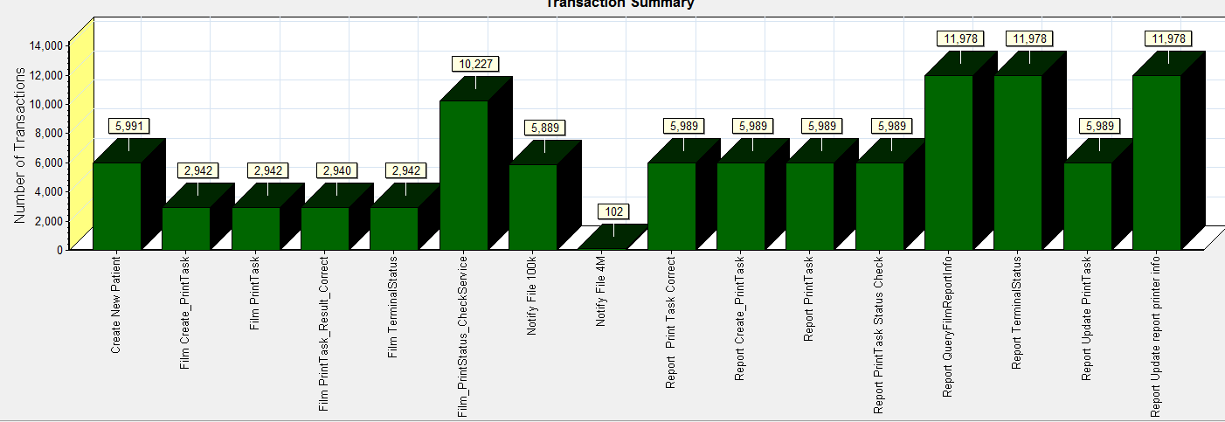

|  |  |  |  |  |  |  |
| --- | --- | --- | --- | --- | --- | --- |
| |  |  |  | | --- | --- | --- | | Color | Scale | Measurement | |  | 1 | Pass | |
|  |
|  |
|  |
|  |
|  |

We can see that there is no transaction failed during the testing works.

### Transaction response time result of PS

We can get the transaction response time information from the figure as follow:

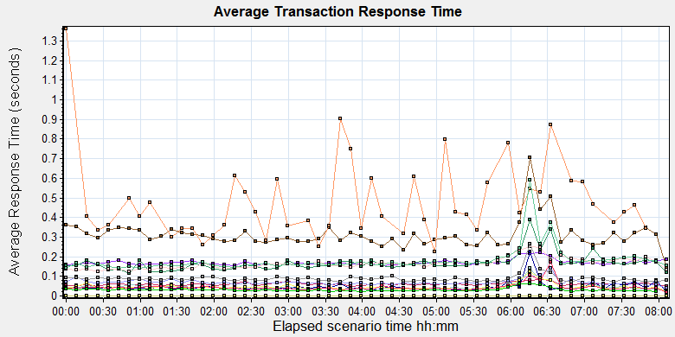

|  |  |  |  |  |  |  |  |  |  |  |  |  |  |  |  |  |  |  |  |  |  |  |  |  |  |  |  |  |  |  |  |  |  |  |  |  |  |  |  |  |  |  |  |  |  |  |  |  |  |  |  |  |  |  |  |  |  |  |  |  |  |  |  |  |  |  |  |  |  |  |  |  |  |  |  |  |  |  |  |  |  |  |  |  |  |  |  |  |  |  |  |  |  |  |  |  |  |  |  |  |  |  |  |  |  |  |  |  |  |  |  |  |  |  |  |  |  |  |  |
| --- | --- | --- | --- | --- | --- | --- | --- | --- | --- | --- | --- | --- | --- | --- | --- | --- | --- | --- | --- | --- | --- | --- | --- | --- | --- | --- | --- | --- | --- | --- | --- | --- | --- | --- | --- | --- | --- | --- | --- | --- | --- | --- | --- | --- | --- | --- | --- | --- | --- | --- | --- | --- | --- | --- | --- | --- | --- | --- | --- | --- | --- | --- | --- | --- | --- | --- | --- | --- | --- | --- | --- | --- | --- | --- | --- | --- | --- | --- | --- | --- | --- | --- | --- | --- | --- | --- | --- | --- | --- | --- | --- | --- | --- | --- | --- | --- | --- | --- | --- | --- | --- | --- | --- | --- | --- | --- | --- | --- | --- | --- | --- | --- | --- | --- | --- | --- | --- | --- | --- |
| |  |  |  |  |  |  |  | | --- | --- | --- | --- | --- | --- | --- | | **Color** | **Scale** | **Measurement** | **Graph's Minimum** | **Graph's Average** | **Graph's Maximum** | **Graph's Median** | |  | 1 | Create New Patient | 0.155 | 0.170 | 0.219 | 0.166 | |  | 1 | Film Create\_PrintTask | 0.116 | 0.167 | 0.386 | 0.158 | |  | 1 | Film PrintTask | 0.047 | 0.060 | 0.086 | 0.060 | |  | 1 | Film PrintTask\_Result\_Correct | 0.000 | 0.000 | 0.000 | 0.000 | |  | 1 | Film TerminalStatus | 0.016 | 0.046 | 0.226 | 0.039 | |  | 1 | Film\_PrintStatus\_CheckService | 0.022 | 0.046 | 0.174 | 0.039 | |  | 1 | Notify File 100k | 0.140 | 0.311 | 0.706 | 0.297 | |  | 1 | Notify File 4M | 0.226 | 0.480 | 1.362 | 0.421 | |  | 1 | Report Print Task Correct | 0.000 | 0.000 | 0.000 | 0.000 | |  | 1 | Report Create\_PrintTask | 0.124 | 0.164 | 0.251 | 0.162 | |  | 1 | Report PrintTask | 0.039 | 0.070 | 0.141 | 0.068 | |  | 1 | Report PrintTask Status Check | 0.021 | 0.045 | 0.124 | 0.042 | |  | 1 | Report QueryFilmReportInfo | 0.139 | 0.180 | 0.590 | 0.166 | |  | 1 | Report TerminalStatus | 0.016 | 0.044 | 0.171 | 0.040 | |  | 1 | Report Update PrintTask | 0.068 | 0.089 | 0.263 | 0.085 | |  | 1 | Report Update report printer info | 0.023 | 0.031 | 0.064 | 0.029 | |
|  |
|  |
| E:\B31_20190628_Terminal_1\Report\dot_trans.gif |
|  |
| |  | | --- | | **Description:**Displays the average time taken to perform transactions during each second of the load test. This graph helps you determine whether the performance of the server is within acceptable minimum and maximum transaction performance time ranges defined for your system. | |

|  |
| --- |
|  |
|  |

Transaction response time

This figure information shows all transaction response time. We can analysis that there are no transaction response time more than 3 seconds. It`s good performance for our system.

## Test result of Web service

### Test Statistic Report of Web

After the performance testing works, the transactions result of we module as follow:

|  |  |
| --- | --- |
| Analysis Summary | Period: 27/06/2019 14:05:36 - 27/06/2019 22:11:40 |

|  |  |
| --- | --- |
| **Scenario Name:** | D:\Performance\ScenarioPUMA\_Reliability\_171.lrs |
| **Results in Session:** | c:\Users\administrator\appdata\local\temp\res1360\res1360.lrr |
| **Duration:** | 8 hours, 6 minutes and 4 seconds. |

|  |
| --- |
| Statistics Summary |

|  |  |
| --- | --- |
| [**Maximum Running Vusers:**](file:///G:\PUMA%20MR2\loadrunner%20result\MR2_B31_20190628_1\VuserStateGraph) | 10 |
| [**Total Throughput (bytes):**](file:///G:\PUMA%20MR2\loadrunner%20result\MR2_B31_20190628_1\Throughput) | 468,743,656 |
|  |  |
|  |  |
| [**Average Throughput (bytes/second):**](file:///G:\PUMA%20MR2\loadrunner%20result\MR2_B31_20190628_1\Throughput) | 16,072 |
|  |  |
|  |  |
| [**Total Hits:**](file:///G:\PUMA%20MR2\loadrunner%20result\MR2_B31_20190628_1\HitsperSecond) | 45,898 |
|  |  |
|  |  |
| [**Average Hits per Second:**](file:///G:\PUMA%20MR2\loadrunner%20result\MR2_B31_20190628_1\HitsperSecond) | 1.574 | [**View HTTP Responses Summary**](file:///G:\PUMA%20MR2\loadrunner%20result\MR2_B31_20190628_1\MR2_B31_20190628_1.html#1) |
|  |  |  |
|  |  |  |

|  |  |  |
| --- | --- | --- |
| |  | | --- | | You can define SLA data using the [SLA configuration wizard](slaconfig:) | | You can analyze transaction behavior using the [Analyze Transaction mechanism](analyze:) | |

|  |
| --- |
| Transaction Summary |

|  |  |  |  |  |
| --- | --- | --- | --- | --- |
| [**Transactions:**](file:///G:\PUMA%20MR2\loadrunner%20result\MR2_B31_20190628_1\TransactionSummary) | Total Passed: 12,921 | Total Failed: 0 | Total Stopped: 0 | [**Average Response Time**](file:///G:\PUMA%20MR2\loadrunner%20result\MR2_B31_20190628_1\ResponseTime) |

|  |  |  |  |
| --- | --- | --- | --- |
|  | **Pass** | **Fail** | **Stop** |
| [Total](file:///G:\PUMA%20MR2\loadrunner%20result\MR2_B31_20190628_1\TransactionSummary0013(Total)0013) | 12,921 | 0 | 0 |

|  |  |  |  |  |  |  |  |  |
| --- | --- | --- | --- | --- | --- | --- | --- | --- |
| **Transaction Name** | **Minimum** | **Average** | **Maximum** | **Std. Deviation** | **90 Percent** | **Pass** | **Fail** | **Stop** |
| [ExpandFilmRecord](file:///G:\PUMA%20MR2\loadrunner%20result\MR2_B31_20190628_1\ResponseTime0000(ExpandFilmRecord)0000) | 0.193 | 0.238 | 0.674 | 0.066 | 0.313 | 417 | 0 | 0 |
| [ExpandReportRecord](file:///G:\PUMA%20MR2\loadrunner%20result\MR2_B31_20190628_1\ResponseTime0000(ExpandReportRecord)0000) | 0.006 | 0.008 | 0.305 | 0.015 | 0.009 | 417 | 0 | 0 |
| [GetDepartmentInfo](file:///G:\PUMA%20MR2\loadrunner%20result\MR2_B31_20190628_1\ResponseTime0000(GetDepartmentInfo)0000) | 0.005 | 0.013 | 0.581 | 0.038 | 0.012 | 551 | 0 | 0 |
| [Reconlication\_Film\_all](file:///G:\PUMA%20MR2\loadrunner%20result\MR2_B31_20190628_1\ResponseTime0000(Reconlication_Film_all)0000) | 0.017 | 0.044 | 1.021 | 0.09 | 0.056 | 501 | 0 | 0 |
| [Reconlication\_Report\_All](file:///G:\PUMA%20MR2\loadrunner%20result\MR2_B31_20190628_1\ResponseTime0000(Reconlication_Report_All)0000) | 0.023 | 0.061 | 0.691 | 0.052 | 0.1 | 501 | 0 | 0 |
| [SetPrintMode](file:///G:\PUMA%20MR2\loadrunner%20result\MR2_B31_20190628_1\ResponseTime0000(SetPrintMode)0000) | 0.018 | 0.069 | 0.422 | 0.052 | 0.123 | 417 | 0 | 0 |
| [SetStatusOfFilmWithExpand\_NOTprinted](file:///G:\PUMA%20MR2\loadrunner%20result\MR2_B31_20190628_1\ResponseTime0000(SetStatusOfFilmWithExpand_NOTprinted)0000) | 0.233 | 0.324 | 0.858 | 0.096 | 0.449 | 68 | 0 | 0 |
| [SetStatusOfFilmWithExpand\_Printed](file:///G:\PUMA%20MR2\loadrunner%20result\MR2_B31_20190628_1\ResponseTime0000(SetStatusOfFilmWithExpand_Printed)0000) | 0.241 | 0.332 | 0.684 | 0.091 | 0.467 | 95 | 0 | 0 |
| [SetStatusOfFilmWithExpand\_Unprinted](file:///G:\PUMA%20MR2\loadrunner%20result\MR2_B31_20190628_1\ResponseTime0000(SetStatusOfFilmWithExpand_Unprinted)0000) | 0.24 | 0.32 | 0.689 | 0.088 | 0.435 | 66 | 0 | 0 |
| [SetStatusOfFilmWithoutExpand\_NOTprinted](file:///G:\PUMA%20MR2\loadrunner%20result\MR2_B31_20190628_1\ResponseTime0000(SetStatusOfFilmWithoutExpand_NOTprinted)0000) | 0.031 | 0.073 | 0.524 | 0.067 | 0.113 | 70 | 0 | 0 |
| [SetStatusOfFilmWithoutExpand\_printed](file:///G:\PUMA%20MR2\loadrunner%20result\MR2_B31_20190628_1\ResponseTime0000(SetStatusOfFilmWithoutExpand_printed)0000) | 0.033 | 0.098 | 1.216 | 0.15 | 0.155 | 72 | 0 | 0 |
| [SetStatusOfFilmWithoutExpand\_unprinted](file:///G:\PUMA%20MR2\loadrunner%20result\MR2_B31_20190628_1\ResponseTime0000(SetStatusOfFilmWithoutExpand_unprinted)0000) | 0.03 | 0.081 | 1.25 | 0.129 | 0.109 | 88 | 0 | 0 |
| [SetStatusOfReportWithExpand\_NOTprinted](file:///G:\PUMA%20MR2\loadrunner%20result\MR2_B31_20190628_1\ResponseTime0000(SetStatusOfReportWithExpand_NOTprinted)0000) | 0.042 | 0.093 | 0.635 | 0.075 | 0.141 | 80 | 0 | 0 |
| [SetStatusOfReportWithExpand\_printed](file:///G:\PUMA%20MR2\loadrunner%20result\MR2_B31_20190628_1\ResponseTime0000(SetStatusOfReportWithExpand_printed)0000) | 0.039 | 0.089 | 0.367 | 0.049 | 0.143 | 80 | 0 | 0 |
| [SetStatusOfReportWithExpand\_unprinted](file:///G:\PUMA%20MR2\loadrunner%20result\MR2_B31_20190628_1\ResponseTime0000(SetStatusOfReportWithExpand_unprinted)0000) | 0.043 | 0.085 | 0.246 | 0.041 | 0.153 | 85 | 0 | 0 |
| [SetStatusOfReportWithoutExpand\_NOTprinted](file:///G:\PUMA%20MR2\loadrunner%20result\MR2_B31_20190628_1\ResponseTime0000(SetStatusOfReportWithoutExpand_NOTprinted)0000) | 0.035 | 0.095 | 0.352 | 0.07 | 0.172 | 70 | 0 | 0 |
| [SetStatusOfReportWithoutExpand\_printed](file:///G:\PUMA%20MR2\loadrunner%20result\MR2_B31_20190628_1\ResponseTime0000(SetStatusOfReportWithoutExpand_printed)0000) | 0.036 | 0.077 | 0.215 | 0.037 | 0.123 | 77 | 0 | 0 |
| [SetStatusOfReportWithoutExpand\_unprinted](file:///G:\PUMA%20MR2\loadrunner%20result\MR2_B31_20190628_1\ResponseTime0000(SetStatusOfReportWithoutExpand_unprinted)0000) | 0.032 | 0.083 | 0.217 | 0.047 | 0.156 | 67 | 0 | 0 |
| [SetTheHoldingTime](file:///G:\PUMA%20MR2\loadrunner%20result\MR2_B31_20190628_1\ResponseTime0000(SetTheHoldingTime)0000) | 0.015 | 0.049 | 0.647 | 0.051 | 0.082 | 417 | 0 | 0 |
| [Terminal\_monitor](file:///G:\PUMA%20MR2\loadrunner%20result\MR2_B31_20190628_1\ResponseTime0000(Terminal_monitor)0000) | 0.139 | 0.211 | 1.418 | 0.134 | 0.306 | 551 | 0 | 0 |
| [User\_login](file:///G:\PUMA%20MR2\loadrunner%20result\MR2_B31_20190628_1\ResponseTime0000(User_login)0000) | 0.042 | 0.142 | 3.508 | 0.191 | 0.309 | 2,420 | 0 | 0 |
| [worklist\_query\_ACC](file:///G:\PUMA%20MR2\loadrunner%20result\MR2_B31_20190628_1\ResponseTime0000(worklist_query_ACC)0000) | 0.009 | 0.023 | 0.26 | 0.035 | 0.03 | 52 | 0 | 0 |
| [worklist\_query\_LastMonth](file:///G:\PUMA%20MR2\loadrunner%20result\MR2_B31_20190628_1\ResponseTime0000(worklist_query_LastMonth)0000) | 0.031 | 0.094 | 0.464 | 0.063 | 0.145 | 66 | 0 | 0 |
| [worklist\_query\_LastTwoToday](file:///G:\PUMA%20MR2\loadrunner%20result\MR2_B31_20190628_1\ResponseTime0000(worklist_query_LastTwoToday)0000) | 0.013 | 0.076 | 0.207 | 0.034 | 0.117 | 64 | 0 | 0 |
| [worklist\_query\_Lastweek](file:///G:\PUMA%20MR2\loadrunner%20result\MR2_B31_20190628_1\ResponseTime0000(worklist_query_Lastweek)0000) | 0.019 | 0.083 | 0.348 | 0.055 | 0.14 | 73 | 0 | 0 |
| [worklist\_query\_Patient\_PatientName](file:///G:\PUMA%20MR2\loadrunner%20result\MR2_B31_20190628_1\ResponseTime0000(worklist_query_Patient_PatientName)0000) | 0.009 | 0.038 | 0.626 | 0.085 | 0.051 | 58 | 0 | 0 |
| [worklist\_query\_Patient\_PID](file:///G:\PUMA%20MR2\loadrunner%20result\MR2_B31_20190628_1\ResponseTime0000(worklist_query_Patient_PID)0000) | 0.008 | 0.024 | 0.275 | 0.035 | 0.027 | 63 | 0 | 0 |
| [Worklist\_Query\_Today](file:///G:\PUMA%20MR2\loadrunner%20result\MR2_B31_20190628_1\ResponseTime0000(Worklist_Query_Today)0000) | 0.018 | 0.097 | 0.314 | 0.059 | 0.142 | 56 | 0 | 0 |
| [WorlkList\_Query\_randomTime](file:///G:\PUMA%20MR2\loadrunner%20result\MR2_B31_20190628_1\ResponseTime0000(WorlkList_Query_randomTime)0000) | 0.035 | 0.078 | 0.299 | 0.047 | 0.127 | 60 | 0 | 0 |

|  |  |  |  |  |  |  |
| --- | --- | --- | --- | --- | --- | --- |
| **Service Level Agreement Legend:** | G:\PUMA MR2\loadrunner result\MR2_B31_20190628_1\led_ok.gif | Pass | G:\PUMA MR2\loadrunner result\MR2_B31_20190628_1\led_error.gif | Fail | G:\PUMA MR2\loadrunner result\MR2_B31_20190628_1\led_no_data.gif | No Data |

|  |
| --- |
| HTTP Responses Summary |

|  |  |  |
| --- | --- | --- |
| **HTTP Responses** | **Total** | **Per second** |
| [HTTP\_200](file:///G:\PUMA%20MR2\loadrunner%20result\MR2_B31_20190628_1\HttpReturnCodes0001(HTTP_200)0001) | 43,478 | 1.491 |
| [HTTP\_302](file:///G:\PUMA%20MR2\loadrunner%20result\MR2_B31_20190628_1\HttpReturnCodes0001(HTTP_302)0001) | 2,420 | 0.083 |

Follow the summary report, we can see all the transactions have passed and transaction response time very good.

### Transaction summary result of Web

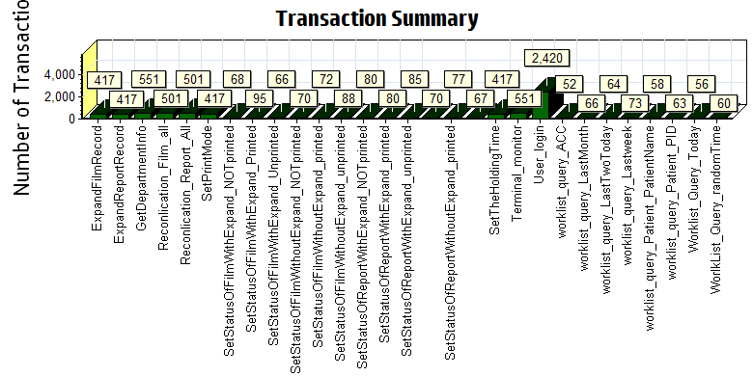

|  |  |  |  |  |  |  |
| --- | --- | --- | --- | --- | --- | --- |
| |  |  |  | | --- | --- | --- | | Color | Scale | Measurement | |  | 1 | Pass | |
|  |
|  |
|  |
|  |
|  |

We can see that there is no transaction failed during the testing works.

### Transaction response time result of Web

We can get the transaction response time information from the figure as follow:

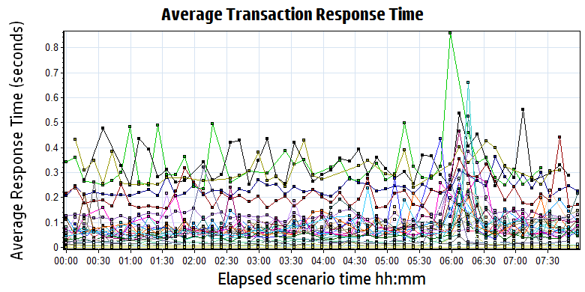

|  |  |  |  |  |  |  |  |  |  |  |  |  |  |  |  |  |  |  |  |  |  |  |  |  |  |  |  |  |  |  |  |  |  |  |  |  |  |  |  |  |  |  |  |  |  |  |  |  |  |  |  |  |  |  |  |  |  |  |  |  |  |  |  |  |  |  |  |  |  |  |  |  |  |  |  |  |  |  |  |  |  |  |  |  |  |  |  |  |  |  |  |  |  |  |  |  |  |  |  |  |  |  |  |  |  |  |  |  |  |  |  |  |  |  |  |  |  |  |  |  |  |  |  |  |  |  |  |  |  |  |  |  |  |  |  |  |  |  |  |  |  |  |  |  |  |  |  |  |  |  |  |  |  |  |  |  |  |  |  |  |  |  |  |  |  |  |  |  |  |  |  |  |  |  |  |  |  |  |  |  |
| --- | --- | --- | --- | --- | --- | --- | --- | --- | --- | --- | --- | --- | --- | --- | --- | --- | --- | --- | --- | --- | --- | --- | --- | --- | --- | --- | --- | --- | --- | --- | --- | --- | --- | --- | --- | --- | --- | --- | --- | --- | --- | --- | --- | --- | --- | --- | --- | --- | --- | --- | --- | --- | --- | --- | --- | --- | --- | --- | --- | --- | --- | --- | --- | --- | --- | --- | --- | --- | --- | --- | --- | --- | --- | --- | --- | --- | --- | --- | --- | --- | --- | --- | --- | --- | --- | --- | --- | --- | --- | --- | --- | --- | --- | --- | --- | --- | --- | --- | --- | --- | --- | --- | --- | --- | --- | --- | --- | --- | --- | --- | --- | --- | --- | --- | --- | --- | --- | --- | --- | --- | --- | --- | --- | --- | --- | --- | --- | --- | --- | --- | --- | --- | --- | --- | --- | --- | --- | --- | --- | --- | --- | --- | --- | --- | --- | --- | --- | --- | --- | --- | --- | --- | --- | --- | --- | --- | --- | --- | --- | --- | --- | --- | --- | --- | --- | --- | --- | --- | --- | --- | --- | --- | --- | --- | --- | --- | --- | --- | --- | --- |
| |  |  |  |  |  |  | | --- | --- | --- | --- | --- | --- | | Color | Scale | Measurement | Minimum | Average | Maximum | |  | 1 | ExpandFilmRecord | 0.193 | 0.238 | 0.674 | |  | 1 | ExpandReportRecord | 0.006 | 0.008 | 0.305 | |  | 1 | GetDepartmentInfo | 0.005 | 0.013 | 0.581 | |  | 1 | Reconlication\_Film\_all | 0.017 | 0.044 | 1.021 | |  | 1 | Reconlication\_Report\_All | 0.023 | 0.061 | 0.691 | |  | 1 | SetPrintMode | 0.018 | 0.069 | 0.422 | |  | 1 | SetStatusOfFilmWithExpand\_NOTprinted | 0.233 | 0.324 | 0.858 | |  | 1 | SetStatusOfFilmWithExpand\_Printed | 0.241 | 0.332 | 0.684 | |  | 1 | SetStatusOfFilmWithExpand\_Unprinted | 0.240 | 0.320 | 0.689 | |  | 1 | SetStatusOfFilmWithoutExpand\_NOTprinted | 0.031 | 0.073 | 0.524 | |  | 1 | SetStatusOfFilmWithoutExpand\_printed | 0.033 | 0.098 | 1.216 | |  | 1 | SetStatusOfFilmWithoutExpand\_unprinted | 0.030 | 0.081 | 1.250 | |  | 1 | SetStatusOfReportWithExpand\_NOTprinted | 0.042 | 0.093 | 0.635 | |  | 1 | SetStatusOfReportWithExpand\_printed | 0.039 | 0.089 | 0.367 | |  | 1 | SetStatusOfReportWithExpand\_unprinted | 0.043 | 0.085 | 0.246 | |  | 1 | SetStatusOfReportWithoutExpand\_NOTprinted | 0.035 | 0.095 | 0.352 | |  | 1 | SetStatusOfReportWithoutExpand\_printed | 0.036 | 0.077 | 0.215 | |  | 1 | SetStatusOfReportWithoutExpand\_unprinted | 0.032 | 0.083 | 0.217 | |  | 1 | SetTheHoldingTime | 0.015 | 0.049 | 0.647 | |  | 1 | Terminal\_monitor | 0.139 | 0.211 | 1.418 | |  | 1 | User\_login | 0.042 | 0.142 | 3.508 | |  | 1 | worklist\_query\_ACC | 0.009 | 0.023 | 0.260 | |  | 1 | worklist\_query\_LastMonth | 0.031 | 0.094 | 0.464 | |  | 1 | worklist\_query\_LastTwoToday | 0.013 | 0.076 | 0.207 | |  | 1 | worklist\_query\_Lastweek | 0.019 | 0.083 | 0.348 | |  | 1 | worklist\_query\_Patient\_PatientName | 0.009 | 0.038 | 0.626 | |  | 1 | worklist\_query\_Patient\_PID | 0.008 | 0.024 | 0.275 | |  | 1 | Worklist\_Query\_Today | 0.018 | 0.097 | 0.314 | |  | 1 | WorlkList\_Query\_randomTime | 0.035 | 0.078 | 0.299 | |
|  |
|  |
| G:\PUMA MR2\loadrunner result\MR2_B31_20190628_1\Report\dot_trans.gif |
|  |
| |  | | --- | |  | |

Transaction response time

Follow the figure: we can see that the transaction average response time is less than 3 seconds.

|  |
| --- |
|  |
|  |
|  |
|  |
|  |

|  |
| --- |
|  |
|  |

## Performance bottleneck analysis

### Hardware usage analysis- Main Server

During the testing work, we use the test tool to monitor the main server hardware usage include the CPU, Memory, hard disk and etc.

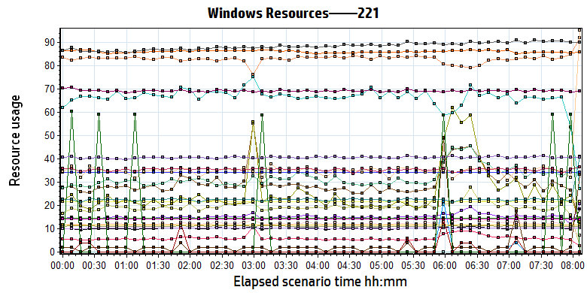

|  |
| --- |
|  |
|  |
|  |
| \\10.184.129.235\puma\Team\Ralf\Performance\ClouldFilm Performance\report_2018_0812\Report\dot_trans.gif   |  |  |  |  |  |  |  |  |  |  |  |  |  |  |  |  |  |  |  |  |  |  |  |  |  |  |  |  |  |  |  |  |  |  |  |  |  |  |  |  |  |  |  |  |  |  |  |  |  |  |  |  |  |  |  |  |  |  |  |  |  |  |  |  |  |  |  |  |  |  |  |  |  |  |  |  |  |  |  |  |  |  |  |  |  |  |  |  |  |  |  |  |  |  |  |  |  |  |  |  |  |  |  |  |  |  |  |  |  |  |  |  |  |  |  |  |  |  |  |  |  |  |  |  |  |  |  |  |  |  |  |  |  |  |  |  |  |  |  |  |  |  |  |  |  |  |  |  |  |  |  |  |  |  |  |  |  |  |  |  |  |  |  |  |  |  |  |  |  |  |  |  |  |  |  |  |  |  |  |  |  |  |  |  |  |  |  |  |  |  |  |  |  |  |  |  |  |  |  | | --- | --- | --- | --- | --- | --- | --- | --- | --- | --- | --- | --- | --- | --- | --- | --- | --- | --- | --- | --- | --- | --- | --- | --- | --- | --- | --- | --- | --- | --- | --- | --- | --- | --- | --- | --- | --- | --- | --- | --- | --- | --- | --- | --- | --- | --- | --- | --- | --- | --- | --- | --- | --- | --- | --- | --- | --- | --- | --- | --- | --- | --- | --- | --- | --- | --- | --- | --- | --- | --- | --- | --- | --- | --- | --- | --- | --- | --- | --- | --- | --- | --- | --- | --- | --- | --- | --- | --- | --- | --- | --- | --- | --- | --- | --- | --- | --- | --- | --- | --- | --- | --- | --- | --- | --- | --- | --- | --- | --- | --- | --- | --- | --- | --- | --- | --- | --- | --- | --- | --- | --- | --- | --- | --- | --- | --- | --- | --- | --- | --- | --- | --- | --- | --- | --- | --- | --- | --- | --- | --- | --- | --- | --- | --- | --- | --- | --- | --- | --- | --- | --- | --- | --- | --- | --- | --- | --- | --- | --- | --- | --- | --- | --- | --- | --- | --- | --- | --- | --- | --- | --- | --- | --- | --- | --- | --- | --- | --- | --- | --- | --- | --- | --- | --- | --- | --- | --- | --- | --- | --- | --- | --- | --- | --- | --- | --- | --- | --- | --- | | |  |  |  |  |  |  | | --- | --- | --- | --- | --- | --- | | **Color** | **Scale** | **Measurement** | **Minimum** | **Average** | **Maximum** | |  | 1 | % Disk Time (PhysicalDisk \_Total):10.184.129.221 | 4.220 | 29.933 | 555.469 | |  | 1 | % Idle Time (PhysicalDisk \_Total):10.184.129.221 | 49.939 | 82.857 | 97.410 | |  | 100 | % Interrupt Time (Processor \_Total):10.184.129.221 | 0.000 | 0.194 | 1.382 | |  | 10 | % Privileged Time (Processor \_Total):10.184.129.221 | 0.086 | 1.232 | 6.145 | |  | 10 | % Processor Time (Processor \_Total):10.184.129.221 | 0.000 | 1.510 | 18.826 | |  | 0.01 | Available MBytes (Memory):10.184.129.221 | 2,136.000 | 2,155.657 | 2,169.000 | |  | 0.001 | Avg. Disk Bytes/Transfer (PhysicalDisk \_Total):10.184.129.221 | 6,303.781 | 31,953.481 | 154,275.081 | |  | 10 | Avg. Disk Queue Length (PhysicalDisk \_Total):10.184.129.221 | 0.084 | 0.599 | 11.109 | |  | 1 | Bytes Total/sec (Network Interface 6TO4 Adapter):10.184.129.221 | 0.000 | 0.000 | 0.000 | |  | 0.001 | Bytes Total/sec (Server):10.184.129.221 | 4,511.848 | 14,139.308 | 20,404.385 | |  | 1E-06 | Cache Bytes (Memory):10.184.129.221 | 39,407,616.000 | 40,611,246.475 | 43,048,960.000 | |  | 1E-09 | Committed Bytes (Memory):10.184.129.221 | 14,608,084,992.000 | 14,622,992,970.982 | 14,645,235,712.000 | |  | 0.01 | Context Switches/sec (System):10.184.129.221 | 641.717 | 1,022.847 | 10,127.233 | |  | 1 | Disk Transfers/sec (PhysicalDisk \_Total):10.184.129.221 | 3.985 | 25.899 | 541.415 | |  | 1 | File Data Operations/sec (System):10.184.129.221 | 3.959 | 22.500 | 229.832 | |  | 0.0001 | Free Megabytes (LogicalDisk \_Total):10.184.129.221 | 341,970.000 | 342,074.687 | 342,226.000 | |  | 0.01 | Interrupts/sec (Processor \_Total):10.184.129.221 | 1,238.023 | 6,661.956 | 28,770.176 | |  | 0.1 | Page Faults/sec (Memory):10.184.129.221 | 131.387 | 348.070 | 7,093.159 | |  | 1000 | Page Reads/sec (Memory):10.184.129.221 | 0.000 | 0.002 | 3.654 | |  | 1000 | Pages/sec (Memory):10.184.129.221 | 0.000 | 0.003 | 8.305 | |  | 1E-07 | Pool Nonpaged Bytes (Memory):10.184.129.221 | 137,523,200.000 | 142,150,985.584 | 154,177,536.000 | |  | 0.0001 | Pool Nonpaged Bytes (Server):10.184.129.221 | 315,060.000 | 353,709.028 | 378,315.000 | |  | 1E-07 | Pool Paged Bytes (Memory):10.184.129.221 | 101,646,336.000 | 101,776,878.640 | 101,933,056.000 | |  | 0.001 | Pool Paged Bytes (Server):10.184.129.221 | 11,576.000 | 11,576.000 | 11,576.000 | |  | 1 | Pool Paged Failures (Server):10.184.129.221 | 0.000 | 0.000 | 0.000 | |  | 1E-07 | Private Bytes (Process \_Total):10.184.129.221 | 848,789,504.000 | 861,157,785.262 | 880,283,648.000 | |  | 10000 | Processor Queue Length (System):10.184.129.221 | 0.000 | 0.001 | 1.000 | |  | 1000 | Split IO/Sec (PhysicalDisk \_Total):10.184.129.221 | 0.000 | 0.001 | 1.661 | |  | 1E-06 | System Cache Resident Bytes (Memory):10.184.129.221 | 39,407,616.000 | 40,611,246.475 | 43,048,960.000 | |  | 0.1 | Threads (Objects):10.184.129.221 | 842.000 | 883.994 | 946.000 | |  | 0.1 | Threads (System):10.184.129.221 | 670.000 | 692.456 | 747.000 | |  | 1E-08 | Working Set (Process \_Total):10.184.129.221 | 1,095,114,752.000 | 1,110,430,531.832 | 1,140,256,768.000 | | |  | |  | | E:\B31_20190628_Terminal_1\Report\dot_trans.gif | |  | | |  | | --- | | **Description:**Displays a summary of the System Resources usage for each Windows based host. | | |
|  |
| |  | | --- | |  | |  | |

Follow this information we can get that:

The main server hardware is works with health status. No bottle neck existed during the testing

### Hardware usage analysis- PS Server

During the testing work, we use the test tool to monitor the PS server hardware usage include the CPU, Memory, hard disk and etc.

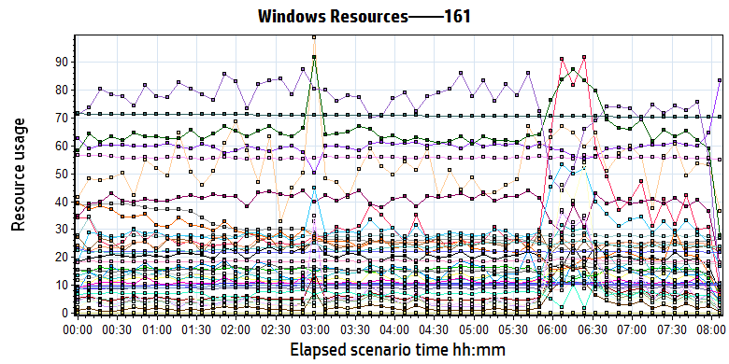

|  |  |  |  |  |  |  |  |  |  |  |  |  |  |  |  |  |  |  |  |  |  |  |  |  |  |  |  |  |  |  |  |  |  |  |  |  |  |  |  |  |  |  |  |  |  |  |  |  |  |  |  |  |  |  |  |  |  |  |  |  |  |  |  |  |  |  |  |  |  |  |  |  |  |  |  |  |  |  |  |  |  |  |  |  |  |  |  |  |  |  |  |  |  |  |  |  |  |  |  |  |  |  |  |  |  |  |  |  |  |  |  |  |  |  |  |  |  |  |  |  |  |  |  |  |  |  |  |  |  |  |  |  |  |  |  |  |  |  |  |  |  |  |  |  |  |  |  |  |  |  |  |  |  |  |  |  |  |  |  |  |  |  |  |  |  |  |  |  |  |  |  |  |  |  |  |  |  |  |  |  |  |  |  |  |  |  |  |  |  |  |  |  |  |  |  |  |  |  |  |  |  |  |  |  |  |  |  |  |  |  |  |  |  |  |  |  |  |  |  |  |  |  |  |  |  |  |  |  |  |  |  |  |  |  |  |  |  |  |  |  |  |  |  |  |  |  |  |  |  |  |  |  |  |  |  |  |  |  |  |  |  |  |  |  |  |  |  |  |  |  |  |  |  |  |  |  |  |  |  |  |  |  |
| --- | --- | --- | --- | --- | --- | --- | --- | --- | --- | --- | --- | --- | --- | --- | --- | --- | --- | --- | --- | --- | --- | --- | --- | --- | --- | --- | --- | --- | --- | --- | --- | --- | --- | --- | --- | --- | --- | --- | --- | --- | --- | --- | --- | --- | --- | --- | --- | --- | --- | --- | --- | --- | --- | --- | --- | --- | --- | --- | --- | --- | --- | --- | --- | --- | --- | --- | --- | --- | --- | --- | --- | --- | --- | --- | --- | --- | --- | --- | --- | --- | --- | --- | --- | --- | --- | --- | --- | --- | --- | --- | --- | --- | --- | --- | --- | --- | --- | --- | --- | --- | --- | --- | --- | --- | --- | --- | --- | --- | --- | --- | --- | --- | --- | --- | --- | --- | --- | --- | --- | --- | --- | --- | --- | --- | --- | --- | --- | --- | --- | --- | --- | --- | --- | --- | --- | --- | --- | --- | --- | --- | --- | --- | --- | --- | --- | --- | --- | --- | --- | --- | --- | --- | --- | --- | --- | --- | --- | --- | --- | --- | --- | --- | --- | --- | --- | --- | --- | --- | --- | --- | --- | --- | --- | --- | --- | --- | --- | --- | --- | --- | --- | --- | --- | --- | --- | --- | --- | --- | --- | --- | --- | --- | --- | --- | --- | --- | --- | --- | --- | --- | --- | --- | --- | --- | --- | --- | --- | --- | --- | --- | --- | --- | --- | --- | --- | --- | --- | --- | --- | --- | --- | --- | --- | --- | --- | --- | --- | --- | --- | --- | --- | --- | --- | --- | --- | --- | --- | --- | --- | --- | --- | --- | --- | --- | --- | --- | --- | --- | --- | --- | --- | --- | --- | --- | --- | --- | --- | --- | --- | --- | --- | --- | --- | --- | --- | --- | --- | --- | --- | --- | --- | --- | --- | --- | --- | --- | --- | --- | --- | --- | --- | --- |
| |  |  |  |  |  |  | | --- | --- | --- | --- | --- | --- | | **Color** | **Scale** | **Measurement** | **Minimum** | **Average** | **Maximum** | |  | 0.1 | % Disk Time (PhysicalDisk \_Total):10.184.129.161 | 11.543 | 102.424 | 1,849.823 | |  | 1 | % Idle Time (PhysicalDisk \_Total):10.184.129.161 | 0.008 | 59.612 | 91.715 | |  | 100 | % Interrupt Time (Processor \_Total):10.184.129.161 | 0.000 | 0.127 | 1.118 | |  | 1 | % Privileged Time (Processor \_Total):10.184.129.161 | 0.346 | 5.939 | 24.814 | |  | 1 | % Processor Time (Processor \_Total):10.184.129.161 | 4.249 | 33.888 | 100.000 | |  | 0.01 | Available MBytes (Memory):10.184.129.161 | 1,908.000 | 2,894.622 | 4,148.000 | |  | 0.0001 | Avg. Disk Bytes/Transfer (PhysicalDisk \_Total):10.184.129.161 | 7,511.579 | 153,802.787 | 681,024.000 | |  | 10 | Avg. Disk Queue Length (PhysicalDisk \_Total):10.184.129.161 | 0.231 | 2.048 | 36.996 | |  | 1 | Bytes Received/sec (Network Interface 6TO4 Adapter):10.184.129.161 | 0.000 | 0.000 | 0.000 | |  | 1 | Bytes Sent/sec (Network Interface 6TO4 Adapter):10.184.129.161 | 0.000 | 0.000 | 0.000 | |  | 1 | Bytes Total/sec (Network Interface 6TO4 Adapter):10.184.129.161 | 0.000 | 0.000 | 0.000 | |  | 1 | Bytes Total/sec (Network Interface isatap.{3F660D18-31C1-45CA-B052-84E45653E92D}):10.184.129.161 | 0.000 | 0.000 | 0.000 | |  | 1 | Bytes Total/sec (Network Interface isatap.{E18336ED-668D-49B7-9802-4752E741ADA2}):10.184.129.161 | 0.000 | 0.000 | 0.000 | |  | 0.001 | Bytes Total/sec (Server):10.184.129.161 | 8,648.095 | 27,761.316 | 814,648.579 | |  | 1E-07 | Cache Bytes (Memory):10.184.129.161 | 108,683,264.000 | 154,321,263.682 | 192,532,480.000 | |  | 1E-09 | Committed Bytes (Memory):10.184.129.161 | 9,223,462,912.000 | 10,632,080,741.867 | 11,603,316,736.000 | |  | 0.001 | Context Switches/sec (System):10.184.129.161 | 3,779.504 | 15,167.153 | 57,191.981 | |  | 100 | Current Disk Queue Length (PhysicalDisk 0 C|):10.184.129.161 | 0.000 | 0.531 | 11.000 | |  | 10 | Current Disk Queue Length (PhysicalDisk 1 D| E|):10.184.129.161 | 0.000 | 1.491 | 37.000 | |  | 1E-05 | Disk Read Bytes/sec (PhysicalDisk 0 C|):10.184.129.161 | 0.000 | 252,336.098 | 12,013,010.808 | |  | 1E-05 | Disk Read Bytes/sec (PhysicalDisk 1 D| E|):10.184.129.161 | 0.000 | 1,095,975.330 | 24,313,591.581 | |  | 1 | Disk Reads/sec (PhysicalDisk 0 C|):10.184.129.161 | 0.000 | 7.394 | 453.205 | |  | 10 | Disk Reads/sec (PhysicalDisk 1 D| E|):10.184.129.161 | 0.000 | 2.585 | 185.695 | |  | 1 | Disk Transfers/sec (PhysicalDisk \_Total):10.184.129.161 | 15.278 | 65.791 | 489.674 | |  | 1E-05 | Disk Write Bytes/sec (PhysicalDisk 0 C|):10.184.129.161 | 178,030.182 | 664,003.562 | 20,888,212.021 | |  | 1E-05 | Disk Write Bytes/sec (PhysicalDisk 1 D| E|):10.184.129.161 | 7,394.840 | 7,543,192.183 | 33,597,636.755 | |  | 1 | Disk Writes/sec (PhysicalDisk 0 C|):10.184.129.161 | 3.654 | 15.494 | 142.572 | |  | 1 | Disk Writes/sec (PhysicalDisk 1 D| E|):10.184.129.161 | 7.307 | 40.318 | 442.054 | |  | 0.001 | File Data Operations/sec (System):10.184.129.161 | 461.492 | 5,057.511 | 33,091.830 | |  | 1E-05 | Free Megabytes (LogicalDisk \_Total):10.184.129.161 | 7,032,633.000 | 7,091,665.659 | 7,153,289.000 | |  | 0.001 | Interrupts/sec (Processor \_Total):10.184.129.161 | 3,458.605 | 9,126.645 | 20,909.347 | |  | 0.0001 | Page Faults/sec (Memory):10.184.129.161 | 110.912 | 44,834.892 | 225,119.824 | |  | 1 | Page Reads/sec (Memory):10.184.129.161 | 0.000 | 8.047 | 513.876 | |  | 0.1 | Pages/sec (Memory):10.184.129.161 | 0.000 | 306.616 | 3,370.490 | |  | 1E-06 | Pool Nonpaged Bytes (Memory):10.184.129.161 | 54,562,816.000 | 55,783,225.173 | 65,871,872.000 | |  | 1E-05 | Pool Nonpaged Bytes (Server):10.184.129.161 | 1,949,101.000 | 2,459,230.435 | 4,860,257.000 | |  | 1E-07 | Pool Paged Bytes (Memory):10.184.129.161 | 217,722,880.000 | 219,998,426.456 | 239,230,976.000 | |  | 0.0001 | Pool Paged Bytes (Server):10.184.129.161 | 207,629.000 | 249,544.497 | 436,807.000 | |  | 1 | Pool Paged Failures (Server):10.184.129.161 | 0.000 | 0.000 | 0.000 | |  | 1E-09 | Private Bytes (Process \_Total):10.184.129.161 | 8,220,446,720.000 | 9,847,188,377.315 | 10,531,950,592.000 | |  | 10 | Processor Queue Length (System):10.184.129.161 | 0.000 | 0.622 | 50.000 | |  | 1 | Split IO/Sec (PhysicalDisk \_Total):10.184.129.161 | 0.000 | 6.865 | 403.196 | |  | 1E-07 | System Cache Resident Bytes (Memory):10.184.129.161 | 108,683,264.000 | 154,321,062.744 | 192,532,480.000 | |  | 0.01 | Threads (Objects):10.184.129.161 | 2,056.000 | 2,366.423 | 2,672.000 | |  | 0.01 | Threads (System):10.184.129.161 | 1,715.000 | 1,864.811 | 2,003.000 | |  | 1E-09 | Working Set (Process \_Total):10.184.129.161 | 8,403,554,304.000 | 9,992,331,980.789 | 11,061,030,912.000 | |
|  |
|  |
| E:\B31_20190628_Terminal_1\Report\dot_trans.gif |
|  |
| |  | | --- | | **Description:**Displays a summary of the System Resources usage for each Windows based host. | |

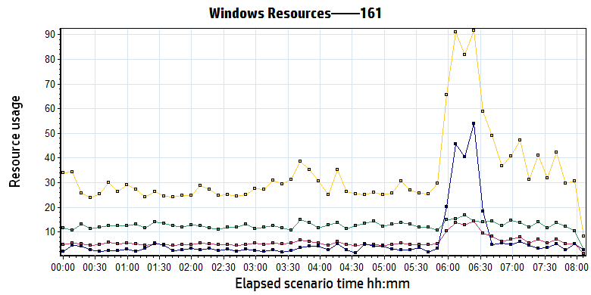

|  |  |  |  |  |  |  |  |  |  |  |  |  |  |  |  |  |  |  |  |  |  |  |  |  |  |  |  |  |  |  |  |  |  |  |  |
| --- | --- | --- | --- | --- | --- | --- | --- | --- | --- | --- | --- | --- | --- | --- | --- | --- | --- | --- | --- | --- | --- | --- | --- | --- | --- | --- | --- | --- | --- | --- | --- | --- | --- | --- | --- |
| |  |  |  |  |  |  |  | | --- | --- | --- | --- | --- | --- | --- | | **Color** | **Scale** | **Measurement** | **Minimum** | **Average** | **Maximum** | **Std. Deviation** | |  | 100 | % Interrupt Time (Processor \_Total):10.184.129.161 | 0.000 | 0.127 | 1.118 | 0.127 | |  | 1 | % Privileged Time (Processor \_Total):10.184.129.161 | 0.346 | 5.939 | 24.814 | 3.468 | |  | 1 | % Processor Time (Processor \_Total):10.184.129.161 | 4.249 | 33.888 | 100.000 | 19.845 | |  | 10 | Processor Queue Length (System):10.184.129.161 | 0.000 | 0.622 | 50.000 | 2.474 | |
|  |
|  |
| E:\B31_20190628_Terminal_1\Report\dot_trans.gif |
|  |
| |  | | --- | | **Description:**Displays a summary of the System Resources usage for each Windows based host. | |

The CPU resource has no bottleneck. The average process time is 34%. The CPU queue length is 0.62, less than 12. (CPU number \*2: 6\*2 = 12).

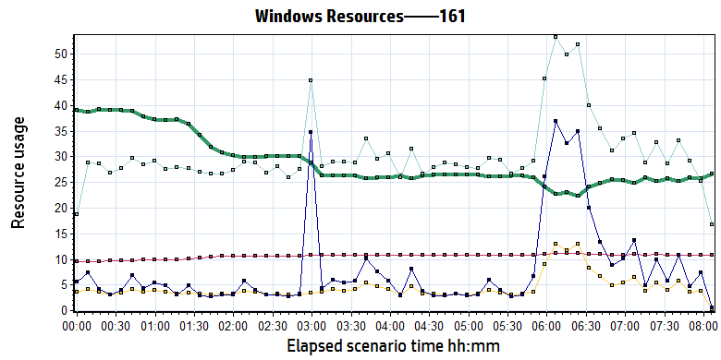

|  |  |  |  |  |  |  |  |  |  |  |  |  |  |  |  |  |  |  |  |  |  |  |  |  |  |  |  |  |  |  |  |  |  |  |  |  |
| --- | --- | --- | --- | --- | --- | --- | --- | --- | --- | --- | --- | --- | --- | --- | --- | --- | --- | --- | --- | --- | --- | --- | --- | --- | --- | --- | --- | --- | --- | --- | --- | --- | --- | --- | --- | --- |
| |  |  |  |  |  |  | | --- | --- | --- | --- | --- | --- | | **Color** | **Scale** | **Measurement** | **Minimum** | **Average** | **Maximum** | |  | 0.01 | Available MBytes (Memory):10.184.129.161 | 1,908.000 | 2,894.622 | 4,148.000 | |  | 1E-09 | Committed Bytes (Memory):10.184.129.161 | 9,223,462,912.000 | 10,632,080,741.867 | 11,603,316,736.000 | |  | 0.0001 | Page Faults/sec (Memory):10.184.129.161 | 110.912 | 44,834.892 | 225,119.824 | |  | 1 | Page Reads/sec (Memory):10.184.129.161 | 0.000 | 8.047 | 513.876 | |  | 0.1 | Pages/sec (Memory):10.184.129.161 | 0.000 | 306.616 | 3,370.490 | |
|  |
|  |
| E:\B31_20190628_Terminal_1\Report\dot_trans.gif |
|  |
| |  | | --- | | **Description:**Displays a summary of the System Resources usage for each Windows based host. | |

The system used more 2.2 GB memory resource during the testing. The system still have 1.9GB memory can be used. (Available MBytes (Memory):10.184.129.161)

There are many page faults issue during the testing. It means some transactions cannot get the recourse from memory. It need get or request the recourse from hard disk or other device. It needed to enhance in our future version. (Page Faults/sec (Memory)).

The memory resource do not has the bottleneck. There is enough resource for system to use.

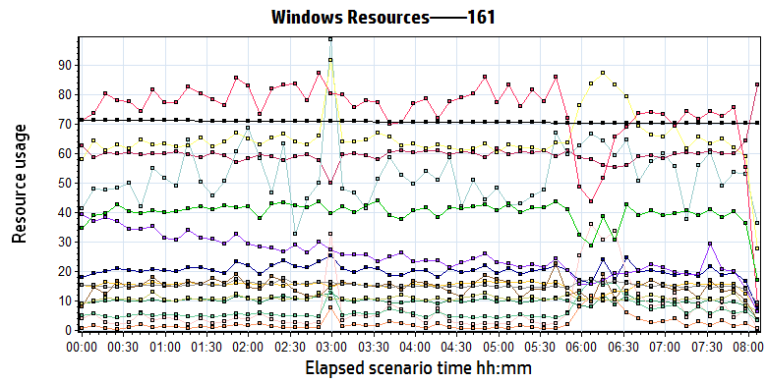

|  |  |  |  |  |  |  |  |  |  |  |  |  |  |  |  |  |  |  |  |  |  |  |  |  |  |  |  |  |  |  |  |  |  |  |  |  |  |  |  |  |  |  |  |  |  |  |  |  |  |  |  |  |  |  |  |  |  |  |  |  |  |  |  |  |  |  |  |  |  |  |  |  |  |  |  |  |  |  |  |  |  |  |  |  |  |  |  |  |  |  |  |  |  |  |  |  |  |  |  |  |  |  |  |  |  |  |  |  |  |  |  |  |  |  |  |  |  |  |  |  |  |
| --- | --- | --- | --- | --- | --- | --- | --- | --- | --- | --- | --- | --- | --- | --- | --- | --- | --- | --- | --- | --- | --- | --- | --- | --- | --- | --- | --- | --- | --- | --- | --- | --- | --- | --- | --- | --- | --- | --- | --- | --- | --- | --- | --- | --- | --- | --- | --- | --- | --- | --- | --- | --- | --- | --- | --- | --- | --- | --- | --- | --- | --- | --- | --- | --- | --- | --- | --- | --- | --- | --- | --- | --- | --- | --- | --- | --- | --- | --- | --- | --- | --- | --- | --- | --- | --- | --- | --- | --- | --- | --- | --- | --- | --- | --- | --- | --- | --- | --- | --- | --- | --- | --- | --- | --- | --- | --- | --- | --- | --- | --- | --- | --- | --- | --- | --- | --- | --- | --- | --- | --- | --- |
| |  |  |  |  |  |  |  | | --- | --- | --- | --- | --- | --- | --- | | **Color** | **Scale** | **Measurement** | **Minimum** | **Average** | **Maximum** | **Std. Deviation** | |  | 0.1 | % Disk Time (PhysicalDisk \_Total):10.184.129.161 | 11.543 | 102.424 | 1,849.823 | 80.847 | |  | 1 | % Idle Time (PhysicalDisk \_Total):10.184.129.161 | 0.008 | 59.612 | 91.715 | 14.809 | |  | 0.0001 | Avg. Disk Bytes/Transfer (PhysicalDisk \_Total):10.184.129.161 | 7,511.579 | 153,802.787 | 681,024.000 | 97,199.189 | |  | 10 | Avg. Disk Queue Length (PhysicalDisk \_Total):10.184.129.161 | 0.231 | 2.048 | 36.996 | 1.617 | |  | 100 | Current Disk Queue Length (PhysicalDisk 0 C|):10.184.129.161 | 0.000 | 0.531 | 11.000 | 1.067 | |  | 10 | Current Disk Queue Length (PhysicalDisk 1 D| E|):10.184.129.161 | 0.000 | 1.491 | 37.000 | 3.163 | |  | 1E-05 | Disk Read Bytes/sec (PhysicalDisk 0 C|):10.184.129.161 | 0.000 | 252,336.098 | 12,013,010.808 | 552,136.915 | |  | 1E-05 | Disk Read Bytes/sec (PhysicalDisk 1 D| E|):10.184.129.161 | 0.000 | 1,095,975.330 | 24,313,591.581 | 1,999,838.788 | |  | 1 | Disk Reads/sec (PhysicalDisk 0 C|):10.184.129.161 | 0.000 | 7.394 | 453.205 | 18.058 | |  | 10 | Disk Reads/sec (PhysicalDisk 1 D| E|):10.184.129.161 | 0.000 | 2.585 | 185.695 | 3.125 | |  | 1 | Disk Transfers/sec (PhysicalDisk \_Total):10.184.129.161 | 15.278 | 65.791 | 489.674 | 31.687 | |  | 1E-05 | Disk Write Bytes/sec (PhysicalDisk 0 C|):10.184.129.161 | 178,030.182 | 664,003.562 | 20,888,212.021 | 742,197.821 | |  | 1E-05 | Disk Write Bytes/sec (PhysicalDisk 1 D| E|):10.184.129.161 | 7,394.840 | 7,543,192.183 | 33,597,636.755 | 5,342,380.654 | |  | 1 | Disk Writes/sec (PhysicalDisk 0 C|):10.184.129.161 | 3.654 | 15.494 | 142.572 | 6.932 | |  | 1 | Disk Writes/sec (PhysicalDisk 1 D| E|):10.184.129.161 | 7.307 | 40.318 | 442.054 | 25.282 | |  | 1E-05 | Free Megabytes (LogicalDisk \_Total):10.184.129.161 | 7,032,633.000 | 7,091,665.659 | 7,153,289.000 | 34,969.392 |   E:\B31_20190628_Terminal_1\Report\dot_trans.gif   |  | | --- | | **Description:**Displays a summary of the System Resources usage for each Windows based host. | |  | |
|  |
|  |
| Follow the figure: we can see that the disk reads and writes operations are very busy. The disk read 1.2MB/S data from disk and write 7.8MB/s data to disk. The Disk is busy but still can accept for design.   |  |  |  |  |  |  |  | | --- | --- | --- | --- | --- | --- | --- | | **Color** | **Scale** | **Measurement** | **Minimum** | **Average** | **Maximum** | **Std. Deviation** | |  | 1E-05 | Disk Read Bytes/sec (PhysicalDisk 0 C|):10.184.129.161 | 0.000 | 252,336.098 | 12,013,010.808 | 552,136.915 | |  | 1E-05 | Disk Read Bytes/sec (PhysicalDisk 1 D| E|):10.184.129.161 | 0.000 | 1,095,975.330 | 24,313,591.581 | 1,999,838.788 | |  | 1E-05 | Disk Write Bytes/sec (PhysicalDisk 0 C|):10.184.129.161 | 178,030.182 | 664,003.562 | 20,888,212.021 | 742,197.821 | |  | 1E-05 | Disk Write Bytes/sec (PhysicalDisk 1 D| E|):10.184.129.161 | 7,394.840 | 7,543,192.183 | 33,597,636.755 | 5,342,380.654 | |

### SQL Server resource usage analysis

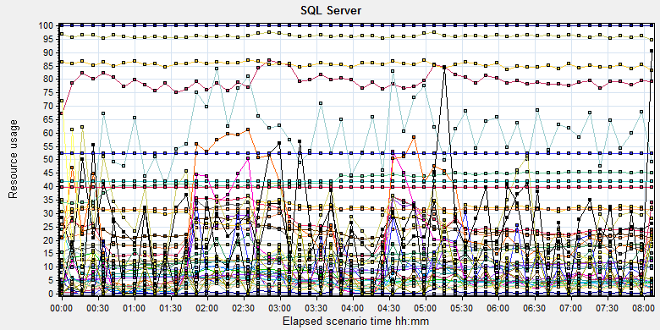

|  |  |  |  |  |  |  |  |  |  |  |  |  |  |  |  |  |  |  |  |  |  |  |  |  |  |  |  |  |  |  |  |  |  |  |  |  |  |  |  |  |  |  |  |  |  |  |  |  |  |  |  |  |  |  |  |  |  |  |  |  |  |  |  |  |  |  |  |  |  |  |  |  |  |  |  |  |  |  |  |  |  |  |  |  |  |  |  |  |  |  |  |  |  |  |  |  |  |  |  |  |  |  |  |  |  |  |  |  |  |  |  |  |  |  |  |  |  |  |  |  |  |  |  |  |  |  |  |  |  |  |  |  |  |  |  |  |  |  |  |  |  |  |  |  |  |  |  |  |  |  |  |  |  |  |  |  |  |  |  |  |  |  |  |  |  |  |  |  |  |  |  |  |  |  |  |  |  |  |  |  |  |  |  |  |  |  |  |  |  |  |  |  |  |  |  |  |  |  |  |  |  |  |  |  |  |  |  |  |  |  |  |  |  |  |  |  |  |  |  |  |  |  |  |  |  |  |  |  |  |  |  |  |  |  |  |  |  |  |  |  |  |  |  |  |  |  |  |  |  |  |  |  |  |  |  |  |  |  |  |  |  |  |  |  |  |  |  |  |  |  |  |  |  |  |  |  |  |  |  |  |  |  |  |  |  |  |  |  |  |  |  |  |  |  |  |  |  |  |  |  |  |  |  |  |  |  |  |  |  |  |  |  |  |  |  |  |  |  |  |  |  |  |  |  |  |  |  |  |  |  |  |  |  |  |  |  |  |  |  |  |  |  |  |  |  |  |  |  |
| --- | --- | --- | --- | --- | --- | --- | --- | --- | --- | --- | --- | --- | --- | --- | --- | --- | --- | --- | --- | --- | --- | --- | --- | --- | --- | --- | --- | --- | --- | --- | --- | --- | --- | --- | --- | --- | --- | --- | --- | --- | --- | --- | --- | --- | --- | --- | --- | --- | --- | --- | --- | --- | --- | --- | --- | --- | --- | --- | --- | --- | --- | --- | --- | --- | --- | --- | --- | --- | --- | --- | --- | --- | --- | --- | --- | --- | --- | --- | --- | --- | --- | --- | --- | --- | --- | --- | --- | --- | --- | --- | --- | --- | --- | --- | --- | --- | --- | --- | --- | --- | --- | --- | --- | --- | --- | --- | --- | --- | --- | --- | --- | --- | --- | --- | --- | --- | --- | --- | --- | --- | --- | --- | --- | --- | --- | --- | --- | --- | --- | --- | --- | --- | --- | --- | --- | --- | --- | --- | --- | --- | --- | --- | --- | --- | --- | --- | --- | --- | --- | --- | --- | --- | --- | --- | --- | --- | --- | --- | --- | --- | --- | --- | --- | --- | --- | --- | --- | --- | --- | --- | --- | --- | --- | --- | --- | --- | --- | --- | --- | --- | --- | --- | --- | --- | --- | --- | --- | --- | --- | --- | --- | --- | --- | --- | --- | --- | --- | --- | --- | --- | --- | --- | --- | --- | --- | --- | --- | --- | --- | --- | --- | --- | --- | --- | --- | --- | --- | --- | --- | --- | --- | --- | --- | --- | --- | --- | --- | --- | --- | --- | --- | --- | --- | --- | --- | --- | --- | --- | --- | --- | --- | --- | --- | --- | --- | --- | --- | --- | --- | --- | --- | --- | --- | --- | --- | --- | --- | --- | --- | --- | --- | --- | --- | --- | --- | --- | --- | --- | --- | --- | --- | --- | --- | --- | --- | --- | --- | --- | --- | --- | --- | --- | --- | --- | --- | --- | --- | --- | --- | --- | --- | --- | --- | --- | --- | --- | --- | --- | --- | --- | --- | --- | --- | --- | --- | --- | --- | --- | --- | --- | --- | --- | --- | --- | --- | --- | --- | --- | --- | --- | --- | --- | --- | --- | --- | --- | --- | --- | --- | --- | --- | --- | --- | --- | --- | --- | --- | --- | --- | --- | --- | --- | --- | --- | --- | --- | --- | --- |
| |  |  |  |  |  |  | | --- | --- | --- | --- | --- | --- | | Color | Scale | Measurement | Minimum | Average | Maximum | |  | 1 | Average Latch Wait Time (ms) (MSSQL$GCPACSWS|Latches):10.184.129.108 | 0.071 | 9.822 | 339.12 | |  | 1 | Buffer cache hit ratio (MSSQL$GCPACSWS|Buffer Manager):10.184.129.108 | 74.508 | 99.997 | 100 | |  | 1 | Cache Hit Ratio (MSSQL$GCPACSWS|Catalog Metadata \_Total):10.184.129.108 | 9.704 | 14.292 | 18.79 | |  | 1 | Cache Hit Ratio (MSSQL$GCPACSWS|Cursor Manager by Type \_Total):10.184.129.108 | 52.86 | 79.243 | 91.066 | |  | 1 | Cache Hit Ratio (MSSQL$GCPACSWS|Plan Cache \_Total):10.184.129.108 | 70.129 | 85.558 | 95.93 | |  | 1 | Checkpoint pages/sec (MSSQL$GCPACSWS|Buffer Manager):10.184.129.108 | 0 | 3.368 | 109.989 | |  | 0.01 | Connection Memory (KB) (MSSQL$GCPACSWS|Memory Manager):10.184.129.108 | 1392 | 2377.505 | 3152 | |  | 0.1 | Connection Reset/sec (MSSQL$GCPACSWS|General Statistics):10.184.129.108 | 27.567 | 121.785 | 295.213 | |  | 1 | CPU usage % (MSSQL$GCPACSWS|Resource Pool Stats default):10.184.129.108 | 0.232 | 22.033 | 95.046 | |  | 1 | CPU usage target % (MSSQL$GCPACSWS|Resource Pool Stats default):10.184.129.108 | 44 | 96.139 | 99 | |  | 1 | Current latch waits (MSOLAP$GCPACSWS|Locks):10.184.129.108 | 0 | 0 | 0 | |  | 1 | Cursor flushes (MSSQL$GCPACSWS|Cursor Manager Total):10.184.129.108 | 0 | 0 | 0 | |  | 0.0001 | Cursor memory usage (MSSQL$GCPACSWS|Cursor Manager by Type \_Total):10.184.129.108 | 88 | 41979.349 | 742576 | |  | 0.0001 | Database pages (MSSQL$GCPACSWS|Buffer Manager):10.184.129.108 | 334059 | 422797.795 | 457491 | |  | 10 | Errors/sec (MSSQL$GCPACSWS|SQL Errors \_Total):10.184.129.108 | 0 | 2.45 | 32.57 | |  | 1 | Free list stalls/sec (MSSQL$GCPACSWS|Buffer Manager):10.184.129.108 | 0 | 0 | 0 | |  | 0.0001 | Free pages (MSSQL$GCPACSWS|Buffer Manager):10.184.129.108 | 22455 | 67404.094 | 182596 | |  | 0.001 | Granted Workspace Memory (KB) (MSSQL$GCPACSWS|Memory Manager):10.184.129.108 | 0 | 22433.926 | 757000 | |  | 1000 | Latch waits/sec (MSOLAP$GCPACSWS|Locks):10.184.129.108 | 0 | 0.005 | 0.358 | |  | 0.01 | Latch Waits/sec (MSSQL$GCPACSWS|Latches):10.184.129.108 | 0 | 895.222 | 3210.907 | |  | 100 | Lazy writes/sec (MSSQL$GCPACSWS|Buffer Manager):10.184.129.108 | 0 | 0.094 | 5.647 | |  | 0.001 | Lock Memory (KB) (MSSQL$GCPACSWS|Memory Manager):10.184.129.108 | 3928 | 5868.252 | 23928 | |  | 1 | Lock Timeouts (timeout > 0)/sec (MSSQL$GCPACSWS|Locks \_Total):10.184.129.108 | 0 | 0 | 0 | |  | 10 | Lock Timeouts/sec (MSSQL$GCPACSWS|Locks \_Total):10.184.129.108 | 0 | 0.474 | 13.617 | |  | 0.1 | Lock Wait Time (ms) (MSSQL$GCPACSWS|Locks \_Total):10.184.129.108 | 0 | 118.467 | 14332.015 | |  | 1 | Lock waits/sec (MSOLAP$GCPACSWS|Locks):10.184.129.108 | 0 | 0 | 0 | |  | 100 | Lock Waits/sec (MSSQL$GCPACSWS|Locks \_Total):10.184.129.108 | 0 | 0.259 | 16.274 | |  | 1E-05 | Max memory (KB) (MSSQL$GCPACSWS|Resource Pool Stats default):10.184.129.108 | 3984568 | 3984568 | 3984568 | |  | 1E-05 | Maximum Workspace Memory (KB) (MSSQL$GCPACSWS|Memory Manager):10.184.129.108 | 2481480 | 3139575.739 | 3151800 | |  | 1 | Memory grant timeouts/sec (MSSQL$GCPACSWS|Resource Pool Stats default):10.184.129.108 | 0 | 0 | 0 | |  | 10 | Memory Grants Outstanding (MSSQL$GCPACSWS|Memory Manager):10.184.129.108 | 0 | 1.952 | 8 | |  | 1 | Memory Grants Pending (MSSQL$GCPACSWS|Memory Manager):10.184.129.108 | 0 | 0 | 0 | |  | 1E-18 | Number of active cursor plans (MSSQL$GCPACSWS|Cursor Manager by Type \_Total):10.184.129.108 | 725 | 1.80719025993054E+19 | 1.84467440737096E+19 | |  | 1 | Number of Deadlocks/sec (MSSQL$GCPACSWS|Locks \_Total):10.184.129.108 | 0 | 0 | 0 | |  | 1 | Number of SuperLatches (MSSQL$GCPACSWS|Latches):10.184.129.108 | 0 | 0 | 0 | |  | 0.001 | Optimizer Memory (KB) (MSSQL$GCPACSWS|Memory Manager):10.184.129.108 | 5008 | 8638.26 | 15632 | |  | 1 | Page Deallocations/sec (MSSQL$GCPACSWS|Access Methods):10.184.129.108 | 0 | 11.98 | 410.726 | |  | 0.001 | Page life expectancy (MSSQL$GCPACSWS|Buffer Manager):10.184.129.108 | 196 | 5322.994 | 86904 | |  | 0.0001 | Page lookups/sec (MSSQL$GCPACSWS|Buffer Manager):10.184.129.108 | 0 | 311309.724 | 677770.149 | |  | 0.1 | Page reads/sec (MSSQL$GCPACSWS|Buffer Manager):10.184.129.108 | 0 | 11.685 | 24852.543 | |  | 10 | Page Splits/sec (MSSQL$GCPACSWS|Access Methods):10.184.129.108 | 0 | 5.792 | 65.425 | |  | 1 | Page writes/sec (MSSQL$GCPACSWS|Buffer Manager):10.184.129.108 | 0 | 5.436 | 185.979 | |  | 1E-05 | Query exec memory target (KB) (MSSQL$GCPACSWS|Resource Pool Stats default):10.184.129.108 | 2483400 | 3139736.453 | 3151800 | |  | 0.01 | Reserved pages (MSSQL$GCPACSWS|Buffer Manager):10.184.129.108 | 0 | 2741.471 | 94577 | |  | 0.001 | SQL Cache Memory (KB) (MSSQL$GCPACSWS|Memory Manager):10.184.129.108 | 1912 | 3650.066 | 13600 | |  | 0.1 | SQL Compilations/sec (MSSQL$GCPACSWS|SQL Statistics):10.184.129.108 | 29.228 | 99.516 | 266.805 | |  | 100 | SQL Re-Compilations/sec (MSSQL$GCPACSWS|SQL Statistics):10.184.129.108 | 0 | 0.139 | 87.35 | |  | 0.0001 | Stolen pages (MSSQL$GCPACSWS|Buffer Manager):10.184.129.108 | 3544 | 34084.111 | 167035 | |  | 1E-05 | Target memory (KB) (MSSQL$GCPACSWS|Resource Pool Stats default):10.184.129.108 | 3984568 | 3984568 | 3984568 | |  | 0.0001 | Target pages (MSSQL$GCPACSWS|Buffer Manager):10.184.129.108 | 524286 | 524286 | 524286 | |  | 1E-05 | Target Server Memory (KB) (MSSQL$GCPACSWS|Memory Manager):10.184.129.108 | 4194288 | 4194288 | 4194288 | |  | 100 | Temp Tables Creation Rate (MSSQL$GCPACSWS|General Statistics):10.184.129.108 | 0 | 0.209 | 12.29 | |  | 10 | Temp Tables For Destruction (MSSQL$GCPACSWS|General Statistics):10.184.129.108 | 0 | 0.582 | 43 | |  | 0.001 | Total Latch Wait Time (ms) (MSSQL$GCPACSWS|Latches):10.184.129.108 | 30.882 | 5819.228 | 188735.349 | |  | 0.0001 | Total pages (MSSQL$GCPACSWS|Buffer Manager):10.184.129.108 | 524286 | 524286 | 524286 | |  | 1E-05 | Total Server Memory (KB) (MSSQL$GCPACSWS|Memory Manager):10.184.129.108 | 4194288 | 4194288 | 4194288 | |  | 1E-05 | Used memory (KB) (MSSQL$GCPACSWS|Resource Pool Stats default):10.184.129.108 | 15720 | 278447.202 | 2023712 | |

Database result

Follow the SQL server monitor resource, we can find the Database works well during the testing. We changed the parallel timeout value to 60, there is no parallel transactions happened during testing. The database exist the Latch contend issues. It caused by the cluster index structure, memory contented, I/O contented etc. We can enhance these issues in the future version.

### MS IIS resource usage analysis

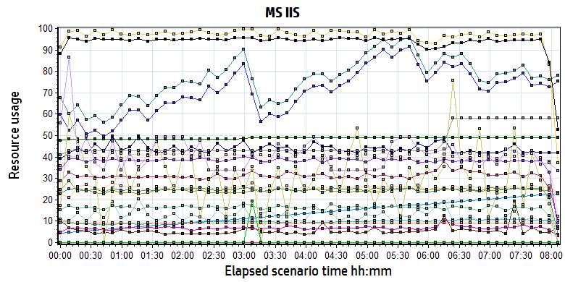

|  |  |  |  |  |  |  |  |  |  |  |  |  |  |  |  |  |  |  |  |  |  |  |  |  |  |  |  |  |  |  |  |  |  |  |  |  |  |  |  |  |  |  |  |  |  |  |  |  |  |  |  |  |  |  |  |  |  |  |  |  |  |  |  |  |  |  |  |  |  |  |  |  |  |  |  |  |  |  |  |  |  |  |  |  |  |  |  |  |  |  |  |  |  |  |  |  |  |  |  |  |  |  |  |  |  |  |  |  |  |  |  |  |  |  |  |  |  |  |  |  |  |  |  |  |  |  |  |  |  |  |  |  |  |  |  |  |  |  |  |  |  |  |  |  |  |  |  |  |  |  |  |  |  |  |  |  |  |  |  |  |  |  |  |  |  |  |  |  |  |  |  |  |  |  |  |  |  |  |  |  |  |  |  |  |  |  |  |  |  |
| --- | --- | --- | --- | --- | --- | --- | --- | --- | --- | --- | --- | --- | --- | --- | --- | --- | --- | --- | --- | --- | --- | --- | --- | --- | --- | --- | --- | --- | --- | --- | --- | --- | --- | --- | --- | --- | --- | --- | --- | --- | --- | --- | --- | --- | --- | --- | --- | --- | --- | --- | --- | --- | --- | --- | --- | --- | --- | --- | --- | --- | --- | --- | --- | --- | --- | --- | --- | --- | --- | --- | --- | --- | --- | --- | --- | --- | --- | --- | --- | --- | --- | --- | --- | --- | --- | --- | --- | --- | --- | --- | --- | --- | --- | --- | --- | --- | --- | --- | --- | --- | --- | --- | --- | --- | --- | --- | --- | --- | --- | --- | --- | --- | --- | --- | --- | --- | --- | --- | --- | --- | --- | --- | --- | --- | --- | --- | --- | --- | --- | --- | --- | --- | --- | --- | --- | --- | --- | --- | --- | --- | --- | --- | --- | --- | --- | --- | --- | --- | --- | --- | --- | --- | --- | --- | --- | --- | --- | --- | --- | --- | --- | --- | --- | --- | --- | --- | --- | --- | --- | --- | --- | --- | --- | --- | --- | --- | --- | --- | --- | --- | --- | --- | --- | --- | --- | --- | --- | --- | --- |
| |  |  |  |  |  |  |  | | --- | --- | --- | --- | --- | --- | --- | | **Color** | **Scale** | **Measurement** | **Minimum** | **Average** | **Maximum** | **Std. Deviation** | |  | 1E-07 | # Bytes in all Heaps (.NET CLR Memory \_Global\_):10.184.129.161 | 221,901,044.000 | 243,615,210.895 | 313,022,088.000 | 11,228,259.903 | |  | 0.1 | # of current logical Threads (.NET CLR LocksAndThreads \_Global\_):10.184.129.161 | 528.000 | 764.028 | 1,007.000 | 104.800 | |  | 0.1 | # of current physical Threads (.NET CLR LocksAndThreads \_Global\_):10.184.129.161 | 458.000 | 707.451 | 961.000 | 112.108 | |  | 0.1 | # of current recognized threads (.NET CLR LocksAndThreads \_Global\_):10.184.129.161 | 79.000 | 97.675 | 115.000 | 7.290 | |  | 0.1 | # of Pinned Objects (.NET CLR Memory \_Global\_):10.184.129.161 | 118.000 | 256.366 | 427.000 | 84.958 | |  | 0.01 | # of total recognized threads (.NET CLR LocksAndThreads \_Global\_):10.184.129.161 | 431.000 | 1,349.028 | 2,257.000 | 528.202 | |  | 100 | % Time in GC (.NET CLR Memory \_Global\_):10.184.129.161 | 0.006 | 0.055 | 3.832 | 0.103 | |  | 1E-06 | Bytes in Loader Heap (.NET CLR Loading \_Global\_):10.184.129.161 | 46,485,504.000 | 48,805,724.422 | 49,500,160.000 | 397,224.289 | |  | 0.01 | Bytes Received/sec (Web Service \_Total):10.184.129.161 | 0.000 | 9,704.307 | 186,128.855 | 4,845.644 | |  | 0.001 | Bytes Sent/sec (Web Service \_Total):10.184.129.161 | 0.000 | 24,625.694 | 467,528.588 | 24,605.995 | |  | 10 | Contention Rate / sec (.NET CLR LocksAndThreads \_Global\_):10.184.129.161 | 0.000 | 0.678 | 11.958 | 0.857 | |  | 1 | Current Connections (Web Service \_Total):10.184.129.161 | 2.000 | 31.211 | 48.000 | 3.046 | |  | 0.001 | Current File Cache Memory Usage (Web Service Cache):10.184.129.161 | 0.000 | 43,801.966 | 73,828.000 | 6,460.773 | |  | 10 | Current Files Cached (Web Service Cache):10.184.129.161 | 0.000 | 1.253 | 6.000 | 0.815 | |  | 1 | Current ISAPI Extension Requests (Web Service \_Total):10.184.129.161 | 0.000 | 0.000 | 0.000 | 0.000 | |  | 1 | Current Metadata Cached (Web Service Cache):10.184.129.161 | 8.000 | 9.027 | 10.000 | 0.162 | |  | 1000 | Current NonAnonymous Users (Web Service \_Total):10.184.129.161 | 0.000 | 0.031 | 3.000 | 0.193 | |  | 1 | Current URIs Cached (Web Service Cache):10.184.129.161 | 5.000 | 40.476 | 60.000 | 7.056 | |  | 10 | Get Requests/sec (Web Service \_Total):10.184.129.161 | 0.000 | 3.826 | 82.046 | 2.481 | |  | 1 | ISAPI Extension Requests/sec (Web Service \_Total):10.184.129.161 | 0.000 | 0.000 | 0.000 | 0.000 | |  | 100 | Kernel| URI Cache Hits/sec (Web Service Cache):10.184.129.161 | 0.000 | 0.163 | 2.325 | 0.228 | |  | 1E-06 | Large Object Heap Size (.NET CLR Memory \_Global\_):10.184.129.161 | 33,574,632.000 | 41,457,016.401 | 110,542,096.000 | 10,510,385.946 | |  | 1 | Locked Errors/sec (Web Service \_Total):10.184.129.161 | 0.000 | 0.000 | 0.000 | 0.000 | |  | 1 | Maximum Connections (Web Service \_Total):10.184.129.161 | 33.000 | 46.203 | 58.000 | 6.206 | |  | 10000 | Not Found Errors/sec (Web Service \_Total):10.184.129.161 | 0.000 | 0.000 | 0.328 | 0.003 | |  | 10 | Post Requests/sec (Web Service \_Total):10.184.129.161 | 0.000 | 9.417 | 179.705 | 2.831 | |
|  |
|  |
| E:\B31_20190628_Terminal_1\Report\dot_trans.gif |
|  |
| |  | | --- | | **Description:**Displays a summary of resources on MsIIS web server. | |

From the finger, we can see that the MS IIS services works well during testing. But we used too many IIS service in the system. These services used too much memory recourse and they will not release in short time. Maybe we should limit some services recourse usage in future version.

## Test Conclusion

We executed the performance testing scenario for 8 hours. (From Period: 6/27/2019 2:06 PM - 6/27/2019 10:13 PM). There is no errors happened during the testing work.

During the testing, the main works result is follow:

|  |  |  |
| --- | --- | --- |
| Type | Count | Size |
| Dicom Archived | 5,804 | 10M |
| Dicom Printed | 2,940 | 10M |
| Report Archived | 8839 | Random 100Kb or 4Mb |
| Report Printed | 5,991 | Random 100Kb or 4Mb |
| Color film Printed | 274 | 80M |

From the statistic result, **we can get that the result can meets the requirements for system**. During the testing, we stop the LRU and SMS service to avoid the disturbance because these services will not execute in the work times as default. And other limited is we add the ROI zone for OCR services, the OCR services is works under a low stress. We will add some stress for next test works.

# Testing work （Phase 1）

## Test Environment

The detailed hardware configurations of all servers are described as follow:

|  |  |  |  |  |  |  |
| --- | --- | --- | --- | --- | --- | --- |
| **Computer name** | **CPU** | **Memory** | **HD** | **OS** | **Other** | **Comments** |
| PUMA Main Server | Intel(R) Xeon® Bronze CPU 3140 @ 1.70 \* 6 | 16GB | 300GB | Windows 2012 R2 64bit |  |  |
| PUMA Store Server | Intel(R) Xeon® Bronze CPU 3140 @ 1.70 \* 6 | 16GB | 8T | Windows 2012 R2 64bit |  |  |
| PUMA virtual server | Intel(R) Xeon® Bronze CPU 3140 @ 1.70 \* 6 | 12GB | 7T | Windows 2012 R2 64bit | SQL server 2008 Sp3 | PS 3.0.4.0.0031 |
| Terminal | Intel(R) Celeron CPU J1900 2.0GHz | 4GB | 450GB | Windows 10 Enterprise 2016 | AUTOIT 3.0 |  |

Table 1 Hardware Configuration

## Test scenario and strategy

Virtual User: 59 Users

Duration: 8 hour

Description: Use the test tool simulates the patient operations. Monitor the server software and hardware resource usage. The detail information as follow:

1. Use automation tool simulate the doctor print film work. Simulate 20 workstations print films to PS server every 90 seconds in 8 hours.
2. Use LR tool simulate 8 K2/K3 terminals to print gray films. Each client prints one film which size is 10MB random 5 to 30 seconds.
3. Use AUTO tool simulate 1 K2/K3 terminals to print color films. Each client prints one film which size is 83MB in real terminal. The color films will print to PDF file with PDF created software instead of the real paper printer.
4. Use LR tool simulate 21 users to do paper report archive and print operations. Each client archive report in random 5 to 30 seconds and size is random with 100kb and 4Mb.
5. The OCR setting will has rule configuration from test tool in step1 and thread setting is set as 40. The OCR rule will has no ROI setting of patient id and accession number in OCR. The OCR will use 70%-80% CPU usage during the testing to make system under a big stress.
6. Simulate 10 users to do the query information, view monitor page, query reconciliation films and report, expand the record, change the status, set holding time and other operations in work list. The users will execute the operations random 60 to 120 seconds.
7. Monitor the transaction response time.
8. Monitor the hardware resource usage on PS.
9. Monitor the resource usage for database on PS.
10. Start/Stop 2 virtual users every 10 seconds and run the scenario for 8 hours.

Note:

We will do the performance testing work under big stress for system. If system can work well under current stress and the transaction process ability meets the requirement, we will give the conclusion the system performance is pass.

## Test Tool

Load Runner 12.

## Database setting

Memory: Set the min and max memory size to 6GB.

Index fill factor: 80.

File: Increase the data and log files size and the rule is increase 500Mb as fixed size.

Settings: Cost threshold for parallelism to 60.

## IIS setting

Connection: Set the max connection value to 4000 and keep other setting as default.

## Test Object version

PUMA 3.0.4.0 B31, Terminal 3.0.4.0 B35

## Background data

We prepared a background records in the PS system. The data size is calculated by the typical site which printed 3,000 films in a workday. That means the records of films in db should more than 972,000 (3000 records / day \*54 weeks \* 6 workday). QA team had prepared these data with SQL script and automation script. These data can backup and import by DB tool.

The detail data records in DB as follow:

|  |  |
| --- | --- |
| **Table Name** | **Data Volume (records)** |
| printer.dbo.DeliveryJob | 1001022 |
| printer.dbo.ImageBox | 3536070 |
| printer.dbo.Page | 320738 |
| printer.dbo.Session | 6156 |
| wggc.dbo.Patient | 12731 |
| wggc.dbo.Study | 1440102 |
| wggc.dbo.AFP\_PrintTerminalInfo | 60 |
| wggc.dbo.Series | 1440052 |
| wggc.dbo.Image | 1440055 |
| wggc.dbo.AFP\_FilmInfo | 1426418 |
| wggc.dbo.AFP\_ReportInfo | 1240944 |
| wggc.dbo.AFP\_ExamInfo | 192295 |
| wggc.dbo.AFP\_PrintTask | 4332167 |
| wggc.dbo.T\_Integration\_ExamInfo | 18230 |
| AFP\_PrintMode | 88415 |
| wggc.dbo.vi\_KIOSK\_ExamInfo\_Order | 853156 |

## Test Error

There are 33 test errors and made 13 transaction errors existed in the testing.

## Test result of PS server

### Test result of PS transactions

After the performance testing works, the transactions result of PS print module as follow:

|  |  |
| --- | --- |
| Analysis Summary | Period: 6/29/2019 2:48 PM - 6/29/2019 10:55 PM |

|  |  |
| --- | --- |
| **Scenario Name:** | E:\ECS\Performance\Script\208\ScenarioPUMA\_Reliability\_171.lrs |
| **Results in Session:** | c:\Users\Administrator\AppData\Local\Temp\res1150\res1150.lrr |
| **Duration:** | 8 hours, 7 minutes and 3 seconds. |

|  |
| --- |
| Statistics Summary |

|  |  |  |
| --- | --- | --- |
| [**Maximum Running Vusers:**](file:///E:\Performance_MR2\B31_PS_20180701_1\VuserStateGraph) |  | 29 |
| [**Total Throughput (bytes):**](file:///E:\Performance_MR2\B31_PS_20180701_1\Throughput) | [Show SLA Results](slarules:total_throughput) | 18,323,541 |
| [**Average Throughput (bytes/second):**](file:///E:\Performance_MR2\B31_PS_20180701_1\Throughput) | [Show SLA Results](slarules:average_throughput) | 627 |
| [**Total Hits:**](file:///E:\Performance_MR2\B31_PS_20180701_1\HitsperSecond) | [Show SLA Results](slarules:total_hits) | 18,989 |
| [**Average Hits per Second:**](file:///E:\Performance_MR2\B31_PS_20180701_1\HitsperSecond) | [Show SLA Results](slarules:average_hits) | 0.65 | [**View HTTP Responses Summary**](file:///E:\Performance_MR2\B31_PS_20180701_1\B31_PS_20180701_1.html#1) |
| [**Total Errors:**](file:///E:\Performance_MR2\B31_PS_20180701_1\TotalErrorsPerSecond) | [Show SLA Results](slarules:errors_per_second) | 33 |  |

|  |  |  |
| --- | --- | --- |
| |  | | --- | | You can define SLA data using the [SLA configuration wizard](slaconfig:) | | You can analyze transaction behavior using the [Analyze Transaction mechanism](analyze:) | |

|  |
| --- |
| Transaction Summary |

|  |  |  |  |  |
| --- | --- | --- | --- | --- |
| [**Transactions:**](file:///E:\Performance_MR2\B31_PS_20180701_1\TransactionSummary) | Total Passed: 98,017 | Total Failed: 13 | Total Stopped: 0 | [**Average Response Time**](file:///E:\Performance_MR2\B31_PS_20180701_1\ResponseTime) |

|  |  |  |  |  |  |  |  |  |  |
| --- | --- | --- | --- | --- | --- | --- | --- | --- | --- |
| **Transaction Name** | **SLA Status** | **Minimum** | **Average** | **Maximum** | **Std. Deviation** | **90 Percent** | **Pass** | **Fail** | **Stop** |
| [Create New Patient](file:///E:\Performance_MR2\B31_PS_20180701_1\ResponseTime0000(Create%20New%20Patient)0000) | [Show SLA Results](slarules:transaction_response_time_CreateNewPatient) | 0.125 | 0.213 | 1.753 | 0.086 | 0.312 | 5,858 | 0 | 0 |
| [Film Create\_PrintTask](file:///E:\Performance_MR2\B31_PS_20180701_1\ResponseTime0000(Film%20Create_PrintTask)0000) | [Show SLA Results](slarules:transaction_response_time_FilmCreate_PrintTask) | 0.194 | 0.585 | 44.092 | 1.604 | 0.78 | 2,904 | 0 | 0 |
| [Film PrintTask](file:///E:\Performance_MR2\B31_PS_20180701_1\ResponseTime0000(Film%20PrintTask)0000) | [Show SLA Results](slarules:transaction_response_time_FilmPrintTask) | 0.016 | 0.093 | 0.905 | 0.068 | 0.172 | 2,904 | 0 | 0 |
| [Film PrintTask\_Result\_Correct](file:///E:\Performance_MR2\B31_PS_20180701_1\ResponseTime0000(Film%20PrintTask_Result_Correct)0000) | [Show SLA Results](slarules:transaction_response_time_FilmPrintTask_Result_Correct) | 0 | 0 | 0.016 | 0 | 0 | 2,903 | 0 | 0 |
| [Film TerminalStatus](file:///E:\Performance_MR2\B31_PS_20180701_1\ResponseTime0000(Film%20TerminalStatus)0000) | [Show SLA Results](slarules:transaction_response_time_FilmTerminalStatus) | 0 | 0.08 | 33.047 | 0.617 | 0.14 | 2,904 | 0 | 0 |
| [Film\_PrintStatus\_CheckService](file:///E:\Performance_MR2\B31_PS_20180701_1\ResponseTime0000(Film_PrintStatus_CheckService)0000) | [Show SLA Results](slarules:transaction_response_time_Film_PrintStatus_CheckService) | 0 | 0.078 | 26.568 | 0.378 | 0.156 | 10,277 | 0 | 0 |
| [Notify File 100k](file:///E:\Performance_MR2\B31_PS_20180701_1\ResponseTime0000(Notify%20File%20100k)0000) | [Show SLA Results](slarules:transaction_response_time_NotifyFile100k) | 0.308 | 0.954 | 19.058 | 0.783 | 1.435 | 5,735 | 5 | 0 |
| [Notify File 4M](file:///E:\Performance_MR2\B31_PS_20180701_1\ResponseTime0000(Notify%20File%204M)0000) | [Show SLA Results](slarules:transaction_response_time_NotifyFile4M) | 0.516 | 1.13 | 4.696 | 0.673 | 1.685 | 113 | 0 | 0 |
| [Report Print Task Correct](file:///E:\Performance_MR2\B31_PS_20180701_1\ResponseTime0000(Report%20%20Print%20Task%20Correct)0000) | [Show SLA Results](slarules:transaction_response_time_ReportPrintTaskCorrect) | 0 | 0 | 0.016 | 0 | 0 | 5,850 | 0 | 0 |
| [Report Create\_PrintTask](file:///E:\Performance_MR2\B31_PS_20180701_1\ResponseTime0000(Report%20Create_PrintTask)0000) | [Show SLA Results](slarules:transaction_response_time_ReportCreate_PrintTask) | 0.201 | 0.518 | 2.964 | 0.217 | 0.796 | 5,850 | 0 | 0 |
| [Report GetReportID\_fail](file:///E:\Performance_MR2\B31_PS_20180701_1\ResponseTime0000(Report%20GetReportID_fail)0000) | [Show SLA Results](slarules:transaction_response_time_ReportGetReportID_fail) | 0 | 0 | 0 | 0 | 0 | 0 | 1 | 0 |
| [Report GetReportPath\_fail](file:///E:\Performance_MR2\B31_PS_20180701_1\ResponseTime0000(Report%20GetReportPath_fail)0000) | [Show SLA Results](slarules:transaction_response_time_ReportGetReportPath_fail) | 0 | 0 | 0 | 0 | 0 | 0 | 2 | 0 |
| [Report PrintTask](file:///E:\Performance_MR2\B31_PS_20180701_1\ResponseTime0000(Report%20PrintTask)0000) | [Show SLA Results](slarules:transaction_response_time_ReportPrintTask) | 0.016 | 0.106 | 1.95 | 0.096 | 0.203 | 5,850 | 0 | 0 |
| [Report PrintTask Status Check](file:///E:\Performance_MR2\B31_PS_20180701_1\ResponseTime0000(Report%20PrintTask%20Status%20Check)0000) | [Show SLA Results](slarules:transaction_response_time_ReportPrintTaskStatusCheck) | 0 | 0.076 | 11.84 | 0.228 | 0.143 | 5,915 | 0 | 0 |
| [Report QueryFilmReportInfo](file:///E:\Performance_MR2\B31_PS_20180701_1\ResponseTime0000(Report%20QueryFilmReportInfo)0000) | [Show SLA Results](slarules:transaction_response_time_ReportQueryFilmReportInfo) | 0.214 | 0.525 | 18.161 | 0.325 | 0.78 | 11,700 | 3 | 0 |
| [Report TerminalStatus](file:///E:\Performance_MR2\B31_PS_20180701_1\ResponseTime0000(Report%20TerminalStatus)0000) | [Show SLA Results](slarules:transaction_response_time_ReportTerminalStatus) | 0 | 0.085 | 27.232 | 0.633 | 0.14 | 11,700 | 2 | 0 |
| [Report Update PrintTask](file:///E:\Performance_MR2\B31_PS_20180701_1\ResponseTime0000(Report%20Update%20PrintTask)0000) | [Show SLA Results](slarules:transaction_response_time_ReportUpdatePrintTask) | 0.016 | 0.136 | 1.498 | 0.102 | 0.265 | 5,850 | 0 | 0 |
| [Report Update report printer info](file:///E:\Performance_MR2\B31_PS_20180701_1\ResponseTime0000(Report%20Update%20report%20printer%20info)0000) | [Show SLA Results](slarules:transaction_response_time_ReportUpdatereportprinterinfo) | 0 | 0.056 | 1.17 | 0.059 | 0.118 | 11,704 | 0 | 0 |

|  |  |  |  |  |  |  |
| --- | --- | --- | --- | --- | --- | --- |
| **Service Level Agreement Legend:** | E:\Performance_MR2\B31_PS_20180701_1\led_ok.gif | Pass | E:\Performance_MR2\B31_PS_20180701_1\led_error.gif | Fail | E:\Performance_MR2\B31_PS_20180701_1\led_no_data.gif | No Data |

|  |
| --- |
| HTTP Responses Summary |

|  |  |  |
| --- | --- | --- |
| **HTTP Responses** | **Total** | **Per second** |
| [HTTP\_200](file:///E:\Performance_MR2\B31_PS_20180701_1\HttpReturnCodes0001(HTTP_200)0001) | 18,989 | 0.65 |

Follow the summary report, we can see most of transactions have passed and transactions` response time can very good.

There are 13 transactions failed during testing. The transaction pass rate is 99.987% (98017/98017+13 = 0.9998673875344282). The result can be accepted.

### Transaction summary result of PS

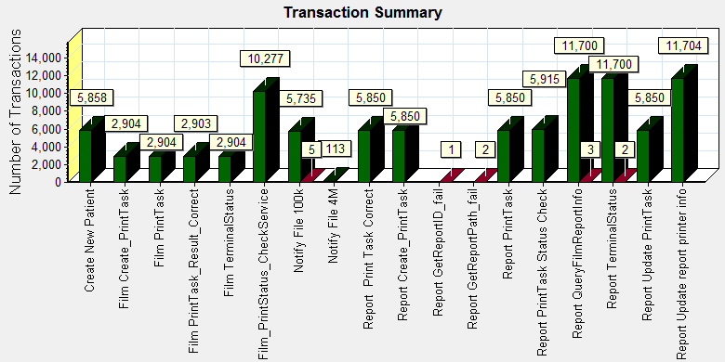

|  |  |  |  |  |  |  |  |  |  |
| --- | --- | --- | --- | --- | --- | --- | --- | --- | --- |
| |  |  |  | | --- | --- | --- | | **Color** | **Scale** | **Measurement** | |  | 1 | Pass | |  | 1 | Fail | |
|  |
|  |
| E:\Performance_MR2\B31_PS_20180701_1\Report\dot_trans.gif |
|  |
| |  | | --- | | **Description:**Displays the number of transactions that passed, failed, stopped, or ended with errors. | |

|  |
| --- |
|  |
|  |
|  |
|  |
|  |
|  |

We can see that there are 13 transactions failed during the testing works.

### Transaction response time result of PS

We can get the transaction response time information from the figure as follow:

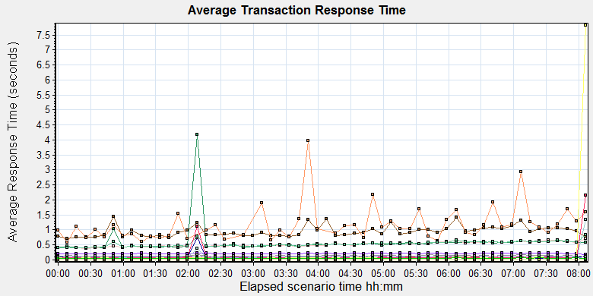

|  |  |  |  |  |  |  |  |  |  |  |  |  |  |  |  |  |  |  |  |  |  |  |  |  |  |  |  |  |  |  |  |  |  |  |  |  |  |  |  |  |  |  |  |  |  |  |  |  |  |  |  |  |  |  |  |  |  |  |  |  |  |  |  |  |  |  |  |  |  |  |  |  |  |  |  |  |  |  |  |  |  |  |  |  |  |  |  |  |  |  |  |  |  |  |  |  |  |  |  |  |  |  |  |  |  |  |  |  |  |  |  |  |  |  |  |  |  |  |  |  |  |  |  |  |  |  |  |  |  |  |  |  |  |  |  |  |
| --- | --- | --- | --- | --- | --- | --- | --- | --- | --- | --- | --- | --- | --- | --- | --- | --- | --- | --- | --- | --- | --- | --- | --- | --- | --- | --- | --- | --- | --- | --- | --- | --- | --- | --- | --- | --- | --- | --- | --- | --- | --- | --- | --- | --- | --- | --- | --- | --- | --- | --- | --- | --- | --- | --- | --- | --- | --- | --- | --- | --- | --- | --- | --- | --- | --- | --- | --- | --- | --- | --- | --- | --- | --- | --- | --- | --- | --- | --- | --- | --- | --- | --- | --- | --- | --- | --- | --- | --- | --- | --- | --- | --- | --- | --- | --- | --- | --- | --- | --- | --- | --- | --- | --- | --- | --- | --- | --- | --- | --- | --- | --- | --- | --- | --- | --- | --- | --- | --- | --- | --- | --- | --- | --- | --- | --- | --- | --- | --- | --- | --- | --- | --- | --- | --- | --- | --- |
| |  |  |  |  |  |  |  |  | | --- | --- | --- | --- | --- | --- | --- | --- | | **Color** | **Scale** | **Measurement** | **Graph's Minimum** | **Graph's Average** | **Graph's Maximum** | **Graph's Median** | **Graph's Std. Deviation** | |  | 1 | Create New Patient | 0.172 | 0.212 | 0.237 | 0.212 | 0.012 | |  | 1 | Film Create\_PrintTask | 0.398 | 0.585 | 4.170 | 0.530 | 0.485 | |  | 1 | Film PrintTask | 0.069 | 0.093 | 0.132 | 0.092 | 0.012 | |  | 1 | Film PrintTask\_Result\_Correct | 0.000 | 0.000 | 0.000 | 0.000 | 0.000 | |  | 1 | Film TerminalStatus | 0.048 | 0.082 | 0.771 | 0.067 | 0.092 | |  | 1 | Film\_PrintStatus\_CheckService | 0.058 | 0.099 | 1.330 | 0.071 | 0.168 | |  | 1 | Notify File 100k | 0.700 | 0.951 | 1.434 | 0.911 | 0.179 | |  | 1 | Notify File 4M | 0.582 | 1.172 | 3.962 | 1.045 | 0.579 | |  | 1 | Report Print Task Correct | 0.000 | 0.000 | 0.000 | 0.000 | 0.000 | |  | 1 | Report Create\_PrintTask | 0.381 | 0.521 | 0.727 | 0.498 | 0.081 | |  | 1 | Report PrintTask | 0.031 | 0.105 | 0.147 | 0.105 | 0.017 | |  | 1 | Report PrintTask Status Check | 0.049 | 0.206 | 7.821 | 0.071 | 1.009 | |  | 1 | Report QueryFilmReportInfo | 0.398 | 0.530 | 0.842 | 0.507 | 0.088 | |  | 1 | Report TerminalStatus | 0.058 | 0.121 | 2.145 | 0.066 | 0.301 | |  | 1 | Report Update PrintTask | 0.104 | 0.136 | 0.173 | 0.135 | 0.016 | |  | 1 | Report Update report printer info | 0.035 | 0.055 | 0.072 | 0.055 | 0.006 | |
|  |
|  |
| E:\Performance_MR2\B31_PS_20180701_1\Report\dot_trans.gif |
|  |
| |  | | --- | | **Description:**Displays the average time taken to perform transactions during each second of the load test. This graph helps you determine whether the performance of the server is within acceptable minimum and maximum transaction performance time ranges defined for your system. | |  | |

|  |
| --- |
|  |
|  |

Transaction response time

This figure information shows all transaction response time. We can analysis that all transactions` response time more than 3 seconds. It`s good performance for our system.

## Test result of Web service

### Test Statistic Report of Web

After the performance testing works, the transactions result of we module as follow:

|  |  |
| --- | --- |
| Analysis Summary | Period: 29/06/2019 14:49:25 - 29/06/2019 22:54:56 |

|  |  |
| --- | --- |
| **Scenario Name:** | D:\Performance\ScenarioPUMA\_Reliability\_171.lrs |
| **Results in Session:** | c:\Users\administrator\appdata\local\temp\res1363\res1363.lrr |
| **Duration:** | 8 hours, 5 minutes and 31 seconds. |

|  |
| --- |
| Statistics Summary |

|  |  |  |
| --- | --- | --- |
| [**Maximum Running Vusers:**](file:///E:\Performance_MR2\B31_Web_20190701\VuserStateGraph) |  | 10 |
| [**Total Throughput (bytes):**](file:///E:\Performance_MR2\B31_Web_20190701\Throughput) | [Show SLA Results](slarules:total_throughput) | 499,452,916 |
|  |  |  |
|  |  |  |
| [**Average Throughput (bytes/second):**](file:///E:\Performance_MR2\B31_Web_20190701\Throughput) | [Show SLA Results](slarules:average_throughput) | 17,144 |
|  |  |  |
|  |  |  |
| [**Total Hits:**](file:///E:\Performance_MR2\B31_Web_20190701\HitsperSecond) | [Show SLA Results](slarules:total_hits) | 45,813 |
|  |  |  |
|  |  |  |
| [**Average Hits per Second:**](file:///E:\Performance_MR2\B31_Web_20190701\HitsperSecond) | [Show SLA Results](slarules:average_hits) | 1.573 | [**View HTTP Responses Summary**](file:///E:\Performance_MR2\B31_Web_20190701\B31_Web_20190701.html#1) |
|  |  |  |  |
|  |  |  |  |

|  |  |  |
| --- | --- | --- |
| |  | | --- | | You can define SLA data using the [SLA configuration wizard](slaconfig:) | | You can analyze transaction behavior using the [Analyze Transaction mechanism](analyze:) | |

|  |
| --- |
| Transaction Summary |

|  |  |  |  |  |
| --- | --- | --- | --- | --- |
| [**Transactions:**](file:///E:\Performance_MR2\B31_Web_20190701\TransactionSummary) | Total Passed: 12,923 | Total Failed: 0 | Total Stopped: 0 | [**Average Response Time**](file:///E:\Performance_MR2\B31_Web_20190701\ResponseTime) |

|  |  |  |  |
| --- | --- | --- | --- |
|  | **Pass** | **Fail** | **Stop** |
| [Total](file:///E:\Performance_MR2\B31_Web_20190701\TransactionSummary0013(Total)0013) | 12,923 | 0 | 0 |

|  |  |  |  |  |  |  |  |  |  |
| --- | --- | --- | --- | --- | --- | --- | --- | --- | --- |
| **Transaction Name** | **SLA Status** | **Minimum** | **Average** | **Maximum** | **Std. Deviation** | **90 Percent** | **Pass** | **Fail** | **Stop** |
| [ExpandFilmRecord](file:///E:\Performance_MR2\B31_Web_20190701\ResponseTime0000(ExpandFilmRecord)0000) | [Show SLA Results](slarules:transaction_response_time_ExpandFilmRecord) | 0.211 | 0.287 | 0.787 | 0.092 | 0.417 | 416 | 0 | 0 |
| [ExpandReportRecord](file:///E:\Performance_MR2\B31_Web_20190701\ResponseTime0000(ExpandReportRecord)0000) | [Show SLA Results](slarules:transaction_response_time_ExpandReportRecord) | 0.006 | 0.016 | 0.234 | 0.023 | 0.029 | 416 | 0 | 0 |
| [GetDepartmentInfo](file:///E:\Performance_MR2\B31_Web_20190701\ResponseTime0000(GetDepartmentInfo)0000) | [Show SLA Results](slarules:transaction_response_time_GetDepartmentInfo) | 0.005 | 0.024 | 0.569 | 0.047 | 0.061 | 552 | 0 | 0 |
| [Reconlication\_Film\_all](file:///E:\Performance_MR2\B31_Web_20190701\ResponseTime0000(Reconlication_Film_all)0000) | [Show SLA Results](slarules:transaction_response_time_Reconlication_Film_all) | 0.028 | 0.128 | 1.963 | 0.154 | 0.283 | 499 | 0 | 0 |
| [Reconlication\_Report\_All](file:///E:\Performance_MR2\B31_Web_20190701\ResponseTime0000(Reconlication_Report_All)0000) | [Show SLA Results](slarules:transaction_response_time_Reconlication_Report_All) | 0.024 | 0.105 | 0.834 | 0.096 | 0.216 | 499 | 0 | 0 |
| [SetPrintMode](file:///E:\Performance_MR2\B31_Web_20190701\ResponseTime0000(SetPrintMode)0000) | [Show SLA Results](slarules:transaction_response_time_SetPrintMode) | 0.017 | 0.123 | 0.769 | 0.112 | 0.258 | 416 | 0 | 0 |
| [SetStatusOfFilmWithExpand\_NOTprinted](file:///E:\Performance_MR2\B31_Web_20190701\ResponseTime0000(SetStatusOfFilmWithExpand_NOTprinted)0000) | [Show SLA Results](slarules:transaction_response_time_SetStatusOfFilmWithExpand_NOTprinted) | 0.259 | 0.421 | 1.373 | 0.175 | 0.622 | 76 | 0 | 0 |
| [SetStatusOfFilmWithExpand\_Printed](file:///E:\Performance_MR2\B31_Web_20190701\ResponseTime0000(SetStatusOfFilmWithExpand_Printed)0000) | [Show SLA Results](slarules:transaction_response_time_SetStatusOfFilmWithExpand_Printed) | 0.275 | 0.474 | 0.91 | 0.174 | 0.777 | 70 | 0 | 0 |
| [SetStatusOfFilmWithExpand\_Unprinted](file:///E:\Performance_MR2\B31_Web_20190701\ResponseTime0000(SetStatusOfFilmWithExpand_Unprinted)0000) | [Show SLA Results](slarules:transaction_response_time_SetStatusOfFilmWithExpand_Unprinted) | 0.272 | 0.469 | 1.54 | 0.209 | 0.72 | 76 | 0 | 0 |
| [SetStatusOfFilmWithoutExpand\_NOTprinted](file:///E:\Performance_MR2\B31_Web_20190701\ResponseTime0000(SetStatusOfFilmWithoutExpand_NOTprinted)0000) | [Show SLA Results](slarules:transaction_response_time_SetStatusOfFilmWithoutExpand_NOTprinted) | 0.032 | 0.125 | 0.348 | 0.082 | 0.262 | 76 | 0 | 0 |
| [SetStatusOfFilmWithoutExpand\_printed](file:///E:\Performance_MR2\B31_Web_20190701\ResponseTime0000(SetStatusOfFilmWithoutExpand_printed)0000) | [Show SLA Results](slarules:transaction_response_time_SetStatusOfFilmWithoutExpand_printed) | 0.027 | 0.108 | 0.807 | 0.104 | 0.18 | 73 | 0 | 0 |
| [SetStatusOfFilmWithoutExpand\_unprinted](file:///E:\Performance_MR2\B31_Web_20190701\ResponseTime0000(SetStatusOfFilmWithoutExpand_unprinted)0000) | [Show SLA Results](slarules:transaction_response_time_SetStatusOfFilmWithoutExpand_unprinted) | 0.035 | 0.126 | 0.961 | 0.126 | 0.24 | 91 | 0 | 0 |
| [SetStatusOfReportWithExpand\_NOTprinted](file:///E:\Performance_MR2\B31_Web_20190701\ResponseTime0000(SetStatusOfReportWithExpand_NOTprinted)0000) | [Show SLA Results](slarules:transaction_response_time_SetStatusOfReportWithExpand_NOTprinted) | 0.05 | 0.131 | 0.351 | 0.073 | 0.227 | 70 | 0 | 0 |
| [SetStatusOfReportWithExpand\_printed](file:///E:\Performance_MR2\B31_Web_20190701\ResponseTime0000(SetStatusOfReportWithExpand_printed)0000) | [Show SLA Results](slarules:transaction_response_time_SetStatusOfReportWithExpand_printed) | 0.053 | 0.135 | 0.503 | 0.083 | 0.221 | 74 | 0 | 0 |
| [SetStatusOfReportWithExpand\_unprinted](file:///E:\Performance_MR2\B31_Web_20190701\ResponseTime0000(SetStatusOfReportWithExpand_unprinted)0000) | [Show SLA Results](slarules:transaction_response_time_SetStatusOfReportWithExpand_unprinted) | 0.051 | 0.144 | 0.426 | 0.08 | 0.271 | 84 | 0 | 0 |
| [SetStatusOfReportWithoutExpand\_NOTprinted](file:///E:\Performance_MR2\B31_Web_20190701\ResponseTime0000(SetStatusOfReportWithoutExpand_NOTprinted)0000) | [Show SLA Results](slarules:transaction_response_time_SetStatusOfReportWithoutExpand_NOTprinted) | 0.035 | 0.12 | 0.452 | 0.068 | 0.184 | 85 | 0 | 0 |
| [SetStatusOfReportWithoutExpand\_printed](file:///E:\Performance_MR2\B31_Web_20190701\ResponseTime0000(SetStatusOfReportWithoutExpand_printed)0000) | [Show SLA Results](slarules:transaction_response_time_SetStatusOfReportWithoutExpand_printed) | 0.045 | 0.128 | 0.438 | 0.082 | 0.236 | 80 | 0 | 0 |
| [SetStatusOfReportWithoutExpand\_unprinted](file:///E:\Performance_MR2\B31_Web_20190701\ResponseTime0000(SetStatusOfReportWithoutExpand_unprinted)0000) | [Show SLA Results](slarules:transaction_response_time_SetStatusOfReportWithoutExpand_unprinted) | 0.037 | 0.124 | 0.52 | 0.083 | 0.204 | 69 | 0 | 0 |
| [SetTheHoldingTime](file:///E:\Performance_MR2\B31_Web_20190701\ResponseTime0000(SetTheHoldingTime)0000) | [Show SLA Results](slarules:transaction_response_time_SetTheHoldingTime) | 0.018 | 0.096 | 0.726 | 0.09 | 0.2 | 416 | 0 | 0 |
| [Terminal\_monitor](file:///E:\Performance_MR2\B31_Web_20190701\ResponseTime0000(Terminal_monitor)0000) | [Show SLA Results](slarules:transaction_response_time_Terminal_monitor) | 0.147 | 0.303 | 2.503 | 0.199 | 0.497 | 552 | 0 | 0 |
| [User\_login](file:///E:\Performance_MR2\B31_Web_20190701\ResponseTime0000(User_login)0000) | [Show SLA Results](slarules:transaction_response_time_User_login) | 0.047 | 0.27 | 3.098 | 0.309 | 0.611 | 2,420 | 0 | 0 |
| [worklist\_query\_ACC](file:///E:\Performance_MR2\B31_Web_20190701\ResponseTime0000(worklist_query_ACC)0000) | [Show SLA Results](slarules:transaction_response_time_worklist_query_ACC) | 0.011 | 0.046 | 0.417 | 0.068 | 0.109 | 46 | 0 | 0 |
| [worklist\_query\_LastMonth](file:///E:\Performance_MR2\B31_Web_20190701\ResponseTime0000(worklist_query_LastMonth)0000) | [Show SLA Results](slarules:transaction_response_time_worklist_query_LastMonth) | 0.064 | 0.151 | 0.443 | 0.072 | 0.224 | 70 | 0 | 0 |
| [worklist\_query\_LastTwoToday](file:///E:\Performance_MR2\B31_Web_20190701\ResponseTime0000(worklist_query_LastTwoToday)0000) | [Show SLA Results](slarules:transaction_response_time_worklist_query_LastTwoToday) | 0.061 | 0.156 | 0.614 | 0.108 | 0.288 | 64 | 0 | 0 |
| [worklist\_query\_Lastweek](file:///E:\Performance_MR2\B31_Web_20190701\ResponseTime0000(worklist_query_Lastweek)0000) | [Show SLA Results](slarules:transaction_response_time_worklist_query_Lastweek) | 0.061 | 0.151 | 0.458 | 0.084 | 0.241 | 64 | 0 | 0 |
| [worklist\_query\_Patient\_PatientName](file:///E:\Performance_MR2\B31_Web_20190701\ResponseTime0000(worklist_query_Patient_PatientName)0000) | [Show SLA Results](slarules:transaction_response_time_worklist_query_Patient_PatientName) | 0.009 | 0.07 | 0.911 | 0.134 | 0.129 | 54 | 0 | 0 |
| [worklist\_query\_Patient\_PID](file:///E:\Performance_MR2\B31_Web_20190701\ResponseTime0000(worklist_query_Patient_PID)0000) | [Show SLA Results](slarules:transaction_response_time_worklist_query_Patient_PID) | 0.009 | 0.044 | 0.299 | 0.049 | 0.076 | 54 | 0 | 0 |
| [Worklist\_Query\_Today](file:///E:\Performance_MR2\B31_Web_20190701\ResponseTime0000(Worklist_Query_Today)0000) | [Show SLA Results](slarules:transaction_response_time_Worklist_Query_Today) | 0.026 | 0.116 | 0.409 | 0.08 | 0.224 | 73 | 0 | 0 |
| [WorlkList\_Query\_randomTime](file:///E:\Performance_MR2\B31_Web_20190701\ResponseTime0000(WorlkList_Query_randomTime)0000) | [Show SLA Results](slarules:transaction_response_time_WorlkList_Query_randomTime) | 0.063 | 0.137 | 2.201 | 0.262 | 0.191 | 66 | 0 | 0 |

|  |  |  |  |  |  |  |
| --- | --- | --- | --- | --- | --- | --- |
| **Service Level Agreement Legend:** | E:\Performance_MR2\B31_Web_20190701\led_ok.gif | Pass | E:\Performance_MR2\B31_Web_20190701\led_error.gif | Fail | E:\Performance_MR2\B31_Web_20190701\led_no_data.gif | No Data |

|  |
| --- |
| HTTP Responses Summary |

|  |  |  |
| --- | --- | --- |
| **HTTP Responses** | **Total** | **Per second** |
| [HTTP\_200](file:///E:\Performance_MR2\B31_Web_20190701\HttpReturnCodes0001(HTTP_200)0001) | 43,393 | 1.49 |
| [HTTP\_302](file:///E:\Performance_MR2\B31_Web_20190701\HttpReturnCodes0001(HTTP_302)0001) | 2,420 | 0.083 |

Follow the summary report, we can see all the transactions have passed and transaction response time very good.

### Transaction summary result of Web

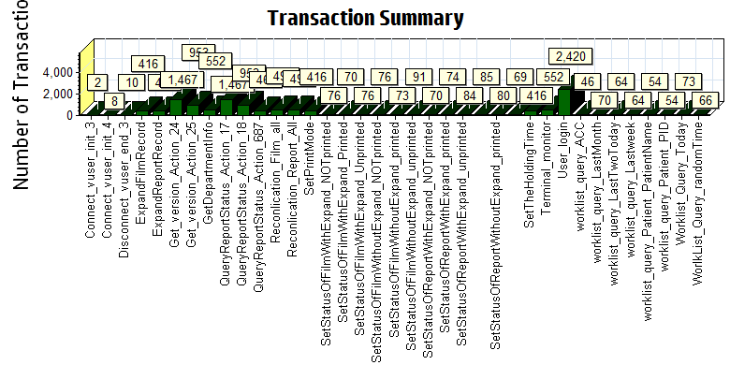

|  |  |  |  |  |  |  |
| --- | --- | --- | --- | --- | --- | --- |
| |  |  |  | | --- | --- | --- | | Color | Scale | Measurement | |  | 1 | Pass | |
|  |
|  |
|  |
|  |
|  |

We can see that there is no transaction failed during the testing works.

### Transaction response time result of Web

We can get the transaction response time information from the figure as follow:

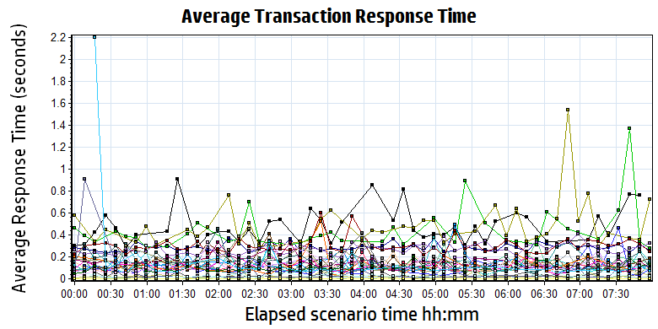

|  |  |  |  |  |  |  |  |  |  |  |  |  |  |  |  |  |  |  |  |  |  |  |  |  |  |  |  |  |  |  |  |  |  |  |  |  |  |  |  |  |  |  |  |  |  |  |  |  |  |  |  |  |  |  |  |  |  |  |  |  |  |  |  |  |  |  |  |  |  |  |  |  |  |  |  |  |  |  |  |  |  |  |  |  |  |  |  |  |  |  |  |  |  |  |  |  |  |  |  |  |  |  |  |  |  |  |  |  |  |  |  |  |  |  |  |  |  |  |  |  |  |  |  |  |  |  |  |  |  |  |  |  |  |  |  |  |  |  |  |  |  |  |  |  |  |  |  |  |  |  |  |  |  |  |  |  |  |  |  |  |  |  |  |  |  |  |  |  |  |  |  |  |  |  |  |  |  |  |  |  |  |  |  |  |  |  |  |  |  |  |  |  |  |  |  |  |  |  |  |  |  |  |  |  |  |  |  |  |  |  |  |  |  |  |  |  |  |  |  |  |  |  |  |  |  |  |  |  |  |  |  |  |  |  |  |  |  |  |  |  |  |  |  |  |  |  |  |  |  |  |  |  |  |  |  |  |  |  |  |  |  |  |  |  |  |  |
| --- | --- | --- | --- | --- | --- | --- | --- | --- | --- | --- | --- | --- | --- | --- | --- | --- | --- | --- | --- | --- | --- | --- | --- | --- | --- | --- | --- | --- | --- | --- | --- | --- | --- | --- | --- | --- | --- | --- | --- | --- | --- | --- | --- | --- | --- | --- | --- | --- | --- | --- | --- | --- | --- | --- | --- | --- | --- | --- | --- | --- | --- | --- | --- | --- | --- | --- | --- | --- | --- | --- | --- | --- | --- | --- | --- | --- | --- | --- | --- | --- | --- | --- | --- | --- | --- | --- | --- | --- | --- | --- | --- | --- | --- | --- | --- | --- | --- | --- | --- | --- | --- | --- | --- | --- | --- | --- | --- | --- | --- | --- | --- | --- | --- | --- | --- | --- | --- | --- | --- | --- | --- | --- | --- | --- | --- | --- | --- | --- | --- | --- | --- | --- | --- | --- | --- | --- | --- | --- | --- | --- | --- | --- | --- | --- | --- | --- | --- | --- | --- | --- | --- | --- | --- | --- | --- | --- | --- | --- | --- | --- | --- | --- | --- | --- | --- | --- | --- | --- | --- | --- | --- | --- | --- | --- | --- | --- | --- | --- | --- | --- | --- | --- | --- | --- | --- | --- | --- | --- | --- | --- | --- | --- | --- | --- | --- | --- | --- | --- | --- | --- | --- | --- | --- | --- | --- | --- | --- | --- | --- | --- | --- | --- | --- | --- | --- | --- | --- | --- | --- | --- | --- | --- | --- | --- | --- | --- | --- | --- | --- | --- | --- | --- | --- | --- | --- | --- | --- | --- | --- | --- | --- | --- | --- | --- | --- | --- | --- | --- | --- | --- | --- | --- | --- | --- | --- | --- | --- | --- | --- | --- | --- | --- | --- | --- | --- | --- |
| |  |  |  |  |  |  |  | | --- | --- | --- | --- | --- | --- | --- | | **Color** | **Scale** | **Measurement** | **Minimum** | **Average** | **Maximum** | **Std. Deviation** | |  | 1 | Connect\_vuser\_init\_3 | 0.000 | 0.000 | 0.000 | 0.000 | |  | 1 | Connect\_vuser\_init\_4 | 0.000 | 0.000 | 0.000 | 0.000 | |  | 1 | Disconnect\_vuser\_end\_3 | 0.000 | 0.000 | 0.000 | 0.000 | |  | 1 | ExpandFilmRecord | 0.211 | 0.287 | 0.787 | 0.092 | |  | 1 | ExpandReportRecord | 0.006 | 0.016 | 0.234 | 0.023 | |  | 1 | Get\_version\_Action\_24 | 0.000 | 0.000 | 0.000 | 0.000 | |  | 1 | Get\_version\_Action\_25 | 0.000 | 0.000 | 0.000 | 0.000 | |  | 1 | GetDepartmentInfo | 0.005 | 0.024 | 0.569 | 0.047 | |  | 1 | QueryReportStatus\_Action\_17 | 0.000 | 0.000 | 0.000 | 0.000 | |  | 1 | QueryReportStatus\_Action\_18 | 0.000 | 0.000 | 0.000 | 0.000 | |  | 1 | QueryReportStatus\_Action\_687 | 0.000 | 0.000 | 0.000 | 0.000 | |  | 1 | Reconlication\_Film\_all | 0.028 | 0.128 | 1.963 | 0.154 | |  | 1 | Reconlication\_Report\_All | 0.024 | 0.105 | 0.834 | 0.096 | |  | 1 | SetPrintMode | 0.017 | 0.123 | 0.769 | 0.112 | |  | 1 | SetStatusOfFilmWithExpand\_NOTprinted | 0.259 | 0.421 | 1.373 | 0.175 | |  | 1 | SetStatusOfFilmWithExpand\_Printed | 0.275 | 0.474 | 0.910 | 0.174 | |  | 1 | SetStatusOfFilmWithExpand\_Unprinted | 0.272 | 0.469 | 1.540 | 0.209 | |  | 1 | SetStatusOfFilmWithoutExpand\_NOTprinted | 0.032 | 0.125 | 0.348 | 0.082 | |  | 1 | SetStatusOfFilmWithoutExpand\_printed | 0.027 | 0.108 | 0.807 | 0.104 | |  | 1 | SetStatusOfFilmWithoutExpand\_unprinted | 0.035 | 0.126 | 0.961 | 0.126 | |  | 1 | SetStatusOfReportWithExpand\_NOTprinted | 0.050 | 0.131 | 0.351 | 0.073 | |  | 1 | SetStatusOfReportWithExpand\_printed | 0.053 | 0.135 | 0.503 | 0.083 | |  | 1 | SetStatusOfReportWithExpand\_unprinted | 0.051 | 0.144 | 0.426 | 0.080 | |  | 1 | SetStatusOfReportWithoutExpand\_NOTprinted | 0.035 | 0.120 | 0.452 | 0.068 | |  | 1 | SetStatusOfReportWithoutExpand\_printed | 0.045 | 0.128 | 0.438 | 0.082 | |  | 1 | SetStatusOfReportWithoutExpand\_unprinted | 0.037 | 0.124 | 0.520 | 0.083 | |  | 1 | SetTheHoldingTime | 0.018 | 0.096 | 0.726 | 0.090 | |  | 1 | Terminal\_monitor | 0.147 | 0.303 | 2.503 | 0.199 | |  | 1 | User\_login | 0.047 | 0.270 | 3.098 | 0.309 | |  | 1 | worklist\_query\_ACC | 0.011 | 0.046 | 0.417 | 0.068 | |  | 1 | worklist\_query\_LastMonth | 0.064 | 0.151 | 0.443 | 0.072 | |  | 1 | worklist\_query\_LastTwoToday | 0.061 | 0.156 | 0.614 | 0.108 | |  | 1 | worklist\_query\_Lastweek | 0.061 | 0.151 | 0.458 | 0.084 | |  | 1 | worklist\_query\_Patient\_PatientName | 0.009 | 0.070 | 0.911 | 0.134 | |  | 1 | worklist\_query\_Patient\_PID | 0.009 | 0.044 | 0.299 | 0.049 | |  | 1 | Worklist\_Query\_Today | 0.026 | 0.116 | 0.409 | 0.080 | |  | 1 | WorlkList\_Query\_randomTime | 0.063 | 0.137 | 2.201 | 0.262 | |
|  |
|  |
| E:\Performance_MR2\B31_Web_20190701\Report\dot_trans.gif |
|  |
| |  | | --- | | **Description:**Displays the average time taken to perform transactions during each second of the load test. This graph helps you determine whether the performance of the server is within acceptable minimum and maximum transaction performance time ranges defined for your system. | |

|  |
| --- |
|  |
|  |
|  |
| G:\PUMA MR2\loadrunner result\MR2_B31_20190628_1\Report\dot_trans.gif |
|  |
| |  | | --- | |  | |

Transaction response time

Follow the figure: we can see that the transaction average response time is less than 3 seconds.

|  |
| --- |
|  |
|  |
|  |
|  |
|  |

|  |
| --- |
|  |
|  |

## Performance bottleneck analysis

### Hardware usage analysis- Main Server

During the testing work, we use the test tool to monitor the main server hardware usage include the CPU, Memory, hard disk and etc.

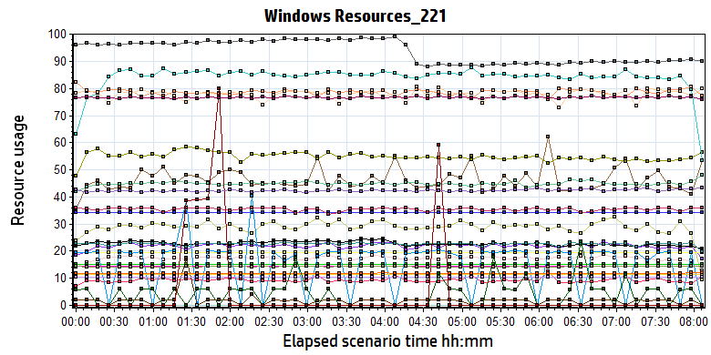

|  |  |  |  |  |  |  |  |  |  |  |  |  |  |  |  |  |  |  |  |  |  |  |  |  |  |  |  |  |  |  |  |  |  |  |  |  |  |  |  |  |  |  |  |  |  |  |  |  |  |  |  |  |  |  |  |  |  |  |  |  |  |  |  |  |  |  |  |  |  |  |  |  |  |  |  |  |  |  |  |  |  |  |  |  |  |  |  |  |  |  |  |  |  |  |  |  |  |  |  |  |  |  |  |  |  |  |  |  |  |  |  |  |  |  |  |  |  |  |  |  |  |  |  |  |  |  |  |  |  |  |  |  |  |  |  |  |  |  |  |  |  |  |  |  |  |  |  |  |  |  |  |  |  |  |  |  |  |  |  |  |  |  |  |  |  |  |  |  |  |  |  |  |  |  |  |  |  |  |  |  |  |  |  |  |  |  |  |  |  |  |  |  |  |  |  |  |  |  |  |  |  |  |  |  |  |
| --- | --- | --- | --- | --- | --- | --- | --- | --- | --- | --- | --- | --- | --- | --- | --- | --- | --- | --- | --- | --- | --- | --- | --- | --- | --- | --- | --- | --- | --- | --- | --- | --- | --- | --- | --- | --- | --- | --- | --- | --- | --- | --- | --- | --- | --- | --- | --- | --- | --- | --- | --- | --- | --- | --- | --- | --- | --- | --- | --- | --- | --- | --- | --- | --- | --- | --- | --- | --- | --- | --- | --- | --- | --- | --- | --- | --- | --- | --- | --- | --- | --- | --- | --- | --- | --- | --- | --- | --- | --- | --- | --- | --- | --- | --- | --- | --- | --- | --- | --- | --- | --- | --- | --- | --- | --- | --- | --- | --- | --- | --- | --- | --- | --- | --- | --- | --- | --- | --- | --- | --- | --- | --- | --- | --- | --- | --- | --- | --- | --- | --- | --- | --- | --- | --- | --- | --- | --- | --- | --- | --- | --- | --- | --- | --- | --- | --- | --- | --- | --- | --- | --- | --- | --- | --- | --- | --- | --- | --- | --- | --- | --- | --- | --- | --- | --- | --- | --- | --- | --- | --- | --- | --- | --- | --- | --- | --- | --- | --- | --- | --- | --- | --- | --- | --- | --- | --- | --- | --- | --- | --- | --- | --- | --- | --- | --- | --- | --- | --- | --- | --- | --- | --- | --- | --- | --- |
| |  |  |  |  |  |  |  |  |  |  |  |  |  |  |  |  |  |  |  |  |  |  |  |  |  |  |  |  |  |  |  |  |  |  |  |  |  |  |  |  |  |  |  |  |  |  |  |  |  |  |  |  |  |  |  |  |  |  |  |  |  |  |  |  |  |  |  |  |  |  |  |  |  |  |  |  |  |  |  |  |  |  |  |  |  |  |  |  |  |  |  |  |  |  |  |  |  |  |  |  |  |  |  |  |  |  |  |  |  |  |  |  |  |  |  |  |  |  |  |  |  |  |  |  |  |  |  |  |  |  |  |  |  |  |  |  |  |  |  |  |  |  |  |  |  |  |  |  |  |  |  |  |  |  |  |  |  |  |  |  |  |  |  |  |  |  |  |  |  |  |  |  |  |  |  |  |  |  |  |  |  |  |  |  |  |  |  |  |  |  |  |  |  |  |  |  |  |  |  | | --- | --- | --- | --- | --- | --- | --- | --- | --- | --- | --- | --- | --- | --- | --- | --- | --- | --- | --- | --- | --- | --- | --- | --- | --- | --- | --- | --- | --- | --- | --- | --- | --- | --- | --- | --- | --- | --- | --- | --- | --- | --- | --- | --- | --- | --- | --- | --- | --- | --- | --- | --- | --- | --- | --- | --- | --- | --- | --- | --- | --- | --- | --- | --- | --- | --- | --- | --- | --- | --- | --- | --- | --- | --- | --- | --- | --- | --- | --- | --- | --- | --- | --- | --- | --- | --- | --- | --- | --- | --- | --- | --- | --- | --- | --- | --- | --- | --- | --- | --- | --- | --- | --- | --- | --- | --- | --- | --- | --- | --- | --- | --- | --- | --- | --- | --- | --- | --- | --- | --- | --- | --- | --- | --- | --- | --- | --- | --- | --- | --- | --- | --- | --- | --- | --- | --- | --- | --- | --- | --- | --- | --- | --- | --- | --- | --- | --- | --- | --- | --- | --- | --- | --- | --- | --- | --- | --- | --- | --- | --- | --- | --- | --- | --- | --- | --- | --- | --- | --- | --- | --- | --- | --- | --- | --- | --- | --- | --- | --- | --- | --- | --- | --- | --- | --- | --- | --- | --- | --- | --- | --- | --- | --- | --- | --- | --- | --- | --- | --- | | |  |  |  |  |  |  | | --- | --- | --- | --- | --- | --- | | **Color** | **Scale** | **Measurement** | **Minimum** | **Average** | **Maximum** | |  | 1 | % Disk Time (PhysicalDisk \_Total):10.184.129.221 | 4.572 | 46.191 | 327.110 | |  | 1 | % Idle Time (PhysicalDisk \_Total):10.184.129.221 | 48.942 | 78.655 | 96.789 | |  | 100 | % Interrupt Time (Processor \_Total):10.184.129.221 | 0.000 | 0.290 | 1.295 | |  | 10 | % Privileged Time (Processor \_Total):10.184.129.221 | 0.087 | 1.740 | 6.477 | |  | 10 | % Processor Time (Processor \_Total):10.184.129.221 | 0.260 | 2.190 | 21.589 | |  | 0.01 | Available MBytes (Memory):10.184.129.221 | 1,928.000 | 1,947.805 | 1,959.000 | |  | 0.001 | Avg. Disk Bytes/Transfer (PhysicalDisk \_Total):10.184.129.221 | 12,820.898 | 44,869.688 | 178,150.141 | |  | 10 | Avg. Disk Queue Length (PhysicalDisk \_Total):10.184.129.221 | 0.091 | 0.924 | 6.542 | |  | 1 | Bytes Total/sec (Network Interface 6TO4 Adapter):10.184.129.221 | 0.000 | 0.000 | 0.000 | |  | 0.001 | Bytes Total/sec (Server):10.184.129.221 | 10,448.220 | 14,498.885 | 24,814.282 | |  | 1E-06 | Cache Bytes (Memory):10.184.129.221 | 41,308,160.000 | 42,359,487.064 | 45,056,000.000 | |  | 1E-09 | Committed Bytes (Memory):10.184.129.221 | 14,993,842,176.000 | 15,005,178,739.261 | 15,025,942,528.000 | |  | 0.01 | Context Switches/sec (System):10.184.129.221 | 1,627.501 | 2,280.503 | 11,998.638 | |  | 1 | Disk Transfers/sec (PhysicalDisk \_Total):10.184.129.221 | 3.990 | 54.859 | 190.583 | |  | 1 | File Data Operations/sec (System):10.184.129.221 | 3.874 | 22.669 | 240.047 | |  | 0.0001 | Free Megabytes (LogicalDisk \_Total):10.184.129.221 | 341,743.000 | 341,830.659 | 341,903.000 | |  | 0.01 | Interrupts/sec (Processor \_Total):10.184.129.221 | 1,832.786 | 8,434.247 | 20,781.671 | |  | 0.1 | Page Faults/sec (Memory):10.184.129.221 | 498.533 | 778.887 | 7,349.647 | |  | 10000 | Page Reads/sec (Memory):10.184.129.221 | 0.000 | 0.002 | 0.350 | |  | 1000 | Pages/sec (Memory):10.184.129.221 | 0.000 | 0.002 | 2.657 | |  | 1E-07 | Pool Nonpaged Bytes (Memory):10.184.129.221 | 140,230,656.000 | 144,643,595.500 | 157,097,984.000 | |  | 0.0001 | Pool Nonpaged Bytes (Server):10.184.129.221 | 323,900.000 | 354,165.166 | 373,587.000 | |  | 1E-07 | Pool Paged Bytes (Memory):10.184.129.221 | 103,510,016.000 | 103,642,716.947 | 103,923,712.000 | |  | 0.001 | Pool Paged Bytes (Server):10.184.129.221 | 11,576.000 | 11,576.000 | 11,576.000 | |  | 1 | Pool Paged Failures (Server):10.184.129.221 | 0.000 | 0.000 | 0.000 | |  | 1E-08 | Private Bytes (Process \_Total):10.184.129.221 | 1,175,175,168.000 | 1,185,506,963.808 | 1,203,503,104.000 | |  | 1000 | Processor Queue Length (System):10.184.129.221 | 0.000 | 0.004 | 2.000 | |  | 10000 | Split IO/Sec (PhysicalDisk \_Total):10.184.129.221 | 0.000 | 0.000 | 0.997 | |  | 1E-06 | System Cache Resident Bytes (Memory):10.184.129.221 | 41,308,160.000 | 42,359,555.007 | 45,056,000.000 | |  | 0.1 | Threads (Objects):10.184.129.221 | 870.000 | 936.554 | 1,027.000 | |  | 0.1 | Threads (System):10.184.129.221 | 746.000 | 766.530 | 813.000 | |  | 1E-08 | Working Set (Process \_Total):10.184.129.221 | 1,413,550,080.000 | 1,427,161,137.797 | 1,455,759,360.000 | | |  | |  | | E:\Performance_MR2\B31_PS_20180701_1\Report\dot_trans.gif | |  | | |  | | --- | | **Description:**Displays a summary of the System Resources usage for each Windows based host. | | |
| |  | | --- | |  | |  | |

Follow this information we can get that:

The main server hardware is works with health status. No bottle neck existed during the testing

### Hardware usage analysis- PS Server

During the testing work, we use the test tool to monitor the PS server hardware usage include the CPU, Memory, hard disk and etc.

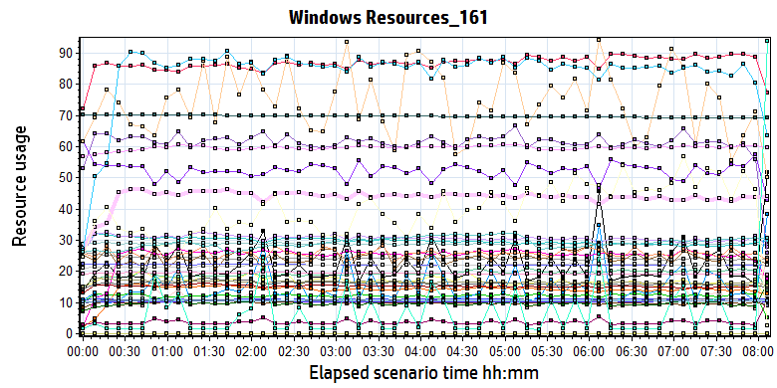

|  |  |  |  |  |  |  |  |  |  |  |  |  |  |  |  |  |  |  |  |  |  |  |  |  |  |  |  |  |  |  |  |  |  |  |  |  |  |  |  |  |  |  |  |  |  |  |  |  |  |  |  |  |  |  |  |  |  |  |  |  |  |  |  |  |  |  |  |  |  |  |  |  |  |  |  |  |  |  |  |  |  |  |  |  |  |  |  |  |  |  |  |  |  |  |  |  |  |  |  |  |  |  |  |  |  |  |  |  |  |  |  |  |  |  |  |  |  |  |  |  |  |  |  |  |  |  |  |  |  |  |  |  |  |  |  |  |  |  |  |  |  |  |  |  |  |  |  |  |  |  |  |  |  |  |  |  |  |  |  |  |  |  |  |  |  |  |  |  |  |  |  |  |  |  |  |  |  |  |  |  |  |  |  |  |  |  |  |  |  |  |  |  |  |  |  |  |  |  |  |  |  |  |  |  |  |  |  |  |  |  |  |  |  |  |  |  |  |  |  |  |  |  |  |  |  |  |  |  |  |  |  |  |  |  |  |  |  |  |  |  |  |  |  |  |  |  |  |  |  |  |  |  |  |  |  |  |  |  |  |  |  |  |  |  |  |  |  |  |  |  |  |  |  |  |  |  |  |  |  |  |  |  |  |  |  |  |  |  |  |  |  |  |  |  |  |  |  |  |  |  |  |  |  |  |  |  |  |  |  |  |  |  |  |  |  |  |  |  |  |  |  |  |  |  |  |  |  |  |  |
| --- | --- | --- | --- | --- | --- | --- | --- | --- | --- | --- | --- | --- | --- | --- | --- | --- | --- | --- | --- | --- | --- | --- | --- | --- | --- | --- | --- | --- | --- | --- | --- | --- | --- | --- | --- | --- | --- | --- | --- | --- | --- | --- | --- | --- | --- | --- | --- | --- | --- | --- | --- | --- | --- | --- | --- | --- | --- | --- | --- | --- | --- | --- | --- | --- | --- | --- | --- | --- | --- | --- | --- | --- | --- | --- | --- | --- | --- | --- | --- | --- | --- | --- | --- | --- | --- | --- | --- | --- | --- | --- | --- | --- | --- | --- | --- | --- | --- | --- | --- | --- | --- | --- | --- | --- | --- | --- | --- | --- | --- | --- | --- | --- | --- | --- | --- | --- | --- | --- | --- | --- | --- | --- | --- | --- | --- | --- | --- | --- | --- | --- | --- | --- | --- | --- | --- | --- | --- | --- | --- | --- | --- | --- | --- | --- | --- | --- | --- | --- | --- | --- | --- | --- | --- | --- | --- | --- | --- | --- | --- | --- | --- | --- | --- | --- | --- | --- | --- | --- | --- | --- | --- | --- | --- | --- | --- | --- | --- | --- | --- | --- | --- | --- | --- | --- | --- | --- | --- | --- | --- | --- | --- | --- | --- | --- | --- | --- | --- | --- | --- | --- | --- | --- | --- | --- | --- | --- | --- | --- | --- | --- | --- | --- | --- | --- | --- | --- | --- | --- | --- | --- | --- | --- | --- | --- | --- | --- | --- | --- | --- | --- | --- | --- | --- | --- | --- | --- | --- | --- | --- | --- | --- | --- | --- | --- | --- | --- | --- | --- | --- | --- | --- | --- | --- | --- | --- | --- | --- | --- | --- | --- | --- | --- | --- | --- | --- | --- | --- | --- | --- | --- | --- | --- | --- | --- | --- | --- | --- | --- | --- | --- | --- | --- | --- | --- | --- | --- | --- | --- | --- | --- | --- | --- | --- | --- | --- | --- | --- | --- | --- | --- | --- | --- | --- | --- | --- | --- | --- | --- | --- | --- | --- | --- | --- | --- | --- | --- | --- | --- | --- | --- | --- | --- | --- | --- | --- | --- | --- | --- | --- |
| |  |  |  |  |  |  |  | | --- | --- | --- | --- | --- | --- | --- | | **Color** | **Scale** | **Measurement** | **Minimum** | **Average** | **Maximum** | **Std. Deviation** | |  | 0.1 | % Disk Time (PhysicalDisk \_Total):10.184.129.161 | 9.536 | 108.553 | 3,672.880 | 114.973 | |  | 1 | % Idle Time (PhysicalDisk \_Total):10.184.129.161 | 0.000 | 52.432 | 93.602 | 16.264 | |  | 100 | % Interrupt Time (Processor \_Total):10.184.129.161 | 0.000 | 0.170 | 1.041 | 0.132 | |  | 1 | % Privileged Time (Processor \_Total):10.184.129.161 | 0.346 | 19.265 | 29.764 | 3.345 | |  | 1 | % Processor Time (Processor \_Total):10.184.129.161 | 2.401 | 86.739 | 100.000 | 8.882 | |  | 0.01 | Available MBytes (Memory):10.184.129.161 | 2,053.000 | 2,417.691 | 2,874.000 | 86.021 | |  | 0.0001 | Avg. Disk Bytes/Transfer (PhysicalDisk \_Total):10.184.129.161 | 6,307.529 | 121,897.152 | 537,971.771 | 63,167.276 | |  | 10 | Avg. Disk Queue Length (PhysicalDisk \_Total):10.184.129.161 | 0.191 | 2.171 | 73.458 | 2.299 | |  | 1 | Bytes Received/sec (Network Interface 6TO4 Adapter):10.184.129.161 | 0.000 | 0.000 | 0.000 | 0.000 | |  | 1 | Bytes Sent/sec (Network Interface 6TO4 Adapter):10.184.129.161 | 0.000 | 0.000 | 0.000 | 0.000 | |  | 1 | Bytes Total/sec (Network Interface 6TO4 Adapter):10.184.129.161 | 0.000 | 0.000 | 0.000 | 0.000 | |  | 1 | Bytes Total/sec (Network Interface isatap.{3F660D18-31C1-45CA-B052-84E45653E92D}):10.184.129.161 | 0.000 | 0.000 | 0.000 | 0.000 | |  | 1 | Bytes Total/sec (Network Interface isatap.{E18336ED-668D-49B7-9802-4752E741ADA2}):10.184.129.161 | 0.000 | 0.000 | 0.000 | 0.000 | |  | 0.001 | Bytes Total/sec (Server):10.184.129.161 | 23,905.308 | 28,835.283 | 54,544.950 | 2,539.390 | |  | 1E-07 | Cache Bytes (Memory):10.184.129.161 | 195,846,144.000 | 219,758,724.932 | 234,278,912.000 | 4,213,137.090 | |  | 1E-09 | Committed Bytes (Memory):10.184.129.161 | 10,768,756,736.000 | 11,224,457,762.499 | 11,580,231,680.000 | 85,056,198.572 | |  | 0.001 | Context Switches/sec (System):10.184.129.161 | 3,399.179 | 29,682.937 | 54,278.138 | 6,849.647 | |  | 100 | Current Disk Queue Length (PhysicalDisk 0 C|):10.184.129.161 | 0.000 | 0.748 | 13.000 | 1.168 | |  | 10 | Current Disk Queue Length (PhysicalDisk 1 D| E|):10.184.129.161 | 0.000 | 1.520 | 37.000 | 2.580 | |  | 1E-05 | Disk Read Bytes/sec (PhysicalDisk 0 C|):10.184.129.161 | 0.000 | 992,938.914 | 4,666,358.555 | 727,085.346 | |  | 1E-05 | Disk Read Bytes/sec (PhysicalDisk 1 D| E|):10.184.129.161 | 0.000 | 2,490,754.803 | 17,499,426.854 | 2,665,588.080 | |  | 1 | Disk Reads/sec (PhysicalDisk 0 C|):10.184.129.161 | 0.000 | 30.644 | 144.297 | 22.587 | |  | 1 | Disk Reads/sec (PhysicalDisk 1 D| E|):10.184.129.161 | 0.000 | 13.945 | 881.832 | 18.837 | |  | 0.1 | Disk Transfers/sec (PhysicalDisk \_Total):10.184.129.161 | 11.947 | 96.526 | 943.309 | 40.347 | |  | 1E-05 | Disk Write Bytes/sec (PhysicalDisk 0 C|):10.184.129.161 | 208,120.550 | 1,521,620.864 | 4,858,442.098 | 754,413.019 | |  | 1E-05 | Disk Write Bytes/sec (PhysicalDisk 1 D| E|):10.184.129.161 | 6,461.243 | 6,146,461.983 | 26,773,699.075 | 4,370,483.824 | |  | 1 | Disk Writes/sec (PhysicalDisk 0 C|):10.184.129.161 | 4.007 | 16.136 | 48.492 | 5.863 | |  | 0.1 | Disk Writes/sec (PhysicalDisk 1 D| E|):10.184.129.161 | 6.310 | 35.802 | 552.259 | 29.899 | |  | 0.001 | File Data Operations/sec (System):10.184.129.161 | 322.572 | 16,550.734 | 30,357.047 | 4,170.722 | |  | 1E-05 | Free Megabytes (LogicalDisk \_Total):10.184.129.161 | 6,919,083.000 | 6,970,767.011 | 7,022,536.000 | 30,017.683 | |  | 0.001 | Interrupts/sec (Processor \_Total):10.184.129.161 | 2,929.411 | 10,857.375 | 21,028.266 | 1,535.243 | |  | 0.0001 | Page Faults/sec (Memory):10.184.129.161 | 106.172 | 108,451.860 | 191,757.339 | 25,365.694 | |  | 1 | Page Reads/sec (Memory):10.184.129.161 | 0.000 | 43.616 | 145.775 | 25.641 | |  | 0.1 | Pages/sec (Memory):10.184.129.161 | 0.000 | 838.109 | 4,132.171 | 652.801 | |  | 1E-06 | Pool Nonpaged Bytes (Memory):10.184.129.161 | 55,382,016.000 | 59,586,284.007 | 66,424,832.000 | 1,049,013.242 | |  | 1E-05 | Pool Nonpaged Bytes (Server):10.184.129.161 | 1,753,229.000 | 2,445,592.604 | 6,303,695.000 | 628,229.502 | |  | 1E-07 | Pool Paged Bytes (Memory):10.184.129.161 | 220,520,448.000 | 221,509,076.639 | 223,629,312.000 | 383,785.762 | |  | 0.0001 | Pool Paged Bytes (Server):10.184.129.161 | 231,389.000 | 257,836.716 | 439,835.000 | 42,520.914 | |  | 1 | Pool Paged Failures (Server):10.184.129.161 | 0.000 | 0.000 | 0.000 | 0.000 | |  | 1E-09 | Private Bytes (Process \_Total):10.184.129.161 | 9,986,129,920.000 | 10,353,419,255.349 | 10,667,360,256.000 | 70,177,773.220 | |  | 10 | Processor Queue Length (System):10.184.129.161 | 0.000 | 4.007 | 53.000 | 6.046 | |  | 1 | Split IO/Sec (PhysicalDisk \_Total):10.184.129.161 | 0.000 | 5.905 | 542.961 | 25.508 | |  | 1E-07 | System Cache Resident Bytes (Memory):10.184.129.161 | 195,846,144.000 | 219,757,935.779 | 234,278,912.000 | 4,212,991.191 | |  | 0.01 | Threads (Objects):10.184.129.161 | 2,426.000 | 2,917.617 | 3,326.000 | 176.032 | |  | 0.01 | Threads (System):10.184.129.161 | 1,771.000 | 1,936.128 | 2,053.000 | 32.781 | |  | 1E-09 | Working Set (Process \_Total):10.184.129.161 | 10,036,203,520.000 | 10,433,029,330.793 | 10,797,621,248.000 | 82,998,309.439 | |
|  |
|  |
| E:\Performance_MR2\B31_PS_20180701_1\Report\dot_trans.gif |
|  |
| |  | | --- | | **Description:**Displays a summary of the System Resources usage for each Windows based host. | |

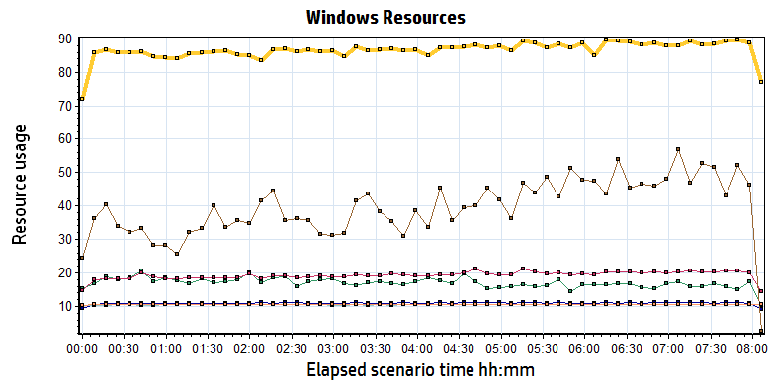

|  |  |  |  |  |  |  |  |  |  |  |  |  |  |  |  |  |  |  |  |  |  |  |  |  |  |  |  |  |  |  |  |  |  |  |  |  |  |  |  |  |  |  |  |  |  |  |  |  |  |  |  |  |  |  |  |  |
| --- | --- | --- | --- | --- | --- | --- | --- | --- | --- | --- | --- | --- | --- | --- | --- | --- | --- | --- | --- | --- | --- | --- | --- | --- | --- | --- | --- | --- | --- | --- | --- | --- | --- | --- | --- | --- | --- | --- | --- | --- | --- | --- | --- | --- | --- | --- | --- | --- | --- | --- | --- | --- | --- | --- | --- | --- |
| |  |  |  |  |  |  |  | | --- | --- | --- | --- | --- | --- | --- | | **Color** | **Scale** | **Measurement** | **Minimum** | **Average** | **Maximum** | **Std. Deviation** | |  | 100 | % Interrupt Time (Processor \_Total):10.184.129.161 | 0.000 | 0.170 | 1.041 | 0.132 | |  | 1 | % Privileged Time (Processor \_Total):10.184.129.161 | 0.346 | 19.265 | 29.764 | 3.345 | |  | 1 | % Processor Time (Processor \_Total):10.184.129.161 | 2.401 | 86.739 | 100.000 | 8.882 | |  | 0.001 | Interrupts/sec (Processor \_Total):10.184.129.161 | 2,929.411 | 10,857.375 | 21,028.266 | 1,535.243 | |  | 1E-09 | Private Bytes (Process \_Total):10.184.129.161 | 9,986,129,920.000 | 10,353,419,255.349 | 10,667,360,256.000 | 70,177,773.220 | |  | 10 | Processor Queue Length (System):10.184.129.161 | 0.000 | 4.007 | 53.000 | 6.046 | |  | 1E-09 | Working Set (Process \_Total):10.184.129.161 | 10,036,203,520.000 | 10,433,029,330.793 | 10,797,621,248.000 | 82,998,309.439 | |
|  |
|  |
| E:\Performance_MR2\B31_PS_20180701_1\Report\dot_trans.gif |
|  |
| |  | | --- | | **Description:**Displays a summary of the System Resources usage for each Windows based host. | |

Follow the figure we can get that the CPU is works under the big stresss. The PCU average usage is 87% and average Processor Queue Length is 4. We set the CPU usage to 60%-80% for prepare conditions by changing the settings of OCR. The CPU uage is can accpected.

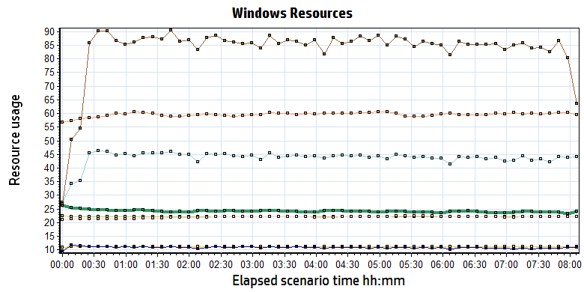

|  |  |  |  |  |  |  |  |  |  |  |  |  |  |  |  |  |  |  |  |  |  |  |  |  |  |  |  |  |  |  |  |  |  |  |  |  |  |  |  |  |  |  |  |  |  |  |  |  |  |  |  |  |  |  |  |  |  |  |  |  |  |  |  |  |  |  |  |  |  |  |
| --- | --- | --- | --- | --- | --- | --- | --- | --- | --- | --- | --- | --- | --- | --- | --- | --- | --- | --- | --- | --- | --- | --- | --- | --- | --- | --- | --- | --- | --- | --- | --- | --- | --- | --- | --- | --- | --- | --- | --- | --- | --- | --- | --- | --- | --- | --- | --- | --- | --- | --- | --- | --- | --- | --- | --- | --- | --- | --- | --- | --- | --- | --- | --- | --- | --- | --- | --- | --- | --- | --- |
| |  |  |  |  |  |  |  | | --- | --- | --- | --- | --- | --- | --- | | **Color** | **Scale** | **Measurement** | **Minimum** | **Average** | **Maximum** | **Std. Deviation** | |  | 0.01 | Available MBytes (Memory):10.184.129.161 | 2,053.000 | 2,417.691 | 2,874.000 | 86.021 | |  | 1E-07 | Cache Bytes (Memory):10.184.129.161 | 195,846,144.000 | 219,758,724.932 | 234,278,912.000 | 4,213,137.090 | |  | 1E-09 | Committed Bytes (Memory):10.184.129.161 | 10,768,756,736.000 | 11,224,457,762.499 | 11,580,231,680.000 | 85,056,198.572 | |  | 0.0001 | Page Faults/sec (Memory):10.184.129.161 | 106.172 | 108,451.860 | 191,757.339 | 25,365.694 | |  | 1 | Page Reads/sec (Memory):10.184.129.161 | 0.000 | 43.616 | 145.775 | 25.641 | |  | 0.1 | Pages/sec (Memory):10.184.129.161 | 0.000 | 838.109 | 4,132.171 | 652.801 | |  | 1E-06 | Pool Nonpaged Bytes (Memory):10.184.129.161 | 55,382,016.000 | 59,586,284.007 | 66,424,832.000 | 1,049,013.242 | |  | 1E-07 | Pool Paged Bytes (Memory):10.184.129.161 | 220,520,448.000 | 221,509,076.639 | 223,629,312.000 | 383,785.762 | |  | 1E-07 | System Cache Resident Bytes (Memory):10.184.129.161 | 195,846,144.000 | 219,757,935.779 | 234,278,912.000 | 4,212,991.191 | |
|  |
|  |
| E:\Performance_MR2\B31_PS_20180701_1\Report\dot_trans.gif |
|  |
| |  | | --- | | **Description:**Displays a summary of the System Resources usage for each Windows based host. | |

The system used more 0.8 GB memory resource during the testing. The system still have 2GB memory can be used. (Available MBytes (Memory):10.184.129.161)

There are many page faults issue during the testing. It means some transactions cannot get the recourse from memory. It need get or request the recourse from hard disk or other device. It needed to enhance in our future version. (Page Faults/sec (Memory)).

The memory resource do not has the bottleneck. There is enough resource for system to use.

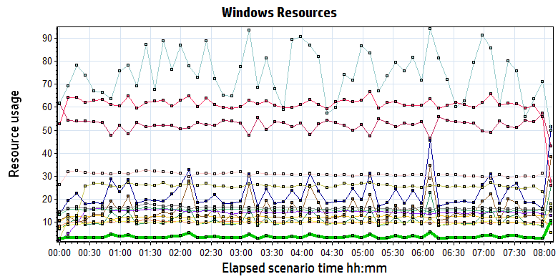

|  |  |  |  |  |  |  |  |  |  |  |  |  |  |  |  |  |  |  |  |  |  |  |  |  |  |  |  |  |  |  |  |  |  |  |  |  |  |  |  |  |  |  |  |  |  |  |  |  |  |  |  |  |  |  |  |  |  |  |  |  |  |  |  |  |  |  |  |  |  |  |  |  |  |  |  |  |  |  |  |  |  |  |  |  |  |  |  |  |  |  |  |  |  |  |  |  |  |  |  |  |  |  |  |  |  |  |  |  |  |  |  |  |  |  |  |  |  |  |  |
| --- | --- | --- | --- | --- | --- | --- | --- | --- | --- | --- | --- | --- | --- | --- | --- | --- | --- | --- | --- | --- | --- | --- | --- | --- | --- | --- | --- | --- | --- | --- | --- | --- | --- | --- | --- | --- | --- | --- | --- | --- | --- | --- | --- | --- | --- | --- | --- | --- | --- | --- | --- | --- | --- | --- | --- | --- | --- | --- | --- | --- | --- | --- | --- | --- | --- | --- | --- | --- | --- | --- | --- | --- | --- | --- | --- | --- | --- | --- | --- | --- | --- | --- | --- | --- | --- | --- | --- | --- | --- | --- | --- | --- | --- | --- | --- | --- | --- | --- | --- | --- | --- | --- | --- | --- | --- | --- | --- | --- | --- | --- | --- | --- | --- | --- | --- | --- | --- | --- | --- |
| |  |  |  |  |  |  |  |  |  |  |  |  |  |  |  |  |  |  |  |  |  |  |  |  |  |  |  |  |  |  |  |  |  |  |  |  |  |  |  |  |  |  |  |  |  |  |  |  |  |  |  |  |  |  |  |  |  |  |  |  |  |  |  |  |  |  |  |  |  |  |  |  |  |  |  |  |  |  |  |  |  |  |  |  |  |  |  |  |  |  |  |  |  |  |  |  |  |  |  |  |  |  |  |  |  |  |  |  |  |  |  |  |  | | --- | --- | --- | --- | --- | --- | --- | --- | --- | --- | --- | --- | --- | --- | --- | --- | --- | --- | --- | --- | --- | --- | --- | --- | --- | --- | --- | --- | --- | --- | --- | --- | --- | --- | --- | --- | --- | --- | --- | --- | --- | --- | --- | --- | --- | --- | --- | --- | --- | --- | --- | --- | --- | --- | --- | --- | --- | --- | --- | --- | --- | --- | --- | --- | --- | --- | --- | --- | --- | --- | --- | --- | --- | --- | --- | --- | --- | --- | --- | --- | --- | --- | --- | --- | --- | --- | --- | --- | --- | --- | --- | --- | --- | --- | --- | --- | --- | --- | --- | --- | --- | --- | --- | --- | --- | --- | --- | --- | --- | --- | --- | --- | --- | | |  |  |  |  |  |  |  | | --- | --- | --- | --- | --- | --- | --- | | **Color** | **Scale** | **Measurement** | **Minimum** | **Average** | **Maximum** | **Std. Deviation** | |  | 0.1 | % Disk Time (PhysicalDisk \_Total):10.184.129.161 | 9.536 | 108.553 | 3,672.880 | 114.973 | |  | 1 | % Idle Time (PhysicalDisk \_Total):10.184.129.161 | 0.000 | 52.432 | 93.602 | 16.264 | |  | 0.0001 | Avg. Disk Bytes/Transfer (PhysicalDisk \_Total):10.184.129.161 | 6,307.529 | 121,897.152 | 537,971.771 | 63,167.276 | |  | 10 | Avg. Disk Queue Length (PhysicalDisk \_Total):10.184.129.161 | 0.191 | 2.171 | 73.458 | 2.299 | |  | 100 | Current Disk Queue Length (PhysicalDisk 0 C|):10.184.129.161 | 0.000 | 0.748 | 13.000 | 1.168 | |  | 10 | Current Disk Queue Length (PhysicalDisk 1 D| E|):10.184.129.161 | 0.000 | 1.520 | 37.000 | 2.580 | |  | 1E-05 | Disk Read Bytes/sec (PhysicalDisk 0 C|):10.184.129.161 | 0.000 | 992,938.914 | 4,666,358.555 | 727,085.346 | |  | 1E-05 | Disk Read Bytes/sec (PhysicalDisk 1 D| E|):10.184.129.161 | 0.000 | 2,490,754.803 | 17,499,426.854 | 2,665,588.080 | |  | 1 | Disk Reads/sec (PhysicalDisk 0 C|):10.184.129.161 | 0.000 | 30.644 | 144.297 | 22.587 | |  | 1 | Disk Reads/sec (PhysicalDisk 1 D| E|):10.184.129.161 | 0.000 | 13.945 | 881.832 | 18.837 | |  | 0.1 | Disk Transfers/sec (PhysicalDisk \_Total):10.184.129.161 | 11.947 | 96.526 | 943.309 | 40.347 | |  | 1E-05 | Disk Write Bytes/sec (PhysicalDisk 0 C|):10.184.129.161 | 208,120.550 | 1,521,620.864 | 4,858,442.098 | 754,413.019 | |  | 1E-05 | Disk Write Bytes/sec (PhysicalDisk 1 D| E|):10.184.129.161 | 6,461.243 | 6,146,461.983 | 26,773,699.075 | 4,370,483.824 | |  | 1 | Disk Writes/sec (PhysicalDisk 0 C|):10.184.129.161 | 4.007 | 16.136 | 48.492 | 5.863 | |  | 0.1 | Disk Writes/sec (PhysicalDisk 1 D| E|):10.184.129.161 | 6.310 | 35.802 | 552.259 | 29.899 | | |  | |  | | E:\Performance_MR2\B31_PS_20180701_1\Report\dot_trans.gif | |  | | |  | | --- | | **Description:**Displays a summary of the System Resources usage for each Windows based host. | | |
|  |
| Follow the figure: we can see that the disk reads and writes operations are very busy. The disk read 3.3MB/S data from disk and write 7.3MB/s data to disk. The Disk is busy but still can accept for design.   |  |  |  |  |  |  |  |  |  |  |  |  |  |  |  |  |  |  |  |  |  |  |  |  |  |  |  |  |  |  |  |  |  |  |  |  | | --- | --- | --- | --- | --- | --- | --- | --- | --- | --- | --- | --- | --- | --- | --- | --- | --- | --- | --- | --- | --- | --- | --- | --- | --- | --- | --- | --- | --- | --- | --- | --- | --- | --- | --- | --- | | |  |  |  |  |  |  |  | | --- | --- | --- | --- | --- | --- | --- | | **Color** | **Scale** | **Measurement** | **Minimum** | **Average** | **Maximum** | **Std. Deviation** | |  | 1E-05 | Disk Read Bytes/sec (PhysicalDisk 0 C|):10.184.129.161 | 0.000 | 992,938.914 | 4,666,358.555 | 727,085.346 | |  | 1E-05 | Disk Read Bytes/sec (PhysicalDisk 1 D| E|):10.184.129.161 | 0.000 | 2,490,754.803 | 17,499,426.854 | 2,665,588.080 | |  | 1E-05 | Disk Write Bytes/sec (PhysicalDisk 0 C|):10.184.129.161 | 208,120.550 | 1,521,620.864 | 4,858,442.098 | 754,413.019 | |  | 1E-05 | Disk Write Bytes/sec (PhysicalDisk 1 D| E|):10.184.129.161 | 6,461.243 | 6,146,461.983 | 26,773,699.075 | 4,370,483.824 | | |  | |  | |  | |

### SQL Server resource usage analysis

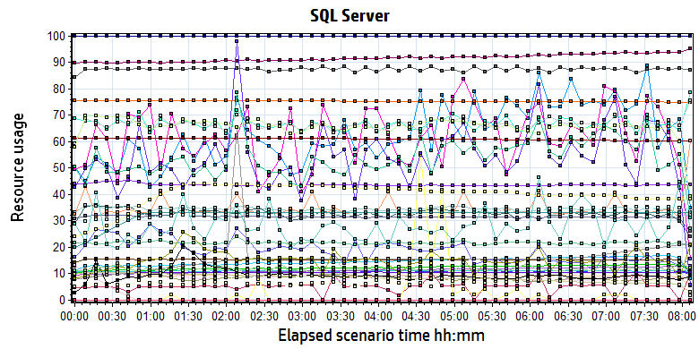

|  |  |  |  |  |  |  |  |  |  |  |  |  |  |  |  |  |  |  |  |  |  |  |  |  |  |  |  |  |  |  |  |  |  |  |  |  |  |  |  |  |  |  |  |  |  |  |  |  |  |  |  |  |  |  |  |  |  |  |  |  |  |  |  |  |  |  |  |  |  |  |  |  |  |  |  |  |  |  |  |  |  |  |  |  |  |  |  |  |  |  |  |  |  |  |  |  |  |  |  |  |  |  |  |  |  |  |  |  |  |  |  |  |  |  |  |  |  |  |  |  |  |  |  |  |  |  |  |  |  |  |  |  |  |  |  |  |  |  |  |  |  |  |  |  |  |  |  |  |  |  |  |  |  |  |  |  |  |  |  |  |  |  |  |  |  |  |  |  |  |  |  |  |  |  |  |  |  |  |  |  |  |  |  |  |  |  |  |  |  |  |  |  |  |  |  |  |  |  |  |  |  |  |  |  |  |  |  |  |  |  |  |  |  |  |  |  |  |  |  |  |  |  |  |  |  |  |  |  |  |  |  |  |  |  |  |  |  |  |  |  |  |  |  |  |  |  |  |  |  |  |  |  |  |  |  |  |  |  |  |  |  |  |  |  |  |  |  |  |  |  |  |  |  |  |  |  |  |  |  |  |  |  |  |  |  |  |  |  |  |  |  |  |  |  |  |  |  |  |  |  |  |  |  |  |  |  |  |  |  |  |  |  |  |  |  |  |  |  |  |  |  |  |  |  |  |  |  |  |  |  |  |  |  |  |  |  |  |  |  |  |  |  |  |  |  |  |  |  |  |  |  |  |  |  |  |  |  |  |  |  |  |  |  |  |  |  |  |  |  |  |  |  |  |  |  |  |  |  |  |  |  |  |  |  |  |
| --- | --- | --- | --- | --- | --- | --- | --- | --- | --- | --- | --- | --- | --- | --- | --- | --- | --- | --- | --- | --- | --- | --- | --- | --- | --- | --- | --- | --- | --- | --- | --- | --- | --- | --- | --- | --- | --- | --- | --- | --- | --- | --- | --- | --- | --- | --- | --- | --- | --- | --- | --- | --- | --- | --- | --- | --- | --- | --- | --- | --- | --- | --- | --- | --- | --- | --- | --- | --- | --- | --- | --- | --- | --- | --- | --- | --- | --- | --- | --- | --- | --- | --- | --- | --- | --- | --- | --- | --- | --- | --- | --- | --- | --- | --- | --- | --- | --- | --- | --- | --- | --- | --- | --- | --- | --- | --- | --- | --- | --- | --- | --- | --- | --- | --- | --- | --- | --- | --- | --- | --- | --- | --- | --- | --- | --- | --- | --- | --- | --- | --- | --- | --- | --- | --- | --- | --- | --- | --- | --- | --- | --- | --- | --- | --- | --- | --- | --- | --- | --- | --- | --- | --- | --- | --- | --- | --- | --- | --- | --- | --- | --- | --- | --- | --- | --- | --- | --- | --- | --- | --- | --- | --- | --- | --- | --- | --- | --- | --- | --- | --- | --- | --- | --- | --- | --- | --- | --- | --- | --- | --- | --- | --- | --- | --- | --- | --- | --- | --- | --- | --- | --- | --- | --- | --- | --- | --- | --- | --- | --- | --- | --- | --- | --- | --- | --- | --- | --- | --- | --- | --- | --- | --- | --- | --- | --- | --- | --- | --- | --- | --- | --- | --- | --- | --- | --- | --- | --- | --- | --- | --- | --- | --- | --- | --- | --- | --- | --- | --- | --- | --- | --- | --- | --- | --- | --- | --- | --- | --- | --- | --- | --- | --- | --- | --- | --- | --- | --- | --- | --- | --- | --- | --- | --- | --- | --- | --- | --- | --- | --- | --- | --- | --- | --- | --- | --- | --- | --- | --- | --- | --- | --- | --- | --- | --- | --- | --- | --- | --- | --- | --- | --- | --- | --- | --- | --- | --- | --- | --- | --- | --- | --- | --- | --- | --- | --- | --- | --- | --- | --- | --- | --- | --- | --- | --- | --- | --- | --- | --- | --- | --- | --- | --- | --- | --- | --- | --- | --- | --- | --- | --- | --- | --- | --- | --- | --- | --- | --- | --- | --- | --- | --- | --- | --- | --- | --- | --- | --- | --- | --- | --- | --- | --- | --- | --- | --- | --- | --- | --- | --- | --- | --- | --- | --- | --- | --- | --- | --- | --- | --- | --- | --- | --- | --- | --- | --- |
| |  |  |  |  |  |  |  |  |  |  |  |  |  |  |  |  |  |  |  |  |  |  |  |  |  |  |  |  |  |  |  |  |  |  |  |  |  |  |  |  |  |  |  |  |  |  |  |  |  |  |  |  |  |  |  |  |  |  |  |  |  |  |  |  |  |  |  |  |  |  |  |  |  |  |  |  |  |  |  |  |  |  |  |  |  |  |  |  |  |  |  |  |  |  |  |  |  |  |  |  |  |  |  |  |  |  |  |  |  |  |  |  |  |  |  |  |  |  |  |  |  |  |  |  |  |  |  |  |  |  |  |  |  |  |  |  |  |  |  |  |  |  |  |  |  |  |  |  |  |  |  |  |  |  |  |  |  |  |  |  |  |  |  |  |  |  |  |  |  |  |  |  |  |  |  |  |  |  |  |  |  |  |  |  |  |  |  |  |  |  |  |  |  |  |  |  |  |  |  |  |  |  |  |  |  |  |  |  |  |  |  |  |  |  |  |  |  |  |  |  |  |  |  |  |  |  |  |  |  |  |  |  |  |  |  |  |  |  |  |  |  |  |  |  |  |  |  |  |  |  |  |  |  |  |  |  |  |  |  |  |  |  |  |  |  |  |  |  |  |  |  |  |  |  |  |  |  |  |  |  |  |  |  |  |  |  |  |  |  |  |  |  |  |  |  |  |  |  |  |  |  |  |  |  |  |  |  |  |  |  |  |  |  |  |  |  |  |  |  |  |  |  |  |  |  |  |  |  |  |  |  |  |  |  |  |  |  |  |  |  |  |  |  |  |  |  |  |  |  |  |  |  |  |  |  |  |  |  |  |  |  |  |  |  |  |  |  |  |  |  |  |  |  |  |  |  |  |  |  | | --- | --- | --- | --- | --- | --- | --- | --- | --- | --- | --- | --- | --- | --- | --- | --- | --- | --- | --- | --- | --- | --- | --- | --- | --- | --- | --- | --- | --- | --- | --- | --- | --- | --- | --- | --- | --- | --- | --- | --- | --- | --- | --- | --- | --- | --- | --- | --- | --- | --- | --- | --- | --- | --- | --- | --- | --- | --- | --- | --- | --- | --- | --- | --- | --- | --- | --- | --- | --- | --- | --- | --- | --- | --- | --- | --- | --- | --- | --- | --- | --- | --- | --- | --- | --- | --- | --- | --- | --- | --- | --- | --- | --- | --- | --- | --- | --- | --- | --- | --- | --- | --- | --- | --- | --- | --- | --- | --- | --- | --- | --- | --- | --- | --- | --- | --- | --- | --- | --- | --- | --- | --- | --- | --- | --- | --- | --- | --- | --- | --- | --- | --- | --- | --- | --- | --- | --- | --- | --- | --- | --- | --- | --- | --- | --- | --- | --- | --- | --- | --- | --- | --- | --- | --- | --- | --- | --- | --- | --- | --- | --- | --- | --- | --- | --- | --- | --- | --- | --- | --- | --- | --- | --- | --- | --- | --- | --- | --- | --- | --- | --- | --- | --- | --- | --- | --- | --- | --- | --- | --- | --- | --- | --- | --- | --- | --- | --- | --- | --- | --- | --- | --- | --- | --- | --- | --- | --- | --- | --- | --- | --- | --- | --- | --- | --- | --- | --- | --- | --- | --- | --- | --- | --- | --- | --- | --- | --- | --- | --- | --- | --- | --- | --- | --- | --- | --- | --- | --- | --- | --- | --- | --- | --- | --- | --- | --- | --- | --- | --- | --- | --- | --- | --- | --- | --- | --- | --- | --- | --- | --- | --- | --- | --- | --- | --- | --- | --- | --- | --- | --- | --- | --- | --- | --- | --- | --- | --- | --- | --- | --- | --- | --- | --- | --- | --- | --- | --- | --- | --- | --- | --- | --- | --- | --- | --- | --- | --- | --- | --- | --- | --- | --- | --- | --- | --- | --- | --- | --- | --- | --- | --- | --- | --- | --- | --- | --- | --- | --- | --- | --- | --- | --- | --- | --- | --- | --- | --- | --- | --- | --- | --- | --- | --- | --- | --- | --- | --- | --- | --- | --- | --- | --- | --- | --- | --- | --- | --- | --- | --- | --- | --- | --- | --- | --- | --- | --- | --- | --- | --- | --- | --- | --- | --- | --- | --- | --- | --- | --- | --- | --- | --- | --- | --- | --- | --- | --- | --- | --- | --- | | |  |  |  |  |  |  |  | | --- | --- | --- | --- | --- | --- | --- | | **Color** | **Scale** | **Measurement** | **Minimum** | **Average** | **Maximum** | **Std. Deviation** | |  | 10 | Active cursors (MSSQL$GCPACSWS|Cursor Manager by Type \_Total):10.184.129.161 | 0.000 | 1.054 | 4.000 | 0.261 | |  | 1 | Active parallel threads (MSSQL$GCPACSWS|Workload Group Stats internal):10.184.129.161 | 0.000 | 0.000 | 0.000 | 0.000 | |  | 1 | Active requests (MSSQL$GCPACSWS|Workload Group Stats internal):10.184.129.161 | 0.000 | 0.000 | 0.000 | 0.000 | |  | 0.1 | Active Temp Tables (MSSQL$GCPACSWS|General Statistics):10.184.129.161 | 108.000 | 110.127 | 143.000 | 1.603 | |  | 1 | Auto-Param Attempts/sec (MSSQL$GCPACSWS|SQL Statistics):10.184.129.161 | 0.000 | 9.333 | 23.058 | 3.308 | |  | 10 | Average Latch Wait Time (ms) (MSSQL$GCPACSWS|Latches):10.184.129.161 | 0.000 | 6.343 | 352.000 | 9.265 | |  | 1 | Average Wait Time (ms) (MSSQL$GCPACSWS|Locks \_Total):10.184.129.161 | 0.000 | 62.217 | 2,320.000 | 159.008 | |  | 1 | Avg. Length of Batched Writes (MSSQL$GCPACSWS|Broker TO Statistics):10.184.129.161 | 0.000 | 0.000 | 0.000 | 0.000 | |  | 1 | Buffer cache hit ratio (MSSQL$GCPACSWS|Buffer Manager):10.184.129.161 | 71.565 | 99.996 | 100.000 | 0.289 | |  | 1 | Cache Hit Ratio (MSSQL$GCPACSWS|Catalog Metadata \_Total):10.184.129.161 | 75.062 | 75.393 | 75.751 | 0.199 | |  | 1 | Cache Hit Ratio (MSSQL$GCPACSWS|Catalog Metadata Printer):10.184.129.161 | 60.263 | 61.041 | 61.432 | 0.358 | |  | 1 | Cache Hit Ratio (MSSQL$GCPACSWS|Catalog Metadata WGGC):10.184.129.161 | 9.586 | 11.327 | 12.820 | 0.927 | |  | 1 | Cache Hit Ratio (MSSQL$GCPACSWS|Cursor Manager by Type \_Total):10.184.129.161 | 80.392 | 87.435 | 91.903 | 1.835 | |  | 1 | Cache Hit Ratio (MSSQL$GCPACSWS|Plan Cache \_Total):10.184.129.161 | 80.310 | 91.660 | 98.405 | 2.777 | |  | 1 | Checkpoint pages/sec (MSSQL$GCPACSWS|Buffer Manager):10.184.129.161 | 0.000 | 5.096 | 441.774 | 23.200 | |  | 0.1 | Connection Reset/sec (MSSQL$GCPACSWS|General Statistics):10.184.129.161 | 65.574 | 153.220 | 436.932 | 39.570 | |  | 1E-05 | Cursor memory usage (MSSQL$GCPACSWS|Cursor Manager by Type \_Total):10.184.129.161 | 705,176.000 | 853,084.005 | 1,080,944.000 | 86,704.279 | |  | 10 | Cursor Requests/sec (MSSQL$GCPACSWS|Cursor Manager by Type \_Total):10.184.129.161 | 0.000 | 3.288 | 15.608 | 2.631 | |  | 0.0001 | Database pages (MSSQL$GCPACSWS|Buffer Manager):10.184.129.161 | 435,071.000 | 437,118.908 | 454,523.000 | 4,452.535 | |  | 1 | Errors/sec (MSSQL$GCPACSWS|SQL Errors DB Offline Errors):10.184.129.161 | 0.000 | 0.000 | 0.000 | 0.000 | |  | 10 | Errors/sec (MSSQL$GCPACSWS|SQL Errors Info Errors):10.184.129.161 | 0.000 | 3.454 | 13.940 | 1.970 | |  | 1 | Errors/sec (MSSQL$GCPACSWS|SQL Errors Kill Connection Errors):10.184.129.161 | 0.000 | 0.000 | 0.000 | 0.000 | |  | 1000 | Errors/sec (MSSQL$GCPACSWS|SQL Errors User Errors):10.184.129.161 | 0.000 | 0.034 | 1.002 | 0.103 | |  | 1 | Free list stalls/sec (MSSQL$GCPACSWS|Buffer Manager):10.184.129.161 | 0.000 | 0.000 | 0.000 | 0.000 | |  | 0.0001 | Free pages (MSSQL$GCPACSWS|Buffer Manager):10.184.129.161 | 107.000 | 8,100.901 | 137,074.000 | 25,064.575 | |  | 0.1 | Full Scans/sec (MSSQL$GCPACSWS|Access Methods):10.184.129.161 | 103.640 | 315.995 | 723.642 | 166.068 | |  | 0.001 | Index Searches/sec (MSSQL$GCPACSWS|Access Methods):10.184.129.161 | 3,027.875 | 32,982.347 | 91,060.029 | 21,501.557 | |  | 0.1 | Latch Waits/sec (MSSQL$GCPACSWS|Latches):10.184.129.161 | 0.680 | 89.769 | 829.348 | 63.451 | |  | 1000 | Lazy writes/sec (MSSQL$GCPACSWS|Buffer Manager):10.184.129.161 | 0.000 | 0.003 | 2.989 | 0.056 | |  | 0.0001 | Lock Requests/sec (MSSQL$GCPACSWS|Locks \_Total):10.184.129.161 | 16,556.662 | 146,659.592 | 368,790.882 | 42,182.575 | |  | 1 | Lock Timeouts (timeout > 0)/sec (MSSQL$GCPACSWS|Locks \_Total):10.184.129.161 | 0.000 | 0.000 | 0.000 | 0.000 | |  | 1 | Lock Timeouts/sec (MSSQL$GCPACSWS|Locks \_Total):10.184.129.161 | 0.000 | 18.787 | 370.322 | 22.365 | |  | 1 | Lock Wait Time (ms) (MSSQL$GCPACSWS|Locks \_Total):10.184.129.161 | 0.000 | 54.544 | 3,373.739 | 129.478 | |  | 10 | Lock Waits/sec (MSSQL$GCPACSWS|Locks \_Total):10.184.129.161 | 0.000 | 0.661 | 20.727 | 0.787 | |  | 0.1 | Logical Connections (MSSQL$GCPACSWS|General Statistics):10.184.129.161 | 165.000 | 217.304 | 259.000 | 7.440 | |  | 100 | Logins/sec (MSSQL$GCPACSWS|General Statistics):10.184.129.161 | 0.000 | 0.668 | 5.695 | 0.507 | |  | 100 | Logouts/sec (MSSQL$GCPACSWS|General Statistics):10.184.129.161 | 0.000 | 0.666 | 6.313 | 0.530 | |  | 100 | Memory Grants Outstanding (MSSQL$GCPACSWS|Memory Manager):10.184.129.161 | 0.000 | 0.282 | 33.000 | 0.825 | |  | 1 | Memory Grants Pending (MSSQL$GCPACSWS|Memory Manager):10.184.129.161 | 0.000 | 0.000 | 0.000 | 0.000 | |  | 1 | Number of Deadlocks/sec (MSSQL$GCPACSWS|Locks \_Total):10.184.129.161 | 0.000 | 0.000 | 0.000 | 0.000 | |  | 1 | Number of SuperLatches (MSSQL$GCPACSWS|Latches):10.184.129.161 | 0.000 | 0.000 | 0.000 | 0.000 | |  | 1 | Open Connection Count (MSSQL$GCPACSWS|Broker/DBM Transport):10.184.129.161 | 0.000 | 0.000 | 0.000 | 0.000 | |  | 0.01 | Optimizer Memory (KB) (MSSQL$GCPACSWS|Memory Manager):10.184.129.161 | 1,040.000 | 1,054.163 | 2,248.000 | 97.228 | |  | 0.001 | Page life expectancy (MSSQL$GCPACSWS|Buffer Manager):10.184.129.161 | 7,597.000 | 15,944.491 | 4,294,965.000 | 61,491.707 | |  | 0.0001 | Page lookups/sec (MSSQL$GCPACSWS|Buffer Manager):10.184.129.161 | 23,821.742 | 123,679.477 | 274,343.109 | 46,747.160 | |  | 1 | Page reads/sec (MSSQL$GCPACSWS|Buffer Manager):10.184.129.161 | 0.000 | 9.439 | 1,061.323 | 24.328 | |  | 1 | Page writes/sec (MSSQL$GCPACSWS|Buffer Manager):10.184.129.161 | 0.000 | 14.970 | 478.311 | 32.617 | |  | 10 | Safe Auto-Params/sec (MSSQL$GCPACSWS|SQL Statistics):10.184.129.161 | 0.000 | 6.602 | 18.350 | 2.525 | |  | 0.001 | SQL Cache Memory (KB) (MSSQL$GCPACSWS|Memory Manager):10.184.129.161 | 23,520.000 | 39,852.603 | 44,216.000 | 4,664.715 | |  | 0.1 | SQL Compilations/sec (MSSQL$GCPACSWS|SQL Statistics):10.184.129.161 | 19.590 | 84.745 | 177.652 | 18.199 | |  | 100 | SQL Re-Compilations/sec (MSSQL$GCPACSWS|SQL Statistics):10.184.129.161 | 0.000 | 0.119 | 1.983 | 0.205 | |  | 0.0001 | Stolen pages (MSSQL$GCPACSWS|Buffer Manager):10.184.129.161 | 191,050.000 | 322,780.192 | 332,564.000 | 27,682.230 | |  | 0.1 | Total Latch Wait Time (ms) (MSSQL$GCPACSWS|Latches):10.184.129.161 | 0.000 | 543.104 | 23,534.815 | 805.006 | | |  | |  | | E:\Performance_MR2\B31_PS_20180701_1\Report\dot_trans.gif | |  | | |  | | --- | | **Description:**Displays a summary of SQL Server Resources. | | |

Database result

Follow the SQL server monitor resource, we can find the Database works well during the testing. We changed the parallel timeout value to 60, there is no parallel transactions happened during testing. The database exist the Latch contend issues. It caused by the cluster index structure, memory contented, I/O contented etc. We can enhance these issues in the future version.

### MS IIS resource usage analysis

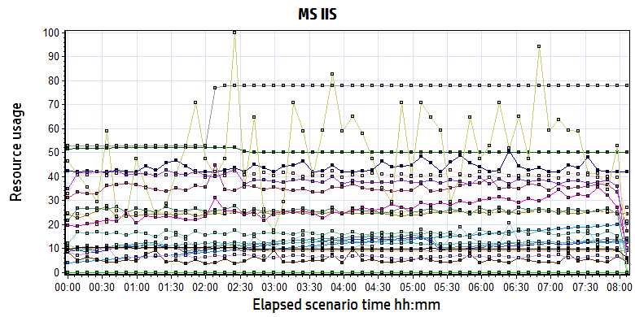

|  |  |  |  |  |  |  |
| --- | --- | --- | --- | --- | --- | --- |
| **Color** | **Scale** | **Measurement** | **Minimum** | **Average** | **Maximum** | **Std. Deviation** |
|  | 1E-07 | # Bytes in all Heaps (.NET CLR Memory \_Global\_):10.184.129.161 | 211,199,564.000 | 247,681,895.729 | 310,446,172.000 | 11,305,257.541 |
|  | 0.01 | # of current logical Threads (.NET CLR LocksAndThreads \_Global\_):10.184.129.161 | 850.000 | 1,238.845 | 1,622.000 | 172.405 |
|  | 0.01 | # of current physical Threads (.NET CLR LocksAndThreads \_Global\_):10.184.129.161 | 760.000 | 1,153.533 | 1,538.000 | 173.461 |
|  | 0.1 | # of current recognized threads (.NET CLR LocksAndThreads \_Global\_):10.184.129.161 | 87.000 | 120.539 | 138.000 | 8.814 |
|  | 0.1 | # of Pinned Objects (.NET CLR Memory \_Global\_):10.184.129.161 | 56.000 | 251.728 | 429.000 | 84.796 |
|  | 0.01 | # of total recognized threads (.NET CLR LocksAndThreads \_Global\_):10.184.129.161 | 398.000 | 1,210.315 | 2,021.000 | 460.771 |
|  | 100 | % Time in GC (.NET CLR Memory \_Global\_):10.184.129.161 | 0.009 | 0.054 | 1.100 | 0.056 |
|  | 1E-06 | Bytes in Loader Heap (.NET CLR Loading \_Global\_):10.184.129.161 | 50,196,480.000 | 50,783,846.653 | 52,318,208.000 | 844,329.835 |
|  | 0.001 | Bytes Received/sec (Web Service \_Total):10.184.129.161 | 0.000 | 10,107.363 | 40,008.705 | 4,388.950 |
|  | 0.001 | Bytes Sent/sec (Web Service \_Total):10.184.129.161 | 0.000 | 25,906.292 | 180,218.359 | 24,933.911 |
|  | 10 | Contention Rate / sec (.NET CLR LocksAndThreads \_Global\_):10.184.129.161 | 0.000 | 2.653 | 26.232 | 2.135 |
|  | 1 | Current Connections (Web Service \_Total):10.184.129.161 | 9.000 | 35.419 | 69.000 | 3.394 |
|  | 0.001 | Current File Cache Memory Usage (Web Service Cache):10.184.129.161 | 42,027.000 | 43,787.515 | 73,828.000 | 6,111.669 |
|  | 10 | Current Files Cached (Web Service Cache):10.184.129.161 | 1.000 | 1.242 | 6.000 | 0.787 |
|  | 1 | Current ISAPI Extension Requests (Web Service \_Total):10.184.129.161 | 0.000 | 0.000 | 0.000 | 0.000 |
|  | 1 | Current Metadata Cached (Web Service Cache):10.184.129.161 | 9.000 | 9.317 | 10.000 | 0.465 |
|  | 1000 | Current NonAnonymous Users (Web Service \_Total):10.184.129.161 | 0.000 | 0.050 | 2.000 | 0.238 |
|  | 1 | Current URIs Cached (Web Service Cache):10.184.129.161 | 4.000 | 40.616 | 61.000 | 6.860 |
|  | 10 | Get Requests/sec (Web Service \_Total):10.184.129.161 | 0.000 | 3.894 | 19.086 | 2.370 |
|  | 1 | ISAPI Extension Requests/sec (Web Service \_Total):10.184.129.161 | 0.000 | 0.000 | 0.000 | 0.000 |
|  | 100 | Kernel| URI Cache Hits/sec (Web Service Cache):10.184.129.161 | 0.000 | 0.163 | 1.387 | 0.228 |
|  | 1E-07 | Large Object Heap Size (.NET CLR Memory \_Global\_):10.184.129.161 | 58,089,616.000 | 68,362,049.762 | 142,367,592.000 | 11,674,185.317 |
|  | 1 | Locked Errors/sec (Web Service \_Total):10.184.129.161 | 0.000 | 0.000 | 0.000 | 0.000 |
|  | 1 | Maximum Connections (Web Service \_Total):10.184.129.161 | 53.000 | 71.416 | 78.000 | 11.005 |
|  | 1 | Not Found Errors/sec (Web Service \_Total):10.184.129.161 | 0.000 | 0.000 | 0.000 | 0.000 |
|  | 1 | Post Requests/sec (Web Service \_Total):10.184.129.161 | 0.000 | 10.059 | 25.296 | 1.957 |

E:\Performance_MR2\B31_PS_20180701_1\Report\dot_trans.gif

|  |
| --- |
| **Description:**Displays a summary of resources on MsIIS web server. |
|  |

From the finger, we can see that the MS IIS services works well during testing. But we used too many IIS service in the system. These services used too much memory recourse and they will not release in short time. Maybe we should limit some services recourse usage in future version.

## Test Conclusion

We executed the performance testing scenario for 8 hours. (From Period: 6/29/2019 2:48 PM - 6/29/2019 10:55 PM). There are only 13 transaction failed during the testing.

During the testing, the main works result is follow:

|  |  |  |
| --- | --- | --- |
| Type | Count | Size |
| Dicom Archived | 4,081 | 10M |
| Dicom Printed | 2,903 | 10M |
| Report Archived | 8,712 | Random 100Kb or 4Mb |
| Report Printed | 5,850 | Random 100Kb or 4Mb |
| Color film Printed | 271 | 80M |

From the statistic result, **we can get that the result can meets the requirements for system**. During the testing, we stop the LRU and SMS service to avoid the disturbance because these services will not execute in the work times as default. And other limited is we do not add the ROI zone for OCR services, the OCR services is works under a big stress. The system can works well under the big stress.

The testing is executed with an ideal environment. Our system still has many issues in our system. Such as if too much unprinted films and reports existed in system, it will cause the terminal performance down. The LRU services will cause the recource contend. The statistic function in web will cause the main work flow failed etc. We need enhance our system to enhance the performance.

The detail tunning suggestion, please see the related charpter content as follow:

## Tune Suggestion

### System related:

1. The physical disks have some stress during testing, suggest enhance the dicom and report archived and transfer process to avoid too much reads and writes.
2. Enhance the LRU and data deleted work rule. Make sure them can execute successfully with big data. Organize the tasks execute with sequential to avoid the recourse contend issues.
3. There are many application pools exist in the system. Some applications are not used in the system except the system which upgrade from history version. Please organize the services.
4. Limited the memory usage for IIS web service to save the memory resource.
5. The integration applications will use 3-4 web services in our system. They will use many memory resources. Normally, the intergration will query data from the view from 3rd system. The view performance is slowly, suggest use table instead of view or materializated view.

### Database related:

1. Deleted the unused views from the database to save the CPU and memory resources.

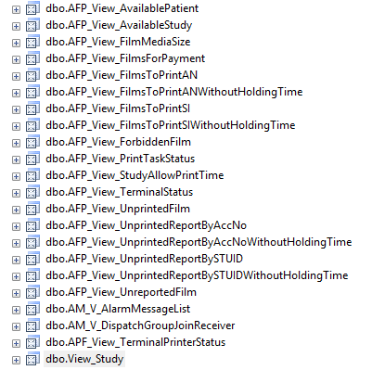

1. The terminals query the patient information from the views in the wggc database. The performance of view is slowly because it cannot use the index. The view is created with very complex condition and cost many memory resourse. Please try to query data with table or limited the size with conditions.
2. Deleted the unused tables, functions, store procedures in the database to save the memory resource. Some of them are not used in PS system.
3. Some SQL used the tempdb tables in the database. It will cost 0.3-2Mb/s IO recourse during testing. QA team suggests use the CTE instead of the temp tables to realize the functions. If the system uses more than 4MB/S IO reads/writes, it will cause the issues of main workflow.
4. Reduce the trigger usage in the database to enhance the performance for DB. The trigger performance is slow and cause the locks issue for our system.
5. Split the hot tables in our system. There are too many operations for our main work flow tables such as filminfo, reportinfo, examinfo, print task, print mode etc. The design will cause some locks issues.
6. The statistic function in web cannot works well. If user does this operation, it will block the main workflow in our system. Suggest creat a table which include all information of patint to do the statistic operation on this table. Notice that the LRU service should back up the data to this table before they delete datas.Add the redundancy tables for statistic functions and history query operations.
7. Use the sequenced column as the cluster key or primary key to avoid the latch issues. Many table cluster key is created by GUID, the GUID value is not a sequenced. IT will cause the index fragment issues. It will make the cluster query very slow and some tables` index fragment rate will more than 90%. It is big issues for our database.
8. There are still some key lookup issues in our database. The index design should be enhance.
9. The database full backup should includ to LRU services. The operations should execut before the data clean operations in LRU.
10. Design the code rule for database such as case sensitive, avoid use \* to query all data, avoid use count(\*) instead of count(cluster), avoid use in and avoid use cusor etc.
11. Some SQL use too much reads or writes during this testing:

SQL1:

*update Study set AcquireStatus = '1'*

This sql will cause the full tables scans, please add some filter conditions for the sql statement like:

*update Study set AcquireStatus = '1' where AcuirStatus = ‘0’*

Add the index for the filter conditions.

SQL2:

*IF EXISTS(SELECT StudyInstanceUID FROM [Printer].[dbo].[DeliveryJob] D WHERE D.StudyInstanceUID = @SIUID)*

The column StudyInstanceUID is not indexed, the SQL will cause the full table scans. Please add the index on the column for table. Other issues for table *DeliveryJob* is that the column SessionInstanceUID is indexed in two indexes. Please delete one from the tables.

SQL3:

*SELECT JobInstanceUID, ForwardStatus = CASE WHEN ForwardStatus IS NULL THEN -1 ELSE ForwardStatus END,*

*ForwardFlag = CASE WHEN ForwardFlag IS NULL THEN -1 ELSE ForwardFlag END,ForwardDestination,ModalityType, CallingAE ,CallingIP,PatientName,PatientID,*

*PatientType = CASE WHEN PatientType IS NULL THEN '' ELSE PatientType END*

*FROM Printer.dbo.DeliveryJob J INNER JOIN printer.dbo.Session S*

*ON J.SessionInstanceUID = S.SessionInstanceUID*

*WHERE J.DeleteStatus = 0 AND (*

*(ForwardStatus = -1 OR ForwardStatus IS NULL ) OR*

*(ForwardStatus = 0 AND ForwardFlag = 1)*

*)*

The SQL will cause the key lookup issues because some columns are not including in the index. Suggest using “include” operations to create the index like :

*CREATE NONCLUSTERED INDEX IX\_Name ON table (index-column)*

*INCLUDE (column1, column2 which key lookup columns);*

*GO*

SQL4:

*INSERT INTO [Study]([StudyInstanceUID],[StudyDate],[StudyTime],[StudyID],[StudyDescription],[AccessionNo],[ReferPhysician],[Printed],[Readed],[PatientGUID],[SeriesCount],[ImageCount],[Reserved],[Hide],[OperateServerAE],[OperateStatus],[Problemed],[StudyDir],[AcqDateTime],[QCStatus],[Send],[AcquireStatus]) values(@1,@2,@3,@4,@5,@6,@7,@8,@9,@10,@11,@12,@13,@14,@15,@16,@17,@18,getdate(),@19,@20,@21)*

QA cannot find why insert sql will use many reads/write. Maybe the sql statement is included in a procedure or trigger. Other SQL caused the issues.

**<End of document>**